|  |  |  |  |
| --- | --- | --- | --- |
| European Railway Agency | | | |
| ERA Braking curves tool handbook | | | |
| **Reference:** | ERA-GUI-05 | **Document type:** | handbook |
| **Version :** | 4.3 |  |  |
| **Date :** | 29/07/24 |  |  |

**Overview:**

The aim of the “ERA_braking_curves_tool” is to compute the braking curves EBD, SBD and GUI, the associated EBI, SBI, Warning, Permitted, Indication and release speed supervision limits, according to the track and train characteristics relevant for the braking curves functionality. The calculations are in line with the requirements set out in the chapter 3.13 of the SRS 4.0.0 taking into account the exceptions valid for the so-called on-board reduced envelope of system versions as specified in the SUBSET-153 1.0.0.

The following track data can be entered as input:

* The target type (MRSP/LOA or EOA/SvL), speed and location
* The initial speed from which the braking to the target is considered
* The gradient profile
* In case of EOA/SvL target, the release speed information
* A list of relocation balises
* One track condition “brake inhibition” area
* One reduced adhesion area.

The following train data and parameters data can be entered as input:

* The type of model used to capture the braking performance of the train: Lambda or Gamma, i.e. whether the speed dependent deceleration models (as step functions) are entered as input or only the brake percentage λ is entered as input
* The ETCS Train Data traction/brake parameters
* The train length
* The speed measurement inaccuracy
* The distance measurement inaccuracy
* The train acceleration

In addition, the following National values can be entered:

* in case the Gamma model is used, the Emergency Brake Confidence Interval (M_NVEBCL) and the weighting factor for the available wheel/rail adhesion (M_NVAVADH)
* in case the lambda model is used, the integrated correction factors
* the three maximum deceleration values under reduced adhesion condition (A_MAXREDADH1, 2, 3)
* the permission for on-board to use the service brake in Target Speed Monitoring (Q_NVSBTSMPERM)
* the permission to use the guidance curve (Q_NVGUIPERM)
* the permission for on-board to inhibit the compensation of the speed measurement inaccuracy (Q_NVINHSMICPERM).

**Organisation:**

This manual explains how to use this program in order to obtain the results.

The explanations are ordered in a logical way from the user point of view. It begins with the “Train (main)” worksheet where the main train characteristics are chosen. The track and target characteristics are chosen in the “Track” worksheet and then, according to the train type choice, the “Brake parameters (Gamma)” worksheet or the “Brake parameters (Lambda)” worksheet will appear together with additional sheets dedicated to the correction factors and they need to be filled as explained below. The National Values can be modified if needed and finally, the curves are computed on the “Curves Gamma train” or “Curves Lambda train” worksheet.

Train (main)

Track

National Values

Brake parameters (Gamma)

Brake parameters (Lambda)

Integrated correction factors

Correction factor Kdry_rst

Gradient correction factors

Curves Gamma train

Curves Lambda train

In all worksheets, the yellow fields correspond to user’s inputs and only the cells that contain an input are unlocked.

**“Train (main)” worksheet:**



The first parameters which can be entered are the train type and the brake position.

The value T_traction_cut_off corresponds to the time delay between the traction cut-off command and the moment the acceleration due to traction is null; it has an influence on the EBI curve.

The speed inaccuracy can be set as fixed percentage (user’s input) or as defined in the Subset 041. In both cases the tool computes, from a percentage of the speed value for which the EBI point is calculated, the vertical EBI shift V_delta0. The contribution of the two other components of the EBI vertical shift (V_delta1 and V_delta2) can also be simulated by entering the train acceleration.

The position inaccuracy is entered through a pair of values (absolute value (m) + a percentage of the travelled distance from the last relocation point), which can be fixed (user’s input) or as defined in the Subset 041 (5m + 5%). The resulting distance is used to shift horizontally the EBI and the SBI2 and possibly the W, P, I supervision limits. This distance is also used to shift horizontally the GUI curve calculated from the SvL or the one calculated from the foot of a LOA/MRSP target.

The train length has an influence on gradient compensation and (for lambda train only) on the brake build up time calculated from the conversion model.

The nominal rotating mass: If no value is entered (as on the picture), the tool uses the fixed value M_rotating_max for uphill (positive gradient) or M_rotating_min for downhill (negative gradient).

**“Track” worksheet:**



In this sheet all the locations/distances (except the distance EOA/SvL) are referred as positive distances from a fictive origin point, where the first location reference (i.e. a LRBG) is placed.

On the “Track” worksheet, the first data to enter is the target type:

* if LOA/MRSP is chosen, the user must only enter the target speed/location and the initial speed (i.e. the value of the MRSP preceding the target speed)
* if EOA/SvL is chosen, the target speed is automatically set to zero, and the user can enter a distance between the EOA and the SvL and the release speed information.

In case the user selects EOA/SvL and release speed calculated on-board, the level must also be selected since it influences the predicted location where the train trip takes place.

It is possible to enter a brake inhibition area (only for Gamma trains) and a reduced adhesion area.

For the brake inhibition area, only the start location must be entered, since the on-board computes the EBD by considering the EBD foot as the end location of the brake inhibition area.

The gradient profile can be entered as a distance step function (negative gradient for downhill, positive gradient for uphill). By default the tool will compute one step with gradient 0 up to either the LOA/MRSP target location or up to the SvL. A maximum number of 50 steps can be entered (gradient value + step end location). In case the last step entered ends at a location in rear of the LOA/MRSP target or in rear of the SvL, the tool will adjust automatically the gradient profile end location either to the LOA/MRSP target location or to the SvL.

In order to process the shifting distances of the EBI, SBI2, W, P and I supervision limits according to the calculated position inaccuracy, it is possible to enter maximum 30 relocation balises, in addition to the one located at the fictive track origin, which is considered as the first relocation point. These relocation points are also taken into account for the release speed calculated on-board.

The shifting of the P, W, SBI2 and EBI supervision limits and the on-board calculation of the release speed (if any) are performed considering a virtual train movement started from the origin location along the envelope of P distances (“P-curve”). The I supervision limit is however shifted according to a virtual train movement along the “I-curve”, in order to reflect the fact that the I supervision limit is crossed by the max safe front end of the train with less accumulated odometer error than when reaching the location when the P-curve starts to decrease.

The “Calculate the track values” button permits to calculate the raw gradient profile, the gradient profile compensated by the train length, and the acceleration due to gradient profile compensated with the rotating masses.

Important remark: the user has to take care that the entered distance between the origin point and the target is long enough so that both the perturbation point and the full range of the EBD, SBD and GUI curves are located in advance of the origin point. Otherwise the tool will stop the calculation of the curves and inform the user accordingly.

**“National values” worksheet:**



The national values that can be entered are coloured in yellow, while the rightmost column recalls the default values.

**Note:** the emergency brake confidence level has to be entered in the “Gamma train” worksheet (through a more intuitive set of 1-10-x values), and it is automatically translated to show the corresponding M_NVEBCL value on the “National values” worksheet. The integrated correction factors for Lambda trains have to be entered in the “Lambda train correction factors”.

**“Brake parameters (Lambda) ” worksheet:**



From the brake percentage λ entered by the user, all the outputs of the conversion model, such as the T_brake_emergency, T_brake_service, A_brake_emergency and A_brake_service step function are automatically calculated from the brake percentage λ. The selection of the A_brake_normal_service amongst the two sets of three predefined step functions is also automatically performed from the brake position and the brake percentage (through the full service brake deceleration at zero speed resulting from the conversion model and the input values A_SB01&A_SB02).



See annex 1 for explanations on how to fill in step function input values.

Moreover it is possible to enter manually a value of T_bs shorter than the one calculated from the conversion model.

**“Integrated correction factors” worksheet:**



The three correction factors applicable to the Lambda trains are entered in this worksheet.

The Kv_int(V) and Kr_int(L) step functions have to be completed in the yellow fields while the Kt_int correction factor is a single value.

See annex 1 for explanations on how to fill in step function input values.

**“Brake parameters (Gamma)” worksheet:**



In the “Brake parameters (Gamma)” worksheet, it is possible to enter the braking data, for two combination of use of the brakes: the first one corresponds to “all brakes” available while the second one is used by the tool when taking into account the track condition profile “inhibition of the special brakes”.

The following braking parameters can be entered for both combinations of use:

* the nominal speed dependent deceleration models for emergency brake
* the emergency brake confidence level (which will select the corresponding Kdry_rst step function , see “Correction factor Kdry_rst” worksheet)
* the Kwet_rst step function
* the speed dependent deceleration models for full service brake
* the speed dependent deceleration models for normal service brake
* the T_brake_emergency and T_brake_service equivalent build up times.

See annex 1 for explanations on how to fill in step function input values.

**“Correction factor Kdry_rst” worksheet:**



This worksheet is necessary in order to enter, for both combination of use of brakes and for each Emergency Brake Confidence Level (EBCL), the corresponding Kdry_rst step function . In this worksheet, the speed step values are fixed and equal to the ones from the nominal emergency brake deceleration.

See annex 1 for explanations on how to fill in step function input values.

**“Gradient correction factors” worksheet:**

Regardless whether the train is Gamma or Lambda, the two correction factors applicable to the normal service brake deceleration profile are entered in this worksheet.



See annex 1 for explanations on how to fill in step function input values.

**“Curves Lambda train” and “Curves Gamma train” worksheets:**

**2**

**1**



**3**

For the “Curves Lambda train” worksheet, as for the “Curves Gamma train” worksheet, the only user’s task is to press the “Calculate the curves” button; this will recalculate and save all the parameters included on all worksheets.

The table 2 shows all the calculation steps, for each curve.

The table 3 registers the distance values, counted positive from the target, for the perturbation location, for each supervision limit (calculated at the initial speed) and both the start of the RSM location and, when relevant, the release speed value at this location.

Note: the perturbation location can be different from the Indication supervision limit at the initial speed, in case a fixed speed inaccuracy and/or a train acceleration is entered.

**Annex 1: how to fill in input values for step functions**

In this program, all the step functions have the same logic: it is possible to define the different intervals with the associated value. The values are repeated twice for graphic reasons, but values have to be inserted just once (in the yellow field).

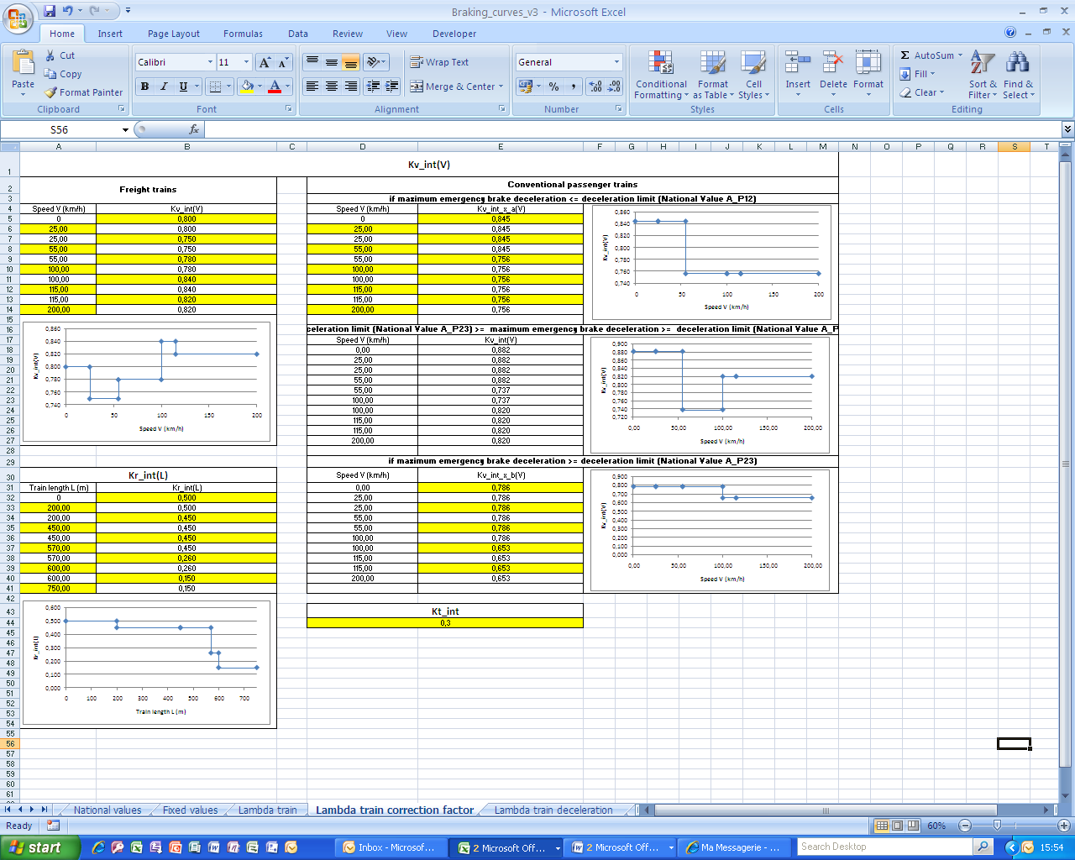

With the exception of the gradient profile, all the step values must be entered, which means that if the step function only contains 3 steps (or intervals), it is necessary to repeat the values e.g. as follows:

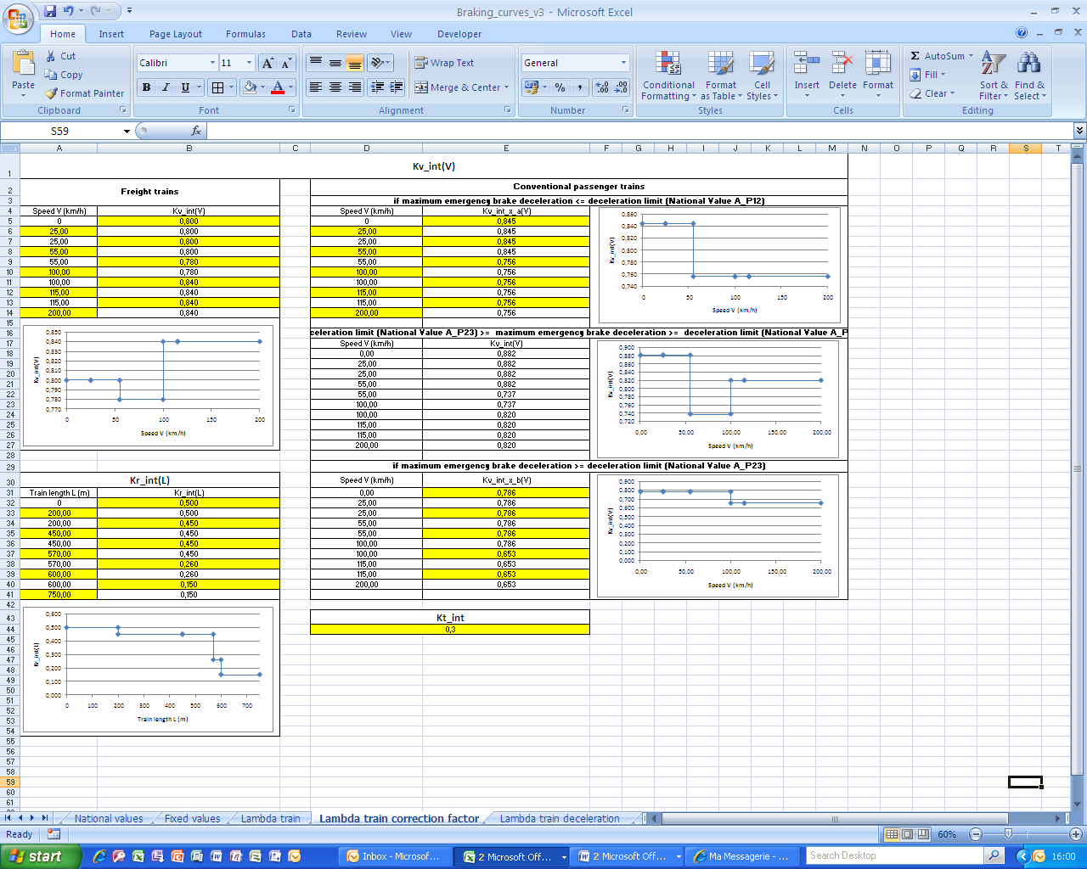

For a single-step function:

