|  |  |  |  |
| --- | --- | --- | --- |
| European Railway Agency | | | |
| ERA Braking curves tool handbook | | | |
| **Reference:** | ERA-GUI-05 | **Document type:** | handbook |
| **Version :** | 5.1 |  |  |
| **Date :** | 14/10/24 |  |  |

**Overview:**

The aim of the “ERA_braking_curves_tool” is to compute the braking curves EBD, SBD and GUI, the associated EBI, SBI, Warning, Permitted, Indication and release speed supervision limits, according to the track and train characteristics relevant for the braking curves functionality. The calculations are in line with the requirements set out in the chapter 3.13 of the SRS 4.0.0.

The following track data can be entered as input:

* The target type (MRSP/LOA or EOA/SvL), speed and location
* The initial speed from which the braking to the target is considered
* The gradient profile
* In case of EOA/SvL target, the release speed information
* A list of relocation balises
* One track condition “brake inhibition” area
* One reduced adhesion area.

The following train data and parameters data can be entered as input:

* The type of model used to capture the braking performance of the train: Lambda or Gamma, i.e. whether the speed dependent deceleration models (as step functions) are entered as input or only the brake percentage λ is entered as input
* The ETCS Train Data traction/brake parameters
* The train length, or in case it is available for e.g. Supervised Manoeuvre, the safe consist length information
* The engine length, together with the distance antenna-engine front
* The speed measurement inaccuracy
* The distance measurement inaccuracy
* The train acceleration

In addition, the following National values can be entered:

* in case the Gamma model is used, the Emergency Brake Confidence Interval (M_NVEBCL) and the weighting factor for the available wheel/rail adhesion (M_NVAVADH)
* in case the lambda model is used, the integrated correction factors
* the three maximum deceleration values under reduced adhesion condition (A_MAXREDADH1, 2, 3)
* the permission for on-board to use the service brake in Target Speed Monitoring (Q_NVSBTSMPERM)
* the permission to use the guidance curve (Q_NVGUIPERM)
* the permission for on-board to inhibit the compensation of the speed measurement inaccuracy (Q_NVINHSMICPERM).

**Organisation:**

This manual explains how to use this program in order to obtain the results.

The explanations are ordered in a logical way from the user point of view. It begins with the “Train (main)” worksheet where the main train characteristics are chosen. The track and target characteristics are chosen in the “Track” worksheet and then, according to the train type choice, the “Brake parameters (Gamma)” worksheet or the “Brake parameters (Lambda)” worksheet will appear together with additional sheets dedicated to the correction factors and they need to be filled as explained below. The National Values can be modified if needed and finally, the curves are computed on the “Curves Gamma train” or “Curves Lambda train” worksheet.

Train (main)

Track

National Values

Brake parameters (Gamma)

Brake parameters (Lambda)

Integrated correction factors

Correction factor Kdry_rst

Gradient correction factors

Curves Gamma train

Curves Lambda train

In all worksheets, the yellow fields correspond to user’s inputs and only the cells that contain an input are unlocked.

**“Train (main)” worksheet:**





The first parameters which can be entered are the train type and the brake position.

The value T_traction_cut_off corresponds to the time delay between the traction cut-off command and the moment the acceleration due to traction is null; it has an influence on the EBI curve.

The speed inaccuracy can be set as fixed percentage (user’s input) or as defined in the Subset 041. In both cases the tool computes, from a percentage of the speed value for which the EBI point is calculated, the vertical EBI shift V_delta0. The contribution of the two other components of the EBI vertical shift (V_delta1 and V_delta2) can also be simulated by entering the train acceleration.

The odometer inaccuracy is entered through a pair of values (absolute value (m) + a percentage of the distance travelled by the antenna from the last relocation point), which can be fixed (user’s input) or as defined in the Subset 041 (5m + 5%). The resulting distance, together with the uncertainty of the consist length between the engine and the train front, which must be taken into account in case of Supervised Manoeuvre, is used to shift horizontally the EBI and the SBI2 and possibly the W, P, I supervision limits. This distance is also used to shift horizontally the GUI curve calculated from the SvL or the one calculated from the foot of a LOA/MRSP target.

The Supervised Manoeuvre can be selected, which will trigger the data entry of the safe consist length information (min, nom and max) both in front and in rear of the engine.

The safe consist length in rear of the engine does include the engine length (same as the “classical” train length). Since the safe consist length in front of the engine does not include the engine length and this latter must be taken into account to calculate the overall train length, the user must also enter the engine length, which will also be used to force the minimum value of the both the consist length in rear of the engine and the train length.

The user must also select whether the orientation of the engine is the same as the train, in order to calculate the distance between the antenna and the train front, and to correctly derive the train position inaccuracy by taking into account the uncertainty of the consist length between the engine and the train front.

Depending on whether the engine orientation is the same as/opposite to the train orientation, the safe consist length information in front/in rear of the engine will be taken into account. See figures below for the possible consist configurations in Supervised Manoeuvre.



Engine orientation same as train orientation

Engine orientation opposite to train orientation

In case the Supervised Manoeuvre is not selected, the user can however select whether the safe consist length information is available. In case the safe consist length information in rear of the engine must be captured instead of the “classical” train length.

From the above data entries, the simulator will derive the overall train length:

* Supervised Manoeuvre = No and Safe consist length info available = No: Overall train length = “classical” train length
* Supervised Manoeuvre = No and Safe consist length info available = Yes: Overall train length = max consist length in rear of the engine
* Supervised Manoeuvre = Yes: Overall train length = max consist length in rear of the engine + max consist length in front of the engine

The overall train length has an influence on gradient compensation and (for lambda train only) on the brake build up time calculated from the conversion model.

The nominal rotating mass: If no value is entered (as on the picture), the tool uses the fixed value M_rotating_max for uphill (positive gradient) or M_rotating_min for downhill (negative gradient).

**“Track” worksheet:**



In this sheet all the locations/distances (except the distance EOA/SvL) are referred as positive distances from a fictive origin point, where the first location reference (i.e. a LRBG) is placed.

On the “Track” worksheet, the first data to enter is the target type:

* if LOA/MRSP is chosen, the user must only enter the target speed/location and the initial speed (i.e. the value of the MRSP preceding the target speed)
* if EOA/SvL is chosen, the target speed is automatically set to zero, and the user can enter a distance between the EOA and the SvL and the release speed information.

In case the user selects EOA/SvL and release speed calculated on-board, two possibilities:

1. Supervised Manoeuvre = no: the level must also be selected since it influences the predicted location where the train trip takes place (d_trip_EOA).
2. Supervised Manoeuvre = yes: no level selection possible because SM is only possible in level 2. The forced level 2 selection is however displayed to remind the user how the release speed will be calculated (d_trip_EOA).

It is possible to enter a brake inhibition area (only for Gamma trains) and a reduced adhesion area.

For the brake inhibition area, only the start location must be entered, since the on-board computes the EBD by considering the EBD foot as the end location of the brake inhibition area.

The gradient profile can be entered as a distance step function (negative gradient for downhill, positive gradient for uphill). By default the tool will compute one step with gradient 0 up to either the LOA/MRSP target location or up to the SvL. A maximum number of 50 steps can be entered (gradient value + step end location).

In case the last step entered ends at a location in rear of the SvL, the tool will adjust automatically the gradient profile end location to the SvL, an ad-hoc pop-up message will be displayed, and the corresponding cell coloured in orange.

In case of LOA/MRSP target, the tool will check whether the last step entered ends at a location in advance of or at the foot of the EBD curve (i.e. at a certain distance from the target, depending on the parameter A_safe used to erect the EBD curve). If it is not the case, the tool will automatically extend the profile with the last gradient value entered, an ad-hoc pop-up message will be displayed, and the exact value of the EBD foot location will be displayed in the cell coloured in orange.

It is possible to enter maximum 30 relocation balises, in addition to the one located at the fictive track origin, which is considered as the first relocation point. These relocation points are taken into account for the shifting of the EBI, SBI2, W, P and I supervision limits according to the calculated train position inaccuracy and for the release speed calculated on-board calculation too.

The “Calculate the track values” button permits to calculate the raw gradient profile, the gradient profile compensated by the train length, and the acceleration due to gradient profile compensated with the rotating masses.

Important remark: the user has to take care that the entered distance between the origin point and the target is long enough so that both the perturbation point and the full range of the EBD, SBD and GUI curves are located in advance of the origin point. Otherwise the tool will stop the calculation of the curves and inform the user accordingly.

**“National values” worksheet:**



The national values that can be entered are coloured in yellow, while the rightmost column recalls the default values.

**Note:** the emergency brake confidence level has to be entered in the “Gamma train” worksheet (through a more intuitive set of 1-10-x values), and it is automatically translated to show the corresponding M_NVEBCL value on the “National values” worksheet. The integrated correction factors for Lambda trains have to be entered in the “Lambda train correction factors”.

**“Brake parameters (Lambda) ” worksheet:**



From the brake percentage λ entered by the user, all the outputs of the conversion model, such as the T_brake_emergency, T_brake_service, T_brake_emergency_react, T_brake_service_react, A_brake_emergency and A_brake_service step function are automatically calculated from the brake percentage λ. The selection of the A_brake_normal_service amongst the two sets of three predefined step functions is also automatically performed from the brake position and the brake percentage (through the full service brake deceleration at zero speed resulting from the conversion model and the input values A_SB01&A_SB02).



See annex 1 for explanations on how to fill in step function input values.

Moreover it is possible to enter manually a value of T_bs shorter than the one calculated from the conversion model, which will also trigger the entry of a T_brake_service value.

**“Integrated correction factors” worksheet:**



The three correction factors applicable to the Lambda trains are entered in this worksheet.

The Kv_int(V) and Kr_int(L) step functions have to be completed in the yellow fields while the Kt_int correction factor is a single value.

See annex 1 for explanations on how to fill in step function input values.

**“Brake parameters (Gamma)” worksheet:**



In the “Brake parameters (Gamma)” worksheet, it is possible to enter the braking data, for two combination of use of the brakes: the first one corresponds to “all brakes” available while the second one is used by the tool when taking into account the track condition profile “inhibition of the special brakes”.

The following braking parameters can be entered for both combinations of use:

* the nominal speed dependent deceleration models for emergency brake
* the emergency brake confidence level (which will select the corresponding Kdry_rst step function , see “Correction factor Kdry_rst” worksheet)
* the Kwet_rst step function
* the speed dependent deceleration models for full service brake
* the speed dependent deceleration models for normal service brake
* the T_brake_emergency and T_brake_service equivalent build up times.
* the T_brake_emergency_react and T_brake_service_react times

See annex 1 for explanations on how to fill in step function input values.

**“Correction factor Kdry_rst” worksheet:**



This worksheet is necessary in order to enter, for both combination of use of brakes and for each Emergency Brake Confidence Level (EBCL), the corresponding Kdry_rst step function . In this worksheet, the speed step values are fixed and equal to the ones from the nominal emergency brake deceleration.

See annex 1 for explanations on how to fill in step function input values.

**“Gradient correction factors” worksheet:**

Regardless whether the train is Gamma or Lambda, the two correction factors applicable to the normal service brake deceleration profile are entered in this worksheet.



See annex 1 for explanations on how to fill in step function input values.

**“Curves Lambda train” and “Curves Gamma train” worksheets:**

**2**

**1**



**3**

For the “Curves Lambda train” worksheet, as for the “Curves Gamma train” worksheet, the only user’s task is to press the “Calculate the curves” button; this will recalculate and save all the parameters included on all worksheets.

The table 2 shows all the calculation steps, for each curve.

The table 3 registers the distance values, counted positive from the target, for the perturbation location, for each supervision limit (calculated at the initial speed) and both the start of the RSM location and, when relevant, the release speed value at this location.

Note: the perturbation location can be different from the Indication supervision limit at the initial speed, in case a fixed speed inaccuracy and/or a train acceleration is entered.

In order to take into account the fact that some distances are supervised by the ETCS on-board against the max safe front end, with this latter at a growing distance from the estimated front end depending on odometer accuracy and how far the on-board antenna is from the last encountered balise group, the tool shifts the EBI, SBI2 and possibly the W, P and I supervision limits to the extent of at most the distance between the estimated front end and the max safe front end (i.e. corresponding to the variable L_DOUBTUNDER).

The shifting of the P, W, SBI2 and EBI supervision limits is performed considering a virtual train movement started with the antenna of the engine at the origin location and effected by the estimated front end along the envelope of P distances (“P-curve”). In other terms the tool will show a P-curve corresponding the position of the estimated train front end while its max safe front end is located at the actual P-curve calculated by the ETCS on-board. At every passage of balise group by the antenna the tool can therefore display a horizontal shift of the P, W and SBI distances, depending on whether the train position inaccuracy is bigger than the distance between the SBI1 and SBI2. In case of Supervised Manoeuvre with a consist length existing between the engine and the train front, this horizontal shift will also occur at a certain distance from the balise group, because of this consist length.

Since they are always supervised with the max safe front end, the EBI and SBI2 supervision limits are systematically shifted.

The I supervision limit is however shifted according to a virtual train movement along the “I-curve”, in order to reflect the fact that the I supervision limit is crossed by the max safe front end of the train with less accumulated odometer error than when reaching the location when the P-curve starts to decrease.

The on-board calculation of the release speed (if any) is performed in the same way, but considering a virtual train movement started with a train position located where the shifted I supervision limit is crossed by the estimated train front at the initial speed.

The figure below shows an example of horizontal shift with a 400m consist in SM mode. Note: the distance between SBI1 and SBI2 being bigger than the train position inaccuracy on passing the last BG (1000m), there is no horizontal shift displayed.



**Annex 1: how to fill in input values for step functions**

In this program, all the step functions have the same logic: it is possible to define the different intervals with the associated value. The values are repeated twice for graphic reasons, but values have to be inserted just once (in the yellow field).

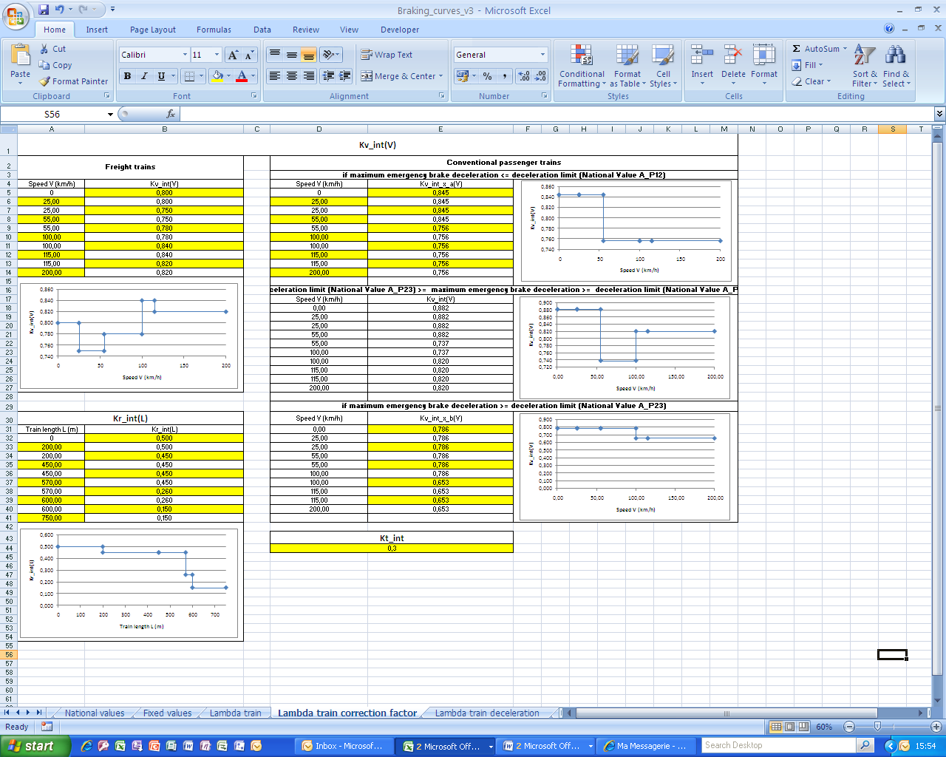

With the exception of the gradient profile, all the step values must be entered, which means that if the step function only contains 3 steps (or intervals), it is necessary to repeat the values e.g. as follows:

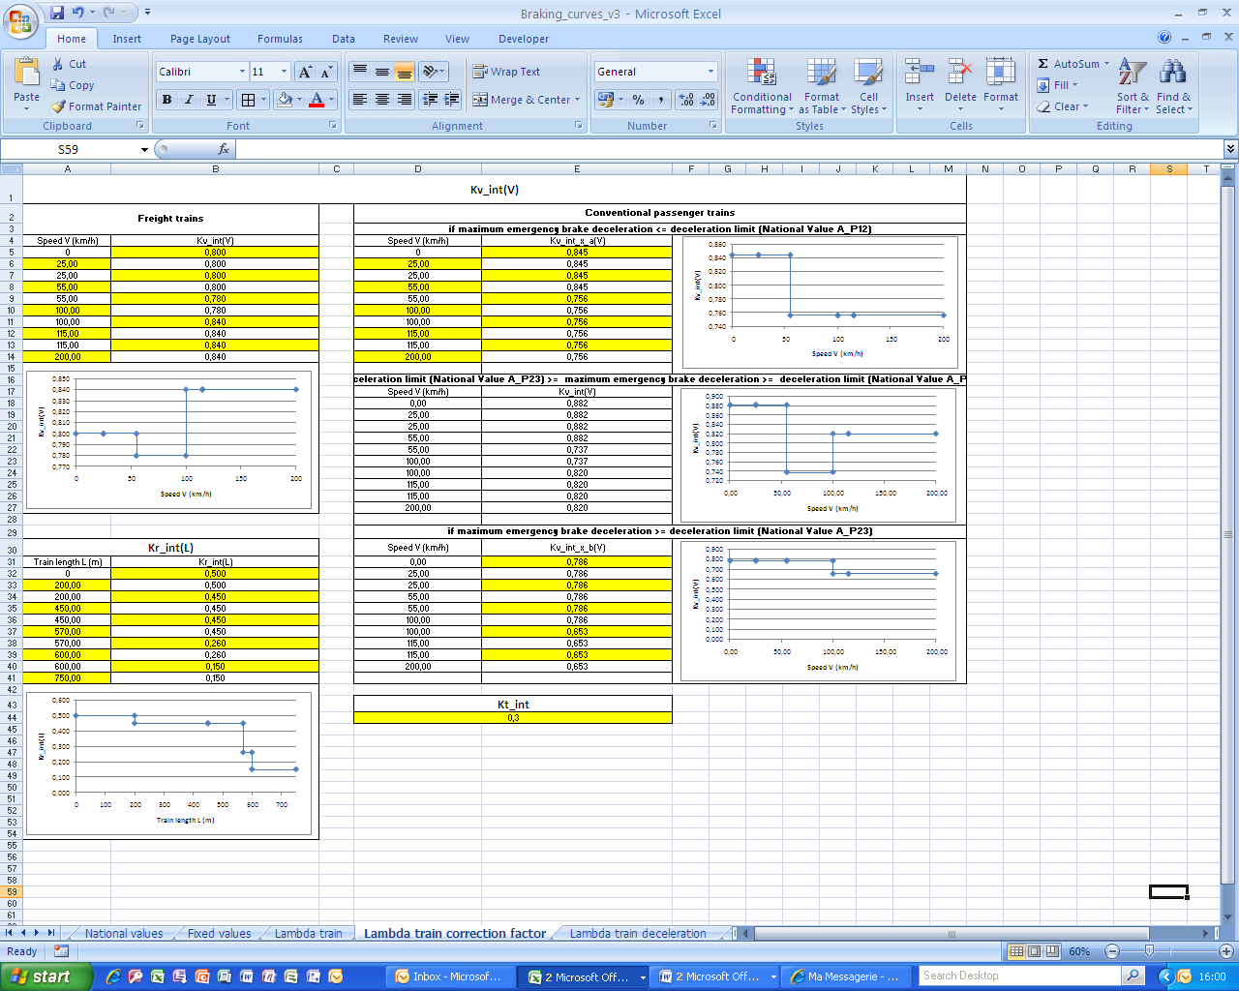

For a single-step function:

