2006
D. Murton, Chief investigator
Rail Incident Investigation Unit (Ireland)
1/1/2006
Annual report to European Rail Authority from National Investigation Body (Ireland)
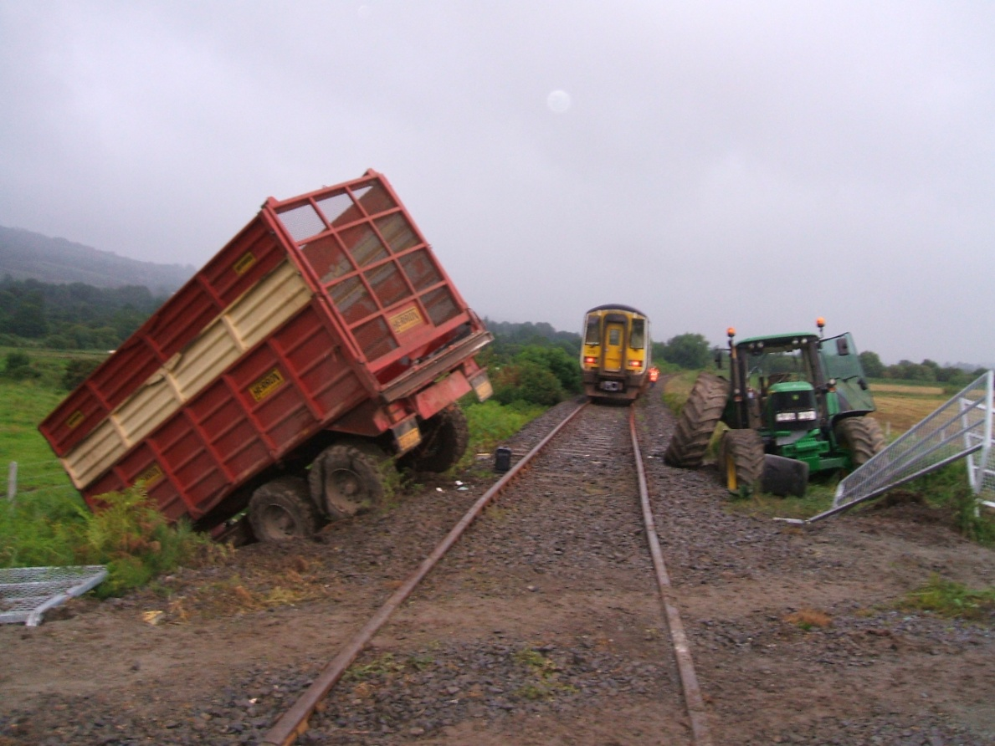

2006 Annual Report to European Railway Agency

Table of Contents

SUMMARY 3
INTRODUCTION 3
ORGANISATION 4
INVESTIGATIONS 6
Summary of accident 6
Recommendations and Iarnród Éireann (IE) position on Actions at September 2006 6

SUMMARY

This report reflects the position and activities of the Investigation Unit in 2006 following the introduction of the Railway Safety Act 2005, the initial formation of the Investigation Unit, and the relationship between the Railway Safety Commission and the Investigation Unit.
This report specifically covers the process of investigation of accidents on the interoperable Irish railway network. This network has a track gauge of 1602mm. It is interoperable with the railway system in Northern Ireland, which falls under the jurisdiction of the United Kingdom.
The final section reviews accident recommendations made in 2006.

INTRODUCTION

On the 30th April 2006 a temporary Chief Investigator was appointed by the Railway Safety Commission to meet its legal obligation, and allow the initial formation of the Investigation Unit. A recruitment process was put in place to fill the position on a permanent basis and the permanent post was filled in April 2007. The temporary Chief Investigator had no permanent staff, and sourced assistance from the Inspectors within the RSC, this was done under the provisions of S57 (5) of the Railway Safety Act 2005.
The investigations units’ process and procedures are currently being developed as is their resource strategy; it is unlikely these will be finalised and in place until late 2008.
The railway Safety Act 2005 sets out the purpose and approach of the Investigation Units investigations.
58.—(1) The purpose of an investigation by the Investigation Unit under this section shall be to improve railway safety by establishing, in so far as possible, the cause or causes of an incident with a view to making recommendations for the avoidance of incidents in the future, or otherwise for the improvement of railway safety.

(2) It shall not be the purpose of an investigation to attribute blame or liability.

In 2006, no formal investigations were carried out; however the final report into a derailment at Cahir Viaduct on 7th October 2003 was published.

ORGANISATION

The Railway Safety Commission (RSC) is an independent government agency charged with safety oversight of public railways. These comprise Iarnród Éireann, LUAS operators Veolia, those heritage railways that are open to the public, currently 10, and those parts of the Bord na Móna industrial railway that interface with the public.
For the purposes of European legislation the RSC comprises two bodies, i.e., the National Safety Authority responsible for regulating railway safety, and the National Investigation Body that conducts causal investigations of railway incidents. Though these bodies share administration and corporate governance, they are functionally separate as required under the Directive.
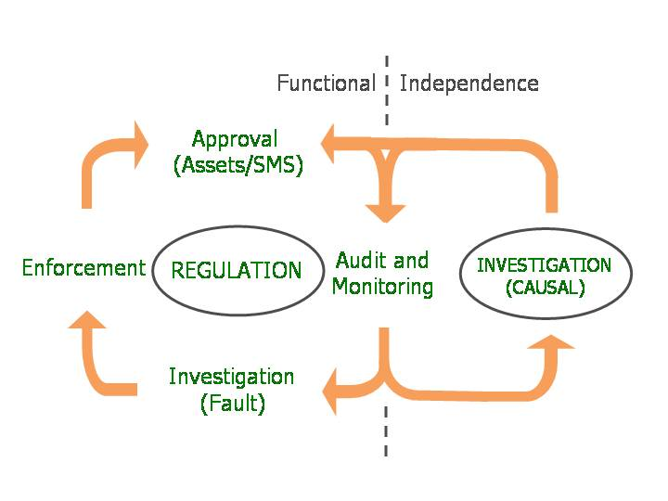

The independence of the investigation unit is also stated in the Railway Safety Act 2005
57.—(1) The Commission shall not influence or seek to influence an investigation by the Investigation Unit of a railway incident or the contents of a report prepared by the Investigation Unit in accordance with sections 60 or 61.

(2) For the purposes of the exercise of its functions under this Part, the Investigation Unit may, where it deems it appropriate to do so as part of an investigation into a railway incident, investigate any decision, action or omission of the Commission which the Investigation Unit considers may be relevant to its investigation and the Commission shall co-operate with the Investigation Unit.

INVESTIGATIONS

No formal investigations were carried out in 2006; the final report into Derailment at Cahir Viaduct on 7th October 2003 was published

Summary of accident
At approximately 06.00 hours on Tuesday 7th October 2003 a bulk cement train (the Train) travelling between Limerick and Waterford became derailed (the Derailment) as it crossed the viaduct that carries the railway over the river Suir (the River) at Cahir.
During the course of the accident the Train, which comprised two locomotives and twenty two laden cement wagons (the wagons), divided. The locomotives and the first ten wagons crossed the viaduct, coming to a stand with the rear of wagon 10 approximately 61m beyond the Viaduct. The remaining twelve wagons fell through the deck of the viaduct coming to rest in the river or on the Waterford bank. While no railway employee or other party was injured in the accident the rear twelve wagons of the Train were damaged beyond repair and the deck of the Viaduct required major reconstruction.

Recommendations and Iarnród Éireann (IE) position on Actions at September 2006

- 1. IÉ should conduct a review of its safety management system to identify all areas where design, inspection and maintenance procedures are not fully developed and documented, and should establish a programme to develop and implement the necessary specifications and standards prioritised on the basis of safety risk. The content and structure of each specification or standard should reflect the safety criticality of the various elements of the associated procedure or physical asset.
(Review 6 months, Establish programme within 24 months)
Action Taken:
Iarnród Éireann Infrastructure has already identified its requirements for standards (300 no.) and has included same in the 2004-2008 Railway Safety Programme. The target of 25 standards for 2005 has been exceeded - 40 produced.
The standard for inspection of bridges and the standard for the inspection and maintenance of waybeams were both produced in 2005. The implementation and roll out of standards has been prioritised on a safety critical basis taking account of design, inspection and maintenance requirements.
- 2. For remaining way-beam structures IÉ should review all available drawings and design documentation to identify, in so far as is practicable, variances from the original designs, and ensure that any safety implications are fully understood and that associated safety risks are reduced to as low as reasonably practicable.
(Review 3 months, Mitigation programme completed 24 months)
Action Taken:
There are 8 no. waybeam bridges remaining on the operational network. The adequacy of all these bridges was assessed in December 2003 and any remedial works were dealt with. In line with the findings of IE’s own internal review, train speeds are restricted to 30 mph maximum on all waybeam bridges and a study of the dynamic interaction of wheel and rail on the waybeam bridges has been commissioned. This report is now complete and concludes that the key derailment indicators remained within safe limits.

- 3. IÉ should review the derailment containment arrangements on its various structures and make whatever modifications might be required to ensure that they are fit for purpose and capable of preventing disproportionate failure.
(Review 3 months, Modification programme completed 12 months)
Action Taken:
Iarnród Éireann has carried out a risk based study to identify the need for containment measures at underline bridges. The study is complete and issued for internal review. The report will provide a prioritised programme of preventative measures.
- 4. In parallel with, and pending implementation of Recommendations 2 and 3, IÉ should periodically review and amend as necessary the safety measures implemented at structures similar to the Viaduct to ensure that operational safety risk is reduced to as low as reasonably practicable.
(Review 3 months ongoing)
Action Taken:
The inspection of waybeam bridges is carried out at yearly intervals (formerly 2 years) and the matters and recommendations 2 & 3 above are being addressed as part of these inspections.
- 5. The training needs analysis conducted by IÉ on foot of the IRMS recommendation should be reviewed and, as necessary extended to include all staff involved in safety critical work. Where necessary new training plans should be introduced or existing plans modified or enhanced.
(Review 6 months, Implementation programme completed 24 months)
Action Taken:
Training needs are regularly reviewed and prioritised by the relevant professional groups. Moreover training needs are reviewed for the introduction of new standards. Training in 2005 in Infrastructure was 8,200 days, a doubling from 2004.
- 6. IÉ should implement a strategy that ensures that its ongoing track monitoring requirements are effectively met, particularly in the short term pending upgrading of the EM50 track recording vehicle.
(Review 3 months, Implementation 6 months)
Action Taken:
All track monitoring procedures are in place. The EM50 track recording vehicle is one of our methods of monitoring track parameters and there are processes in place to verify its calibration.
- 7. In developing a strategy for upgrading the EM50 track recording vehicle IÉ should ensure that all available technologies for monitoring track condition are fully assessed and the specified functionality reflects the best combination of available technologies.
(Assessment 3 months, Strategy 6 months)
Action Taken:
The above recommendation is the position being taken by Iarnród Éireann in the context of these technologies.
- 8. IÉ should review, and amend as necessary, its asset management systems to ensure that data is pertinent, comprehensive, concise and accessible and provides evidence that all outstanding issues are appropriately actioned and closed out.
(Review 3 months, Amendment programme completed 12 months)
Action Taken:
The Infrastructure Asset Management System (IAMS) has the necessary modules to record assets, review condition register faults and programme inspection/maintenance
- 9. IÉ should ensure that, pending full implementation and validation of new data management systems including those currently in course of development, comprehensive and up to date records of infrastructure asset inspection and maintenance are maintained and that relevant data is effectively promulgated to inspectors, maintainers and managers.
(Review and implementation 3 months).
Action Taken:
IÉ have well established inspection and maintenance procedures with effective dissemination of information to all relevant levels of Infrastructure staff. This is reviewed periodically and amended as necessary in light of developing conditions. IAMS will enhance and systemize these processes and roll out of the system has commenced.
Implementation of all modules will take a number of years as is the case with other railway administrations - the target timetable is the end of 2008.
- 10. Provision is being made in the proposed Railway Safety Programme 2004-2008, for the establishment of internal IÉ auditing procedures. As with the overall safety development programme, IÉ should ensure that the introduction of these procedures is risk based with auditing introduced first in those areas presenting that greatest safety risk.
(Review 3 months, Risk based audit programme commenced 6 months)
Action Taken:
There are well established inspection, monitoring and audit regimes in place. These monitoring processes are being further developed with the introduction of standards and procedures - for example the Safety Audit Unit introduced in 2005.
- 11. IÉ should review the performance characteristics of two-axle bulk cement wagons within the context of their wagon and track maintenance limits, to determine the extent to which these maintenance limits and maximum permitted speeds are mutually compatible and to propose practical solutions if necessary.
(Review 3 months).
Action Taken:
Iarnród Éireann have carried out a dynamic analysis of the two axle bulk cement wagons on each of our remaining Waybeam Bridges and can confirm that they are safe for the speeds over them.
- 12. IÉ should review and amend as necessary it’s arrangements for monitoring adherence to both permanent and temporary maximum train speed limits, through a combination of line-side measurement and interrogation of in-cab recorded data, to ensure that they are appropriate in the context of current driving practice.
(Review 3 months, Necessary amendments introduced 6 months)
Action Taken:
A programme of speed checks is in place in accordance with Railway Safety Standard No. 2.
- 13. The functionality of the Teloc equipment currently in use by IÉ should be assessed, and modified as necessary, to ensure that it provides the level of access to data necessary for effective day to day safety management.
(Review 3 months, Necessary modification implemented 24 months)
Action Taken:
The review is completed and all new 201 locos have modern data recording equipment. This new equipment has been ordered for 071 class locos and fitment has commenced. Locos older than this will not be fitted with this equipment as it is planned to withdraw them from service over the next 2 – 5 years.
- 15. IÉ should review its existing communications systems and take whatever action is necessary to ensure that on all parts of system train drivers are provided with an effective means of communication with the controlling signalman.
(Review 3 months, Necessary change implemented 24 months)
Action Taken:
Full train radio coverage will be provided on all main radial lines with the resignalling of the Mayo/Ballina and Rosslare lines in early 2008. The communications systems on the lightly used lines and freight lines are under review.
All Recommendations were accepted by Iarnród Éireann -Next review scheduled for October 2007

