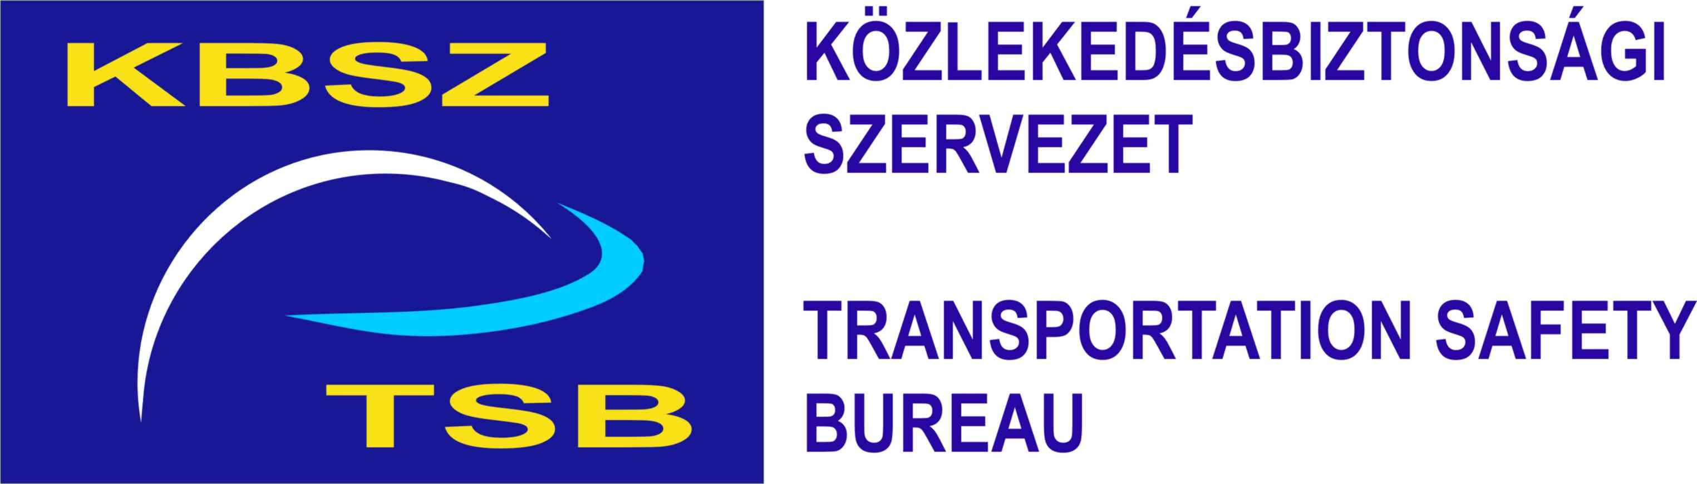
ANNUAL REPORT 2006
Transportation Safety Bureau
Hungary
Main characteristics of rail transport in Hungary
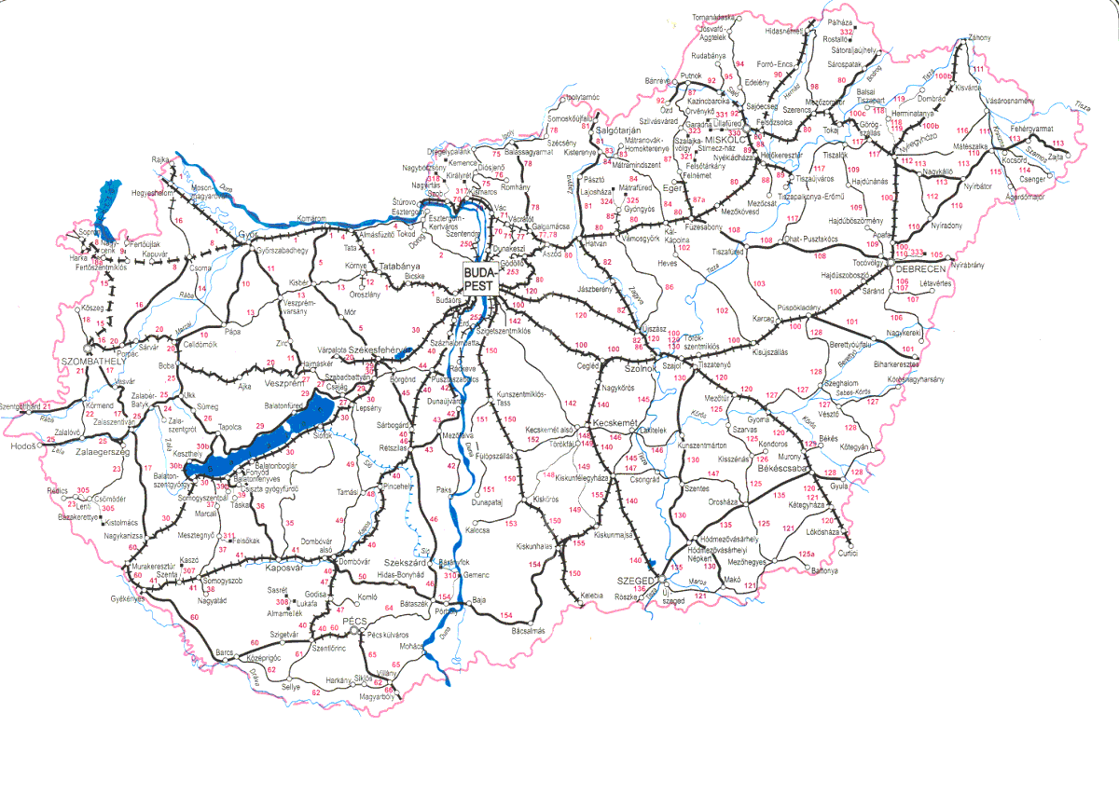
Characteristics of the railway lines of Hungary
Main lines | 5200 km
Secondary lines | 2700 km
Other lines | 400 km
Total | 8300 km
Electrified lines (out of total) | 2800 km
Lines equipped with track condition and occupancy detection (out of total) | 2178 km
Number of protected level crossings | 2846
Total number of level crossings | 5981
Actors in the Hungarian railway market
State actors
Ministry of Economy and Transport
National Transport Authority (NSA)
Transportation Safety Bureau (NIB)
Hungarian Rail Office
Railway undertakings
Number of undertakings in possession of a nationwide operating licence
Railway network operation 1 (the biggest IM has no licence yet)
Forwarding of goods 13
Transportation of passengers 3
Number of undertakings in possession of a regional operating licence
Railway network operation 13
Forwarding of goods 3
Transportation of passengers 13
All regional rail networks have narrow-gauge tracks.
Number of undertakings in possession of a special operating licence
Railway network operation and forwarding of goods: 23

1. Summary
The Republic of Hungary fully implemented all essential requirements concerning accident investigation of the Railway Safety Directive 2004/49/EC in its national law. The Transportation Safety Bureau (TSB) was established on 1st January 2006 as the legal successor of Civil Aviation Safety Bureau (founded in 2002).TSB operates in a multimodal form. Its main duty is the independent technical investigation of aviation, rail and marine accidents and incidents. Within the organisational framework of TSB, the Railway Department began to operate on 1st March 2006. The number of reports increased continuously. The Railway Department started the first investigation in June 2006.
In 2006, there were no occurrences that TSB would have been obliged to investigate under the law. TSB, at its own discretion, conducted investigations on 16 occasions, all of which will be closed in 2007. Based on the investigations, TSB recommended immediate preventive actions on 3 occasions, most of which were accepted by the addresses of the recommendations.

2. Introduction

2.1. Introduction to the report
The Transportation Safety Bureau of Hungary (TSB) as a multimodal organisation for the investigation of accidents was established on 1st January 2006.
The Annual Report 2006 of TSB - in accordance with Article 23/3 of the Railway Safety Directive 2004/49/EC - gives an account on the following:
- the implementation of 2004/49/EC Railway Safety Directive into the Hungarian law,
- the circumstances of the establishment of TSB,
- the experiences of the independent technical investigations carried out by TSB,
- the safety recommendations issued by TSB and the provisions made in relation to the recommendations.
- the participation of TSB in the work of the European Railway Agency

2.2. Overview of the last 12 months
Within the organisational framework of TSB, the Railway Department began to operate on 1st March 2006. This is when TSB introduced the essential elements of the investigation to railway undertakings and to operators of railway infrastructure. During the first few months, the personal and technical background of the Railway Department was established. Practically, the first investigations began in the summer of 2006.
In 2006, there were not any serious railway accidents in Hungary which TSB would have been obliged to investigate. Therefore TSB only investigated occurrences which – at its own discretion – deserved particular attention. 175 railway occurrences were reported in 2006, 16 of which were investigated, however, none of them provided information based on which conclusions could be drawn regarding the safety conditions of the overall railway transportation in Hungary. The investigations which began in 2006 will be closed in 2007 due to the necessity of establishing adequate methodology, efficient procedures and practice of the investigations, to the time-consuming character of the investigations as well as to the Hungarian legislation which allows 60 days for the relevant parties, persons and organisations to make reflections on the preliminary reports. Therefore the final reports can only be closed and made public after this 60-day-period.
Reported railway occurrences in 2006 by months
In a nutshell, it can be stated that the reporting of railway occurrences was rather deficient in the initial period. Subsequently, as the relevant parties have gradually become acquainted with their legal rights and responsibilities as well as the tasks of TSB, the number of reports increased continuously. The present status of reporting can be considered satisfactory as only a few insignificant occurrences are not reported to TSB. Nowadays all major occurrences are reported and therefore known by TSB. The improvement of ‘safety culture’ is well represented by the fact that such occurrences are also reported that - - do not fall within the scope of duties of TSB (mostly security issues, e. g. bomb alerts). Looking to the future, it would be desirable to reduce the time between the occurrence and its report to TSB. At present, the information on a given occurrence reaches TSB approximately 30 minutes after the occurrence on average, which may cause significant delays if the site of the occurrence is relatively far.
After establishing the organisational framework of the Railway Department, TSB joined the work of the European Railway Agency and began to provide data to the Agency. The experts of TSB participate in the plenary sessions of ERA as well as in the work of all task forces responsible for railway transport safety.

2.3. Accident investigation philosophy of TSB of Hungary
Under the Hungarian regulations, TSB shall investigate serious railway accidents.
The definition of ‘serious accident’ under the national regulations - in accordance with the Railway Safety Directive 2004/49/EC – is as follows:
“Any train collision or derailment of trains, resulting in the death of at least one person or serious injuries to five or more persons or extensive damage to rolling stock, the infrastructure or the environment of at least HUF 500 million and any other similar accident with an obvious impact on railway safety regulation or the management of safety”.
Reported railway occurrences in 2006 by category
Category of occurrence | Number of occurrences
Serious accident | 0
Accident | 155
Incident | 20
Apart from serious accidents, the national regulations permit TSB to investigate other accidents that - at its discretion - have an impact on the safety of rail transport as well as on the regulations and management of railway safety.
In 2006, there were not any serious railway accidents in Hungary which TSB would have been obliged to investigate under the current regulations.
Reported but not investigated occurrences in 2006 by content
Occurrence | Number of occurrences | %
Mechanical failure of contact line | 4 | 2,3
Derailment (including shunting movement) with minor material damage | 15 | 8,9
Collision of train with road vehicle at level crossing with fatal injury | 11 | 6,6
Collision of train with road vehicle at level crossing with non-fatal injury | 24 | 14,4
Collision of train with road vehicle at level crossing with no injury | 36 | 21,4
Injuries caused by rolling stock in motion (including supposed suicides) | 52 | 31,0
Others | 26 | 15,4
TSB availed itself of the opportunity provided by the regulations to decide which accidents – apart from serious accident – are to be investigated. TSB based its decision regarding which occurrences require investigation on some fundamental principles. These principles are as follows:
- occurrences resulting in serious injuries to persons, extensive material damage and/or hindering railway transport significantly,
- the latent danger of the occurrence can be considered significant – irrespective of its actual consequences,
- accidents or incidents recurring at the same site or in the same manner should be investigated.
The investigated 16 occurrence by the amount of damages
Amount of damages | Number of occurrences
Over HUF 500 million (Euro 2 million) | 0
HUF 100-500 million | 2
HUF 0-100 million | 12
No damages | 2
TSB has compiled an ‘Investigators Manual’ for the enforcement of the uniform requirements and methods of investigations. This Manual lays down the methodological and technical requirements based on which the investigations shall be conducted by the investigators of TSB taking the special characteristics of railway transport into account.

2.4. The implementation of the Safety Directive in the Hungarian law
The Republic of Hungary implemented all essential requirements concerning accident investigation of the Railway Safety Directive 2004/49/EC in Act CLXXXIV of 2005 on the technical investigation of aviation, rail and marine accidents and incidents. Based on the Directive, Transportation Safety Bureau was established on 1st January 2006 which – as a multimodal organisation - is responsible for the independent technical investigation of aviation, rail and marine accidents and incidents.
The detailed regulations of the technical investigation are included in the decrees of Act CLXXXIV of 2005 which were separately issued for the three modes of transports by the Minister for Economy and Transport. The decree on the regulations of the technical investigation of serious railway accidents, railway accidents and incidents (7/2006 GKM) was issued on 27th February 2006.
Within the organisational framework of TSB, the Railway Department began to operate on 1st March 2006 under the regulations.
The national Act guarantees the complete independence of TSB from all other actors of the concerned transport sector. The Act defines the objective of the independent technical investigation as follows:
“The objective of the independent technical investigation is to reveal the causes and circumstances of serious railway accidents, accidents and incidents and to initiate the necessary technical measures and make recommendations in order to prevent similar cases in the future.” It also states that “it is not the purpose of the investigation carried out by TSB to apportion blame or legal liability”.
The Act contains the rights and responsibilities of the investigators defined in the Safety Directive.
According to the national regulations:
- All aviation, rail and marine occurrences shall be reported to TSB.
- The members of the Investigating Committee of TSB are authorized to be present at the site of any occurrence and to conduct the technical investigation parallel with the police investigation (if there is one).
- Based on the results of the investigation, TSB is entitled to issue safety recommendations and recommend immediate preventive actions before the completion of the investigation, if necessary. The execution of safety recommendations is not obligatory, however, the addresses must report to TSB once a year whether they have accepted or rejected them. (The addresses must forthwith respond to the recommended immediate preventive actions.)
- The anonymity of the relevant parties is guaranteed. TSB shall make public the final reports on the results of the technical investigation. However, the final report shall not contain data based on which the relevant parties can be identified. The final report shall not be used in criminal procedures.

3. Organisation

3.1. Introduction to the organisation
TSB regards prevention as the main objective of its activity. TSB endeavours to share the findings, the results and the experiences of the technical investigation with a wide circle of organisations in the profession as well as with the civil sector.

The predecessor of TSB was the Civil Aviation Safety Bureau which conducted investigations in the field of aviation between 2002 and 2005 in line with Directive 94/56/EC establishing the fundamental principles governing the investigation of civil aviation accidents and incidents.

TSB was established on 1st January 2006. The Aviation Department and the 24/7 Duty Services operated from the beginning of 2006 and the other departments and units grew gradually during the year. The Railway and the Marine Department begin to work officially on 1st March 2006. The total number of permanent staff at the end of 2006 was 50, all of whom were civil servants.

FőigazgatóDirector-General
Head of Gazdasági IgazgatóFinancial Dept.
Jogi osztályvezetőHead of Legal Dept.
Kommunikációs vezetőHead of Communication Dept.
Nemzetközi ügyintézőManager of International Safety Affairs
Repülési
főosztályAviation Department
Vasúti
főosztályRailway Department
Hajózási
főosztályMarine Department
Ügyeleti szolgálat

24 h24/7 duty services
Dispachers,
Technicians

The Railway Department – in accordance with the regulations – begin to work on 1st March 2006 with 5 employees delegated by the Safety Directorate of Hungarian State Railways Plc. (MÁV Zrt). This was a temporary solution as during the two months after the enactment of the previously mentioned Act, it was difficult to find competent staff who would have met both the legal and professional requirements. The Head of the Railway Department was appointed on 1st April 2006 and TSB began to hire new staff for the position of ‘investigator of railway accidents and incidents’. At the same time, the staff delegated by MÁV Zrt. was gradually made redundant. The planned number of staff in the Railway Department was 13, however, two positions remained vacant as TSB was unable to find well-qualified experts who would have had the required professional experience and would also have met the legal requirements.
When recruiting accident investigators, the most essential requirements were the following:
Third-level degree, expertise and experience in the field of railways and knowledge of a foreign language. TSB selected its experts from the most important fields of the profession, such as rail traffic, engineering, safety installation (signal box), permanent-way staff, etc.
The knowledge of foreign languages posed a problem at the recruitment. Only four of the new staff had elementary or intermediate level language knowledge at the time of the recruitment, therefore the language education of the colleagues began immediately.

3.2 Organisational flow
jogalkotóklegislators
regulating ministries and authoritiesszabályozó hatóságok,
minisztériumok
üzembentartókoperators
rendőrségpolice
katasztrófavédelemdisaster response
Gazdasági és Közlekedési MinisztériumMinistry of Economy and Transport
TSB

- TSB is supervised by the Ministry of Economy and Transport. The Director General of TSB works under direct oversight of the Minister. According to the national law, the Minister shall not instruct TSB in matters concerning the independent investigations.
- The Minister reports to the government annually on the activities of TSB, the lessons learned from the independent investigations, the processes and trends concerning transportation safety.
- Based on the outcome of the investigation, TSB can issue safety recommendations to the other actors of the concerned transportation sector (operators, legislators, etc). The execution of the safety recommendations is not compulsory, however, the addressees are obliged to compile an annual report on their response (acceptation, implementation, or refusal).

- TSB is authorized to get access to all data relevant to the occurrence in question (including data stored on data recorders).

- The Investigating Committee of TSB can conduct its site investigation simultaneously with the police investigation.

- TSB and the police can help each other’s work with exchange of factual data and results of expert analyses. The IC may withhold information obtained in the course of the investigation from other authorities in occurrences when the owner of the information would have had the right to do so.
- TSB, the police and the disaster response officials mutually inform each other about the occurrence reports received.
4. Investigation process

4.1. Independent basis of investigation
Under the national law, TSB is independent of all persons and organisations whose interests are contrary to the duties of the investigating organisation, in particular:
- authorities granting permission to put vehicles into service,
- authorities granting permission and controlling the operation and the maintenance of the vehicles
- ,
- authorities issuing driving licences,
- the organisation operating the transport infrastructure,
- transport companies,
- railway undertakings
- the organisation determining railway tariffs,
- the organisation distributing routes,
- the safety authority and
- all regulators in the field of railways.
Under the national law, the civil servants of TSB shall not be the owners, senior officials or employees of the above mentioned organisations.

The Director-General and the Investigating Committee of TSB shall not be instructed in their scope of duties concerning the technical investigation.

4.2. Institutions involved in the investigation
TSB regularly cooperates with Budapest University of Technology and Economics (BME) in cases requiring special expertise, equipment, analyses and expert opinion.

4.3. The investigation process of TSB
The Duty Services of TSB (dispatchers) receive the reports of the occurrences 24 hours a day.
The members of the Investigating Committee (IC) are appointed by the Director-General. The IC consists of one on-site technician and at least one accident investigator. In case of more serious or complicated occurrences, one of the heads of department on duty and/or the spokesperson of TSB may be present on the site.

If an occurrence is not obliged to be investigated under the law, the head of the concerned department decide whether or not to conduct an investigation.

The Investigating Committee carries out the on-site inspection (parallel with other authorities) and decides on the direction of the investigation, the required technical and technological examinations as well as selecting the organisations and/or experts to be initiated in the investigation if necessary
.
The preliminary reports of the occurrences are discussed by a board made up of the heads of departments of TSB.
The relevant parties of the investigation may make reflections on the preliminary report within 60 days from the date of receipt which are to be evaluated when compiling the final report.
After this 60-day-period, TSB convenes a meeting for a final discussion with the participation of the representatives of the persons and organisations concerned. Subsequently, the final report is made public.
All the three major departments of TSB have a separate ‘Investigators Manual’ which lays down the methodological and technical requirements based on which the investigations shall be conducted by the investigators of TSB, taking the special characteristics of the given mode of transport into account.

5. Investigations

5.1. Overview of investigations conducted by TSB

In 2006, there were no serious railway accidents in Hungary which TSB would have been obliged to investigate. Therefore, TSB conducted investigations - at its own discretion - on 16 occasions based on the fundamental principles listed in 2.3. These investigations are currently in progress and will be closed in 2007.

The investigated 16 occurrences in 2006 by their nature
Nature of the occurrence | Number of occurrences
Collision in level crossing | 7
Derailment | 5
Movements approaching each other | 3
Others | 1
See Appendix 1 for the short summary of the occurrences investigated by TSB in 2006.

Since the Railway Department began its work in March 2006 without any antecedent, the experiences of the past ten months prove to be rather scarce to draw a clear picture of the tendencies regarding transportation safety. However, there are a few determining characteristics to be highlighted.
The investigated 16 occurrences in 2006 by their presumed cause (based on the reports)
Cause of the occurrence | Number of occurrences
Human factor  - personnel of railway undertaking  - unknown person | 12  5  7
Technical factor  - defect in the track  - defect of the rolling stock | 5  1  4
On one occasion, both factors are presumed to have contributed to the occurrence
- In the course of the investigation of the causes, the investigators found that human factors, technical deficiencies as well as imperfection of the regulations may have contributed to the occurrences. On most occasions, the determinant cause derived from the human factor.
- Regulations, safety education/testing as well as internal control embedded into the work process and external audition by the competent authorities play a significant role in the decrease of accidents linkable to human factors. It is expected that the new national railway safety rules (to be published soon) and the establishment of a railway safety supervisory organization within the National Transport Authority will also positively affect the safety of rail transport.
- Generally speaking, should the safety regulations in force have been followed, the majority of investigated accidents could have been prevented. Compliance with the regulations can only be guaranteed by continuous and professional control conducted by the National Transport Authority and the safety management of railway undertakings.

5.2. Lessons learnt from major investigations
In 2006, there were no serious railway accidents in Hungary which - under the law - TSB would have been obliged to investigate.
Among the 16 investigated accidents, 3 can be highlighted as they are good examples of typical situations.
Accident no. 1. 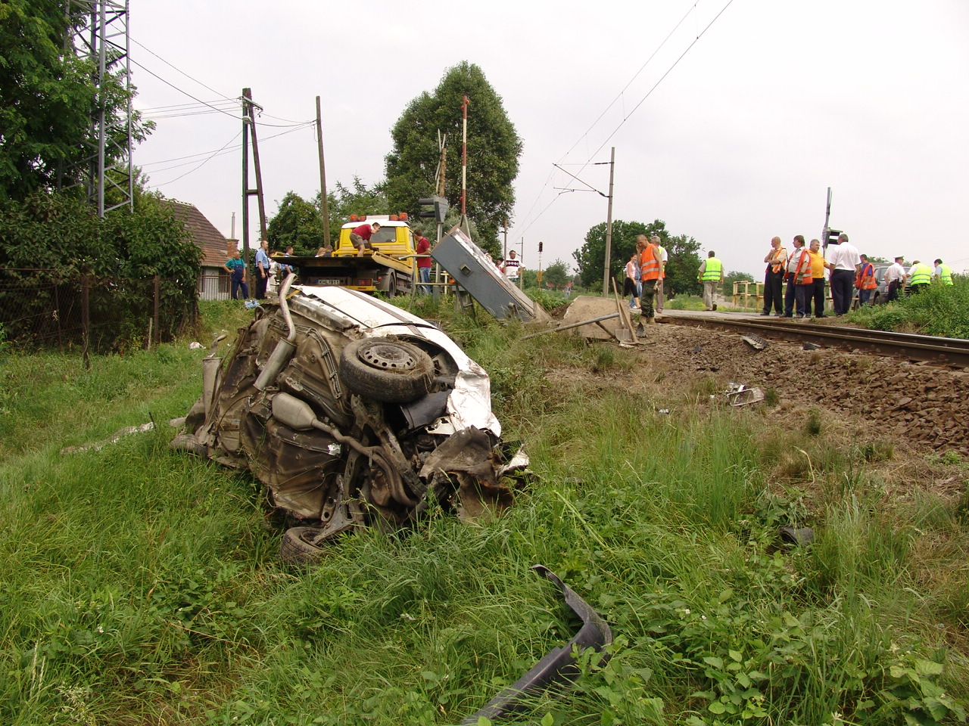
Four people were injured when a passenger train collided with a car at a level crossing protected by light signal and half-barrier between Érd and Tárnok at 11.32 on 3rd July 2006. At the time of the accident, the light signal did not work as the cables of the signal box had been cut and stolen by unknown persons at 11.10 the same morning. According to the findings of the investigation, the level crossing was not distinctively visible either for the engine driver or for the driver of the car because of the vegetation. At the same time, the engine driver did not slow down the train approaching the barrier effectively. Not following the regulations precisely from one side, and the inefficiency of the existing regulations on the other side may have contributed to the accident.

Accident no. 2. 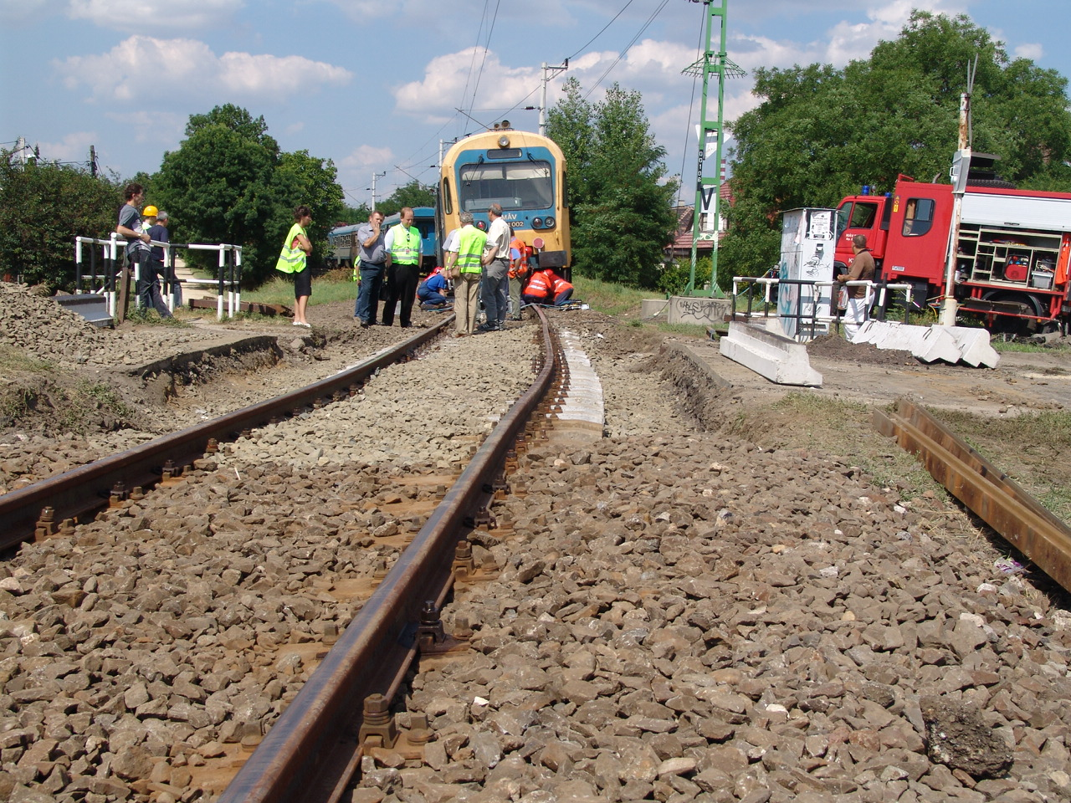
Last carriage of passenger train derailed on a track being under reconstruction but in service between Rákospalota-Újpest and Fót at section no. 12+32. According to the findings of the investigation, the accident occurred due to the exchange of a short section of the track, the ballast of which had not been completed. The day-traffic was permitted up to 20 km/h.
Temperature tension caused by daylight warming of the rails and the forces transmitted to the rails from the wheels of the cars rolling on curved track sections resulted in shifting of the track panel. TSB issued an immediate preventive action that suggested that the operator should suspend all traffic on the track until it is safe enough (i. e. the lateral and longitudinal stability is assured). The operator has accepted the recommendation.
Accident no. 3.
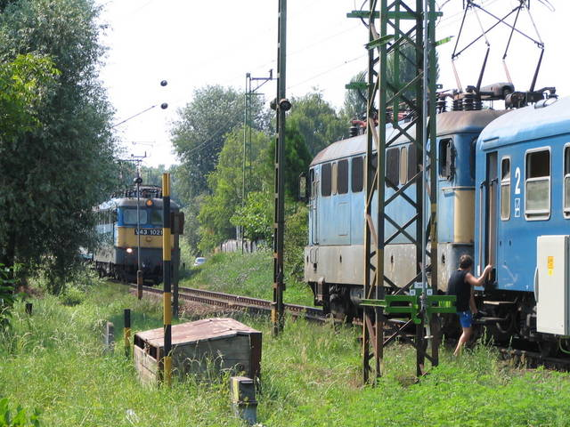
This railway accident was one of the most significant railway occurrences in 2006 because it had the potential of becoming a serious accident. On 23rd July 2006 at 13.55 passenger train 5209-2 passed the ‘Stop’ signal of the exit signal and left Balatonmáriafürdő station pushing switch no.3 open and stopping approximately 50 meters from entering train 5608-1. One of the trains was stopped by the safety installation of the locomotive, while the other train’s engine driver noticed the danger and stopped the train.
The preliminary report on the investigation has been completed which states that this occurrence was caused by human error. The investigation, however, also highlighted the difficult working conditions of engine drivers (especially during summer months) and the deficiencies in training of railway employees. The investigating committee of TSB is considering of issuing further safety recommendations, regarding not only the above mentioned two questions but also the area of railway traffic management.

5.3. International cooperation
After establishing the organisational framework of the Railway Department, TSB joined in the work of the European Railway Agency and began to provide data to the Agency. The experts of TSB participate in the plenary sessions of ERA as well as in the work of all task forces responsible for railway transport safety.
Upon the Austrian partner-organisation’s request, the experts of TSB participated in the investigation of an accident occurred in Austria. The reason behind this was that the overhaul of a derailed vehicle had been performed in Hungary. The Austrian investigators requested information on the circumstances and the documentation of the overhaul, on the applied standards and technologies as well as on the licence of the workshop in which the overhaul had been performed. Subsequently, the Austrian organisation sent the draft report and the final report of the investigation to TSB.
6. Recommendations
In the course of the investigations in 2006, TSB issued 6 safety recommendations suggesting immediate preventive actions related to the above mentioned 3 accidents. The response of the operators was as follows:
Provisions have been made to implement the recommendation | in 3 cases
The recommendation was accepted, however, the implementation was considered too expensive at the time of the accident (but will be implemented in the future) | in 1 case
The current regulations were considered adequate | in 1 case
The recommendation was rejected | in 1 case
All the addresses of the safety recommendations were operators, however, since 2007 the majority of the addressees has been the National Transport Authority (in accordance with the EU directive).
The immediate preventive actions (as part of the safety recommendations) suggested by TSB in the course of the investigations in 2006 are as follows:
To Accident no.1. (described in 5.2 of the report)
- Good visibility (and visibility triangle) should immediately be assured at level crossings in accordance with the regulations in force.
- The communications regarding unserviceable open track LC light signals should be recorded in the traffic log of the railway station.
- If a train is approaching the unserviceable LC light signal and is not in possession of a written instruction regarding its failure, it should be given a certain signal warning the engine driver to stop the train in order to avoid further accidents.
- When setting the automatic block signal to ‘Stop’, there should be a continuous signalling which technically makes the train stop.
The operator has made the following reflections to the above mentioned safety recommendations:
- Provisions have been made to provide good visibility at level crossings.
- The amendment of F.2. Traffic Regulations is being planned (independent of the accident in question).
- The operator has found the effectiveness of the recommendation questionable (the warning signal may also stop other trains in the precincts of the given station and as a consequence, it may interfere with the operation of the other barriers).
- The implementation of the recommendations is not possible in the short run due to economical reasons. However, the gradual introduction of the ETCS system can solve this problem in the long run.
To Accident no. 2 (described in 5.2 of the report)
„In order to maintain the safety of transportation, the operator should take measures to suspend the traffic until the reconstructed track section is stable enough, the sufficient lateral and longitudinal resistance is assured and the ballast is resettled (in case of reconstructions when the CWR tracks are being disintegrated and the weather conditions are unfavourable).”
The addressee of the safety recommendation has considered the regulations in force adequate. The accident was caused by neglecting the technological regulations, therefore the addressee draw the attention of the persons concerned to comply with the technological instructions in the future.
To the derailment occurred on 6th August 2006 (described in Appendix 1)
„TSB recommends the introduction of an instrument or sign which makes the scotch block clearly visible and noticeable from a distance. The reason for the recommendation is that neither of the two personnel of the railway undertakings noticed the scotch block under the wheels of the train even though they had walked along the side of the train.”
The addressee of the safety recommendation has found the regulations in force in this matter adequate.
APPENDIX 1
Accidents investigated by TSB in 2006
Date  2006 | Event | Classification | Investigation | Provisions made
06. 28. | Collision of passenger train with lorry at level crossing protected by light signal and half-barrier (both operating normally) at Vásárosnamény station – 1 person injured. | Accident | Investigation in progress
07. 03. | Collision of passenger train with car at level crossing protected by light signal and half-barrier (which did not operate due to theft of cables) between Érd-elágazás and Tárnok – 4 persons injured. | Accident | Investigation in progress | Immediate preventive actions recommended, 3 of which accepted and 1 rejected as the operator considered it too expensive
07. 05. | Last carriage of train derailed on a track being under reconstruction but in service between Rákospalota-Újpest and Fót at section no. 12+32  No injuries. | Accident | Investigation in progress | Immediate preventive action recommended and accepted
07. 11. | Collision of train with car in level crossing protected by light signal (operating normally) between Csajág and Balatonkenese.  No injuries. | Accident | Investigation in progress
07. 15. | Collision of train with car in level crossing protected by light signal (operating normally) between Csajág and Balatonkenese. – 1 person injured, 1 died. | Accident | Investigation in progress
07. 23. | Passenger train passed the ‘Stop’ signal of the exit signal and left Balatonmáriafürdő station pushing switch no.3 open then stopped approximately 50 meters from entering train (no. 5608-1)  No injuries. | Accident | Investigation in progress
08. 02. | Door of tilting over self-discharging wagon of entering freight train knocked down the two catenary supports and V1 exit signal at Pusztapó.  No injuries. | Accident | Investigation in progress

08. 06. | First two cars of departing freight train derailed at Komárom due to left scotch block under the first set of wheels of the first car.  No injuries. | Accident | Investigation in progress | Immediate preventive action recommended -  Máv Zrt. (Hungarian State Railways) considered the current regulations adequate and did not respond to the recommendation.
08. 30. | Collision of passenger train with lorry on track due to road accident at Nagytartcsa road junction between Isaszeg and Pécel stations.  No injuries. | Accident | Investigation in progress
09. 09. | Collision of passenger train with car at level crossing protected by light signal (operating normally) between Csajág and Balatonkenese - 4 persons injured | Accident | Investigation in progress
09. 16. | Light engine and freight train approaching each other between Börgönd és Abasárkeresztúr stations. They stopped opposite each other without collision. No injuries. | Accident | Investigation in progress
10. 28. | A wheel bearing box of first bogie of a machine sequenced into a freight train melted at Pusztaszentiván halt (between Mende and Sülysáp). As a result, the machine derailed and the track was damaged.  No injuries. | Accident | Investigation in progress
11. 06. | Collision of passenger train with car at level crossing protected by light signal (operating normally) between Rákospalota-Újpest and Dunakeszi – 2 persons injured, 1 died | Accident | Investigation in progress
12. 07. | Seven cars of passing freight train derailed in the entry switching zone of Ebes station, two of which tumbled down on their sides.  No injuries. | Accident | Investigation in progress

12. 12. | Passenger train travelling with the speed of 60 km/h collided with other passenger train standing at the ‘Stop’ signal in front of it between Szolnok and Újszász stations.  6 persons injured. | Accident | Investigation in progress
12. 27. | Several cars of freight train derailed between Lébény-Mosonszentmiklós and Kimle damaging the track on an approximately 2 km length section.  No injuries. | Accident | Investigation in progress

