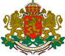

**R E P U B L I C OF B U L G A R I A**

**NATIONAL AIR, MARITIME AND RAILWAY TRANSPORT ACCIDENTS INVESTIGATION BOARD**

|  |  |
| --- | --- |
| 9 Dyakon Ignatiy str., Sofia 1000  tel. (+359 2) 940 9317  fax: (+3592) 940 9350 | [bskrobanski@mtitc.government.bg](mailto:bskrobanski@mtitc.government.bg)  [bskrobanski@abv.bg](mailto:bskrobanski@abv.bg) |

**ANNUAL REPORT**

**NATIONAL RAILWAY TRANSPORT ACCIDENTS**

**INVESTIGATION BOARD**

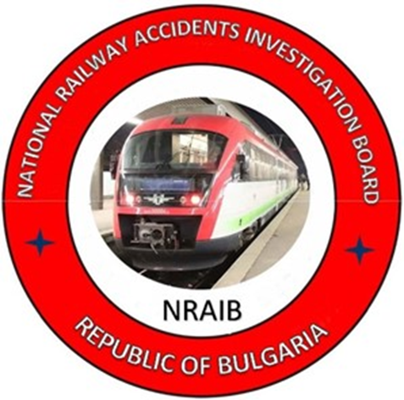

**2022**

The present report is issued in accordance with:

* Directive (EU) 2016/798 of the EP and the Council of 11 May 2016;
* Railway Transport Act, SG issue 108, in force since 01.01.2007;
* Ordinance № 59, SG issue 102, in force since 05.12.2006.

The normative acts are available at:

https://www.mtitc.government.bg

**TABLE OF CONTENTS**

|  |  |
| --- | --- |
| **Preface** | **4** |
| **1. INVESTIGATION BODY** | **5** |
| * 1. *Legal base* | **5** |
| * 1. *Purpose and functions* | **5** |
| * 1. *Organization of the activity*   2. *International activity*   3. *Participation of the NRTAIB in other events* | **7**  **8**  **8** |
| **2. PROCESS OF INVESTIGATION** | **10** |
| *2.1. Events that are subject to investigation* | **10** |
| *2.2. Institutions related to the investigation* | **11** |
| *2.3. Process of investigation and investigation body approach* | **11** |
| *2.4. Safety research based on the annual reports from 2022* | **13** |
| **3. INVESTIGATIONS** | **16** |
| *3.1. Review of investigations completed in 2022.* | **16** |
| *3.2.**Investigations started and completed in 2022*  *3.3. Description of the investigated accidents in 2022* | **17**  **17** |
| *3.3.1.Lateral collision of rail switch № 39 in Ilyiantsi station of locomotive № 91522086001-8 with locomotive № 91522086005-9* | **17** |
| *3.3.2. Performed functional tests of locomotive № 91520043309-1, before commissioning in Locomotive Depot Plovdiv* | **18** |
| *3.3.3. Collision at rail level crossing, locomotive of FT № 7623 in a freight truck between the stations Oreshets – Dimovo* | **20** |
| *3.3.4. Derailment of wagons of DFT № 30592 between the stations Yana and Kremikovtsi*  *3.4.* *Investigations started in 2022 and completed in 2023*  *3.4.1.* *Fire in two wagons of FT № 2613 occurred between Kaspitchan – Provadya*  *3.5. Investigated accidents and incidents in 2022* | **20**  **22**  **22**  **23** |
| **4. SAFETY RECOMMENDATIONS** | **24** |
| *4.1. Brief summary of the safety recommendations issued by NRTAIB* | **24** |
| *4.2. Safety recommendations issued in 2022* | **25** |
| *4.2.1. Lateral collision of railway switch № 39 in Ilyiantsi station of locomotive № 91522086001-8 with locomotive № 91522086005-9* | **25** |
| *4.2.2. Performance of functional tests of locomotive № 91520043309-1, before commissioning in Plovdiv locomotive depot* | **25** |
| *4.2.3. Collision at railway level-crossing, the locomotive of FT № 7623 in a freight truck between the stations Oreshets – Dimovo*  *4.2.4. Derailment of wagons of DFT № 30592 between the stations Yana and Kremikovtsi*  *4.3. Safety recommendations issued in 2023*  *4.3.1. Fire in two wagons of FT № 2613 occurred between Kaspitchan – Provadya* | **26**  **27**  **27**  **27** |

# Preface

# The annual report presents the investigated railway events and issued safety recommendations in 2022, as well as the activity of the National Investigation Body of the Republic of Bulgaria as per the requirements of article 24, paragraph 3 of Directive (EU) 2016/798/EP and of the Council on the railway transport safety.

By a Decision of the Council of Ministers of the Republic of Bulgaria in 2020 was established a multimodal authority for investigating transport accidents on the safety, the “National Air, Maritime and Railway Transport Accidents Investigation Board” (NAMRTAIB) within the Council of Ministers under the direct supervision of the Prime Minister. There were adopted Rules of the activity, structure and organization of the National Air, Maritime and Railway Transport Accidents Investigation Board. The Board consists of three safety investigation areas in aviation, maritime and railway accidents. The Board is chaired by a Management Council consisting of three members — Heads of the respective areas. The Board is a secondary spending unit with a guaranteed and secured separate budget for each accident investigation area. The investigation functions in the field of the National Railway Transport Accidents Investigation Board (NRTAIB) are stipulated in the Railway Transport Act (RTA), Ordinance № 59 of 05.12.2006 on railway safety management. Since 11.04.2023, the NAMRTAIB has signed an "Agreement on cooperation in the investigation of accidents and incidents in air, water and rail transport between the Prosecutor's Office of the Republic of Bulgaria, and the Ministry of Internal Affairs.

The annual report includes data on the railway accidents investigated in 2022, including the causes for their occurrence and the recommendations issued to improve the safety in railway transport to the National Safety Authority – Railway Administration Executive Agency RAEA. It includes information on the measures taken by the entities for their implementation and performance. Summary data from the railway events realized in 2022 and the damages presented by the State Enterprise “National Railway Infrastructure Company” (SE NRIC) and the railway undertakings (carriers and entities, performing repair and maintenance).

# INVESTIGATION BODY

## Legal base

The investigation body investigates accidents and incidents in accordance with the requirements of Directive 2016/798/EP and of the Council of 11 May 2016 on railway safety, which has been transposed into the Railway Transport Act (RTA) and Ordinance №59/05.12.2006 for management of safety in railway transport and the signed Agreement for interaction during the investigation of accidents and incidents in the field of transport between the Prosecutor's Office of the Republic of Bulgaria, and the Ministry of Internal Affairs, and the NAMRTAIB.

**Chronology and restructuring of the investigation body**

In 2006, in line with the requirements of Article 21 of Directive 2004/49/EC on safety on the Community’s railways, within the Ministry of Transport and Communications (MTC) was established a specialised investigation body for the investigation of railway accidents and incidents - the "Specialized Railway Transport Accidents and Incidents Investigation Unit" (SRTAIIU). In view of its independence, it is directly subordinated to the Minister for Transport and Communications. The resources to secure the investigation are provided from the Ministry’s budget.

In 2020, was established an independent multimodal investigation authority the “National Air, Maritime and Railway Transport Accidents Investigation Board” (NAMRTAIB) at the Council of Ministers under the direct supervision of the Prime Minister.

The NRTAIB is part of the NAMRTAIB for investigation of railway transport accidents and incidents in the Republic of Bulgaria.

## Purposes and functions

The purposes of the investigation of railway transport accidents and incidents is to avoid and prevent accidents, giving priority to the prevention of significant accidents.

The prevention of the investigation body is to establish the causes for their occurrence and to elaborate relevant safety recommendations in order to improve the safety and to prevent significant accidents without seeking personal fault and responsibility.

The functions and tasks of the NRTAIB are described in detail in the European and National normative acts.

Main functions and responsibilities of the NRTAIB:

- Organizing and leading the investigation of significant accidents and incidents that occurred on the territory and at the border crossings of the Republic of Bulgaria;

- Establishing the causes, circumstances and facts related to the occurrence of significant accidents and incidents, including identification of evidence, performance of analysis, including the human factor, decision-making, preparation of expertise and documentation of events;

- Coordination of the activities for conducting common investigations in which the competent bodies of the Prosecutor's Office of the Republic of Bulgaria - the Investigation Bodies and the Ministry of Interior (MoI) also participate;

- Preparation and sending to all the affected entities a draft final report with safety recommendations from the completed investigation of an accident or incident for expressing opinions and statements;

- After analysing the views and opinions of the involved parties, a final report containing safety recommendations is drawn up and sent to all the interested parties, which is published on the website of NRTAIB;

- Participation in the working meetings of the Network of National Investigation Bodies of the EU Member States, and conferences and trainings organized and coordinated by the European Union Railway Transport Agency;

- Participation in working groups for harmonization of the national normative acts with the European legislation, related to the safety and investigation of railway accidents and incidents;

- Analysis of data on occurred accidents and incidents in the railway transport system;

- Keeping an archive of the investigated accidents and incidents and maintaining an information database within the NRTAIB.

## Organization of the activity

The main activity of the NRTAIB is in its quality of national investigation body for railway accidents and incidents, is investigation of accidents and incidents classified in accordance with the requirements of art. 20 of Directive (EU) 2016/798/EP and the Council, RTA and Ordinance № 59.

The vice-chairperson of the Management Board of NAMRTAIB manages the NRTAIB, with a doctorate in railway safety, a master's degree engineer in "Operation and management of railway transport" he also chairs the accident investigation commissions;

The investigations are performed by a commission, which includes external experts on a civil contract, with professional experience and qualifications for the relevant accident.

Investigations are provided with funds from the budget of the NAMRTAIB.

The decisions to initiate an investigation follow the requirements of the European and national normative acts, and are taken by the vice-chairperson of the Management Board of the NAMRTAIB and are in accordance with:

- Directive 2016/798/EP and the Council;

- Railway Transport Act;

- Ordinance No. 59/05.12.2006 on safety management in railway transport.

The Head of the NRTAIB shall inform in writing the Agency for Railway Transport of the European Union about any undertaken investigation of a railway event through the notification system. The investigations are completed with a draft final report and, if necessary, safety recommendations are issued and sent to all stakeholders;

The Head of the NRTAIB shall inform the Agency for Railway Transport of the European Union in writing of any completed investigation, providing an electronic copy of the original final report in English in accordance with the requirements of Regulation (EU) 2052/2020/EC of 24 April 2020.

After validation of the report by the Agency, it becomes publicly available on the website of the NAMRTAIB.

**1.4. International activity in 2022**

1. Participation of the Head of the NRTAIB in the 48th plenary session of the Network Investigation Bodies of Railway Accidents from the EU Member States held on 2 and 3 March 2022 in Valenciennes, France.

2. Participation of the Head of the NRTAIB in a conference with subject ERTMS 2022, in the period 26-28 April 2022, held in Valenciennes, France. The Conference was focused on the ERTMS deployment in the member-states and the package for revision of CCS and TSI.

3. Participation of the Head of the NRTAIB in the 49th plenary session of the Network Investigation Bodies of Railway Accidents from the EU Member States held on 18 and 19 May 2022 in Valenciennes, France.

4. Participation of the Head of the NRTAIB in the 50th plenary session of the Network Investigation Bodies of Railway Accidents from the EU Member States held on 12 and 13 October 2022 in Valenciennes, France.

5. Participation of the Head of the NRTAIB in a conference with subject HOF „Integration of human and organizational factors: Management of the loading and fatigue in the rail transport“, held on 06 and 07 December 2022 in Valenciennes, France.

**1.5. Participation in direction NRTAIB in other events**

1. As per the requirements of art. 11 (2) of Ordinance № 59/5.12.2006 monthly (until the tenth day of each month) operational information on the general safety indicators from the manager of the railway infrastructure, railway undertakings and the entities in charge of maintenance is sent to the National Safety Authority (RAEA) and to the Head of the National Railway Transport Accidents and Incidents Investigation Authority. The head of the NRTAIB and the RAEA perform analysis, summarize the received information and appoint measures for the safety improvement;
2. In accordance with the requirements of art. 12 (1) of Ordinance No. 59/5.12.2006, the Head of NRTAIB and the RAEA, every year until the end of May, receive in writing the annual reports of the manager of the railway infrastructure and railway undertakings. The head of NRTAIB performed a safety analysis for 2022 based on the provided data;
3. The head of the NRTAIB daily receives operational information about the accidents, incidents, and irregularities that occurred during the past 24 hours on the national railway network, prepared and presented by the train traffic management division at the railway infrastructure manager;
4. The head of NRTAIB prepared and published an annual report on the activity and investigated accidents in 2022, which was sent by September 30 to the European Union Railway Agency;
5. The head of the NAMRTAIB creates optimal conditions and organization for timely and effective work with the bodies of pre-trial proceedings in accordance with the Agreement of 11.04.2023 on interaction in the investigation of transport accidents and incidents between the Prosecutor's Office of the Republic of Bulgaria, the Ministry of Interior and NAMRTAIB;

6. In the course of the investigation, the head of NRTAIB creates working contacts with the entities involved in the accident - the railway infrastructure manager, (SE NRIC), the railway undertakings/carriers, the entities in charge of maintenance, as well as with RAEA, the users of railway services with regard to the investigated accident, Scientific Research Technical Institutes, Centres for professional qualification of the entities, and other structures and, if necessary, with the National multi-profile transport hospitals in the country indicated in (fig. 1.1).

**Interaction of the NRTAIB with other authorities and institutions**

**in the investigation process**

**Fig. 1.1**

# PROCESS OF INVESTIGATION

## Events that are subject to investigation

In accordance with the requirements of Directive (EU) 2016/798/EP and of the Council, the Railway Transport Act and Ordinance № 59, the National Railway Transport Accident Investigation Board investigates railway events:

- Significant railway accidents;

- Accidents and incidents that in different circumstances, could lead to significant accidents;

- At its discretion, investigates technical failures in the structural subsystems and interoperability constituents, taking into account their significance.

In the event of an accident or incident occurrence, the authorized officials of the railway infrastructure manager and railway undertakings shall immediately notify the Head of the NRTAIB department in accordance with their approved Safety Procedures stipulated in the Safety Management Systems as per Ordinance № 59.

## Institutions related to the investigation.

In the course of the investigation, the Chairperson of the Commission assigns technical expertise, and requests analysis and opinions from the following:

* Technical University of Sofia;
* Higher School of Transport "Todor Kableshkov";
* Professional Training Centres for railway staff;
* Bulgarian Academy of Sciences;
* National multidisciplinary transport hospitals in the country;
* Fire safety laboratory;
* Other institutions for each specific case, indicated in (fig. 2.1).

**Structure of the Investigation Commission for railway events**

**Fig. 2.1.**

## Process of investigation and Investigation Body Approach

Following the notification of an accident, the Head of the NRTAIB, analyses and classifies the railway event and takes a decision to undertake an investigation, establishes an organisation for timely departure to the place of the accident. If authorities of the pre-trial proceedings have arrived on the spot, an organisation for independent inspection, taking photograph materials, controlled removal of separately damaged elements and details of railway infrastructure and rolling stock shall be established.

The security authorities of the Ministry of Interior preliminarily fence off and limit the access of outsiders and the media to the scene of the accident, in order to preserve the visible physical evidence. When there is an injury (staff and/or passengers) from the accident, the emergency medical teams are given the opportunity to provide first aid to the injury. In the event of a fire occurring in the rolling stock of the bodies of "Fire Safety and Civil Protection" (FSaCP), an opportunity is provided to extinguish the fire, after which the investigative structures begin inspections and investigation procedures.

After taking a decision, the Head of the NRTAIB appoints a commission to investigate the accident. The Commission shall include independent external experts with relevance given the type of the investigated event, stipulated in item 2.2. When deciding to initiate an investigation, the head of the NRTAIB shall inform all the interested parties in the event. Within a week after the initiation of the investigation, shall inform the European Union Agency for Railways in writing of the initiation of an investigation through the notification system.

The Chairperson of the Commission manages and coordinates the activities of the investigation independently of the bodies of the pre-trial proceedings - Prosecutor's Office, Investigation, Ministry of Interior, and other investigation institutions, in order to ensure the necessary conditions for conducting an independent investigation. He supports the activities related to the teams of "Emergency Medical Aid" and "Fire Safety and Civil Protection" (FSaCP). The Infrastructure Manager, the Railway Undertaking and other legal entities involved in the event shall provide the Chairperson of the Investigation Commission with all the records and conversations of the staff involved in the train traffic management, as well as any other important information and documents related to signalling and rail track.

The National Safety Authority (RAEA) shall provide any important information giving clarity on the accident or incident under investigation as well as information on the rolling stock involved in the accident, registered in the European register of the vehicles.

The Commission conducts interviews with the personnel involved in the accident, as well as with eyewitnesses and witnesses of the event and requires written testimony from all legal entities and individuals directly and indirectly related to the event.

The Commission receives the full support and assistance from the competent investigation authorities of the Prosecutor's Office and the Ministry of Interior, which conduct their own parallel investigation, in accordance with the requirements of the Code of Criminal Procedure (CPC).

The safety investigation carried out by the NRTAIB is conducted as openly as possible in order to exchange information, opinions and statements to the extent appropriate to the investigative procedures.

To the Commission are submitted the collected documents and materials provided by the Task force, which the Infrastructure manager assigns, and in which participate representatives of the parties involved in the accident.

The Commission analyses the collected documents and materials provided by the Task force, the opinions and expertise prepared before, during and after the accident in order to clarify the circumstances and the causes that led to its occurrence.

The Chairperson of the Commission, depending on the severity of the accident under investigation, prepares a draft final report, which he sends to the RAEA and the affected entities, structures and organizations, as well as to the relatives of the victims in the accident (if any).

In accordance with the requirements of the Directive, any accident or incident investigated within one year from the date of its occurrence shall end with a final report, and in the event of an extension, an interim report shall be drawn up describing the action taken to date.

The final report shall set out the chronology of the Commission Implementing Regulation (EU) 2020/572 of 24 April 2020 on the reporting structure that shall be followed for railway accident and incident investigation reports.

If necessary, recommendations are made to improve the safety, in order to prevent other events of similar nature. The safety recommendations are addressed to the RAEA and the entities involved in the event - the railway infrastructure manager, the railway undertakings, and other interested participants in the event.

The National Safety Authority RAEA and other bodies or structures to which the recommendations are addressed shall regularly report to the Investigation Body on the measures taken and planned as a result from the recommendations.

The Head of the NRTAIB shall inform the European Union Railway Agency in writing of the completion of the investigation, sending a copy of the final report translated into English with the safety recommendations given. The final report is made publicly available on the website of the NAMRTAIB in the field of railway transport.

## Safety research of 2022.

The Head of the NRTAIB unit received the annual reports from the railway infrastructure manager and railway undertakings (carriers) with registered in them totally **748** railway events, classified under categories:

• **351** accidents, incl. 6 – train collision in railway vehicle, 210 – train collision in obstacle, 38 – derailment of RRS, 22 – accidents at level-crossings, 32 – accidents with persons, 22 – fire in RRS, 8 – others and 14 – suicides;

• **73** incidents, incl. 14 – damage in the rail track, 35 – deformed rail track, 0 – damage in the SE, 24 – SPAD (signal passed at danger) and 0 – RRS broken wheel;

• **324** situations, close to incidents.

The summarized railway accidents in 2022 are in accordance with the General safety indicators (GSI):

- 32 significant accidents – incl. 1 – train collision in railway vehicle 2 – train collision in obstacle within the limits of the clearance gauge, 1 – derailment, 10 – accidents at railway level-crossings, 18 – accidents with persons, caused by rolling stock in motion, excluding suicides.

* 15 fatalities as a result of occurred accidents caused by rolling stock in motion;
* 18 seriously injured persons, as a result of occurred accidents caused by rolling stock in motion;
* 2 seriously injured passengers, as a result of occurred accidents caused by rolling stock in motion;
* 3 seriously injured employees;
* 6 seriously injured level-crossing users;
* 7 seriously injured trespassers;

- 14 suicides;

- 1 suicide attempt;

As a result of the occurred significant railway accidents, the value of the caused material damages of the railway infrastructure, and of the rolling stock amounts to BGN 2 666 227 (EUR 1 360 320).

**Railway events registered in the railway network in 2022.**

| **№** | **TYPE OF EVENTS** | **NUMBER** |
| --- | --- | --- |
| **ACCIDENTS** | | |
| 1 | Train collision with railway vehicle | 6 |
| 2 | Train collision with obstacle | 210 |
| 3 | RRS Derailment | 38 |
| 4 | Level crossing accident | 22 |
| 5 | Accident with persons | 32 |
| 6 | Fire in RRS | 21 |
| 7 | Other | 8 |
| 8 | Suicides | 14 |
| **Total**: | | **351** |
| **INCIDENTS** | | |
| 1 | Rail track failure | 14 |
| 2 | Signalling failure | 35 |
| 3 | SPAD (signal passed at danger) | 24 |
| 4 | Broken wheel of RRS | 1 |
| **Total:** | | **73** |
| **SITUATIONS, CLOSE TO INCIDENTS** | | |
| 1 | RRS failure on the RI, caused the delay | 9 |
| 2 | Rail track failure | 136 |
| 3 | Signalling equipment failure | 70 |
| 4 | Catenary failure | 49 |
| 5 | Incorrect or incoherent actions of EP from RI | 11 |
| 8 | Dispatched train without approval | 1 |
| 9 | Dispatched train to occupied interstation | 2 |
| 10 | No dropped manual barriers for trains | 3 |
| 11 | Movement on unprepared route | 3 |
| 12 | Interruption of movement | 40 |
| **Total :** | | **324** |

**Chart of the railway events in 2022**

**RAILWAY EVENTS 2022**

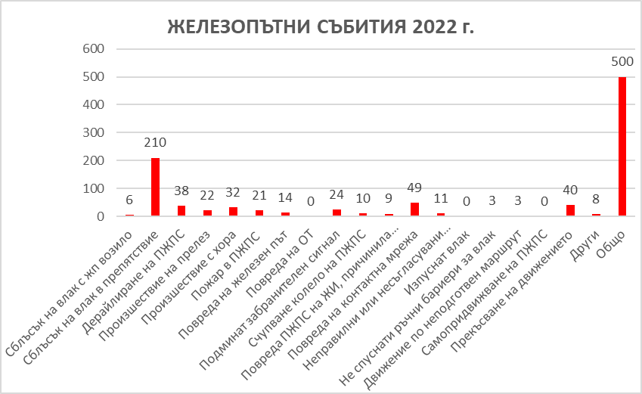

Train collision with a railway vehicle-6

Train collision with obstacle-210

Derailment of RRS-38

Level -crossing accident-22

Accident with persons-32

Fire in RRS-21

Rail track failure-14

Signalling equipment failure-0

SPAD-24

Broken wheel of RRS-10

RRS failure on RI-9

Catenary failure-49

Incorrect action by the EP-0

Missed train-3

No manual barriers for train-0

Movement on unprepared route-0

Self-propulsion of RRS-0

Interruption of movement-40

Other-8

TOTAL-500

**Chart of the railway events and caused damages in the period 2012 ÷ 2022**

**RAILWAY EVENTS AND DAMAGES IN THE PERIOD 2013-2022**

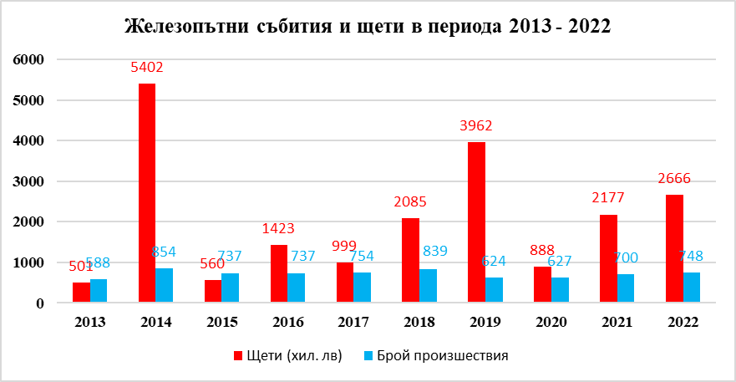

Damages (thousand BGN) Number of accidents

**Railway events with caused damages**

In 2013 compared to 2012, the deviation damages/BGN is + 206 902 BGN (+105 787 EUR)

In 2014 compared to 2013, the deviation damages/BGN is + 5 402 000 BGN (+2 762 000 EUR)

In 2015 compared to 2014, the deviation damages/BGN is – 4 842 076 BGN (–2 472 591 EUR)

In 2016 compared to 2015, the deviation damages/BGN is + 863 286 BGN (+440 452 EUR)

In 2017 compared to 2016, the deviation damages/BGN is – 136 200 BGN (–69 597 EUR)

In 2018 compared to 2017, the deviation damages/BGN is + 1 641 141 BGN (+839 115 EUR)

In 2019 compared to 2018, the deviation damages/BGN is – 74 728 BGN (–35 135 EUR)

In 2020 compared to 2019 the deviation damages/BGN is + 1 156 291 BGN (+592 970 EUR)

In 2021 compared to 2020 the deviation damages/BGN is + 1 020 277 BGN (+517 524 EUR)

In 2022 compared to 2021 the deviation damages/BGN is + 1 645 950 BGN (+839 770 EUR)

**National network of the Republic of Bulgaria at 2022.**

● Total length of the railway network – 6446 km, of which rail gauge 1 435 mm – 6 293 km, incl.:

- length of open rail track – 3 904 km;

- double-track railway lines – 995 km;

- railway switches – 6 800 units;

- level-crossings – 757;

- railway bridges – 995, with total length 43,1 km;

- railway tunnels – 186, with total length 47,9 km;

- continuously welded rail track – with total length 2 317 km.

● Lines with rail gauge 760 mm – 125 km.

# INVESTIGATIONS

# Summary of the investigations completed in **2022**

In 2022, the NRTAIB investigated five railway accidents.

**Table** 1: **Investigated accidents and incidents in** 2022

|  |  |  |  |  |  |
| --- | --- | --- | --- | --- | --- |
| **Type of investigated accidents and incidents** | **Number of accidents** | **Number of victims** | | **Damages** | |
| **Fatalities** | **Seriously injured** | **BGN** | **EURO** |
| Fire in RRS | 1 | - | - | 61 561,70 | 31 409,03 |
| Derailment of RRS | 1 | - | - | 327 657,07 | 167 172,02 |
| Train collision with railway vehicle | 1 | - | - | 186 861,00 | 95 337,25 |
| Level crossing accident | 1 | 3 | - | 122 675,17 | 62 589,37 |
| Accident during RRS tests performance | 1 | 1 | - | - | - |
| **TOTAL:** | **5** | **1** | **-** | **1 492 146,11** | **761 298,10** |

* 1. **Investigations, started and completed in** 2022

Table 2: **Investigations, started and completed in** 2022

|  |  |  |  |
| --- | --- | --- | --- |
| **Date of the event** | **Visit card of the investigation** | **Legal base** | **Completed on** |
| 21.01.2022 | Railway accident – derailment during lateral collision of railway switch № 39 in Ilyiantsi station of locomotive №91522086001-8, serviced DFT № 20691 with locomotive № 91522086005-9, serviced DFT № 20698 on 21.01.2022. | Directive 2016/798/EP, art. 20, par. 2/а, art. 115k, par. 1, item 2 of RTA, art. 78, par. 1 and 2 of Ordinance № 59 | 31.05.2022 |
| 24.03.2022 | Railway accident – functional tests performance of locomotive №91520043309-1, before placing into service on 24.03.2022. | Directive 2016/798/EP, art. 20, par. 1, art. 115к, par. 1, item 1 of RTA, art. 78, par. 1 and art. 2 of Ordinance № 59 | 25.07.2022 |
| 07.06.2022 | Railway accident – railway collision at railway level crossing of the locomotive of FT № 7623 in freight truck between the stations Oreshets – Dimovo on 07.06.2022. | Directive 2016/798/EP, art. 20, par. 1/а, art. 115к, par. 1, item 1 of RTA, art. 78, par. 1 and art. 2 of Ordinance № 59 | 15.12.2022 |
| 26.07.2022 | Railway accident – Derailment of five wagons of DFT № 30592 between the stations Yana – Kremikovtsi on 26.07.2022. | Directive 2016/798/EP, art. 20, par. 2/а, art. 115к, par. 1, item 2 of RTA, art. 78, par. 1 and art. 2 of Ordinance № 59 | 28.11.2022 |

* 1. **Description of the investigated accidents in 2022**
     1. Railway accident – lateral collision on railway switch № 39 in Ilyiantsi station of locomotive № 91522086001-8, serviced DFT № 20691 with locomotive №91522086005-9, serviced DFT № 20698 on 21.01.2022.

*Brief description*

At 03:13 a.m., DFT No. 20691 with locomotive No. 91522086001-8 departed from the eighth acceptance-departure track at Iliyantsi station for Kurilo station in the direction of Ruse marshalling yard with an open exit signal and an order for departure given by the traffic manager on duty at the station. The departure order was received by the locomotive driver second person and passed to the locomotive driver first person.

At 03:13 a.m., DFT No. 20698 with locomotive No. 91522086005-9 also departed from the ninth track at Iliyantsi station, without a permissive indication of the signalling from the ninth track for Svetovrachene station in the direction of Pirdop station. At the time of departure, the first-person locomotive driver was alone in the locomotive control cabin. During that time, the second-person locomotive driver was in the engine compartment of the locomotive. When the locomotives of the two trains on switch No. 39 entered at the same time, they collided sideways and derailed to the left and right of the railway switch with all wheel sets.

Locomotives and personnel of the railway undertaking for freight transport „Bulmarket Rail Cargo“ EOOD served the two trains.

|  |  |  |  |
| --- | --- | --- | --- |
| |  |  | | --- | --- | |  | *Consequences*  Because of the derailment of the train, severe damage was caused to the two locomotives, to the railway infrastructure - railway track, railway switches, overhead contact line and signalling equipment. The movement of trains through Ilyiantsi station was not interrupted. | |  |

*Causes*

Track 9 at Ilyiantsi station was found to be located to the right of track 8 in the direction of increasing mileage, with most of track 9 running parallel to track 8 from south to north, with a wheelbase of 4.83 meters, after which the 9th track deviates to the right with a right curve and a left counter curve and the wheelbase between the two tracks increases to 6.58 meters. The two exit semaphores for tracks 8 and 9 are ground level.

The Investigation Commission found that when looking from the locomotive driver's cabin from the place where locomotive No. 91522086005-9 was located on the 9th track, it was quite possible that the locomotive driver mistakenly took the clearance reading of the ground signal given for the 8th track exit semaphore for DFT No. 20691. This circumstance cannot be considered as the main cause for the accident, since the legal documents and the technology of Ilyiantsi station forbid the locomotive driver to leave the station only upon a permissive indication of the exit semaphore, but it is probably influenced to a certain extent.

Therefore, as the direct cause of the accident, it can be considered that DFT No. 20698 departed from the ninth track without fulfilling the regulatory requirements for sending a train from Ilyiantsi station.

*Status of the investigation*

The investigation was closed with a final report and six safety recommendations on 31.05.2022.

* + 1. Railway accident – functional tests performance of locomotive №91520043309-1, before placing into service (commissioning) on 24.03.2022

*Brief description*

After repair in the repair workshop of locomotive No. 91520043309-1 at Locomotive Depot Plovdiv, it was handed over for operation. At around 15:20 p.m. on 24/03/2022, it was removed from the repair shop and positioned on the 5th track in the depot under a catenary, where functional tests were carried out before commissioning.

In the course of the tests carried out by competent experts, they found that the train heating of the locomotive was not working. The head of the workshop ordered the Organizer of production and repair of railway transport, master, to eliminate the identified malfunction in the locomotive. The supervisor got off the locomotive, took the necessary tool and returned to the locomotive to remove it. During the elimination of malfunctions, violations of the normative and inter-departmental acts (regulations, rules and instructions) regulating safe working conditions when working with electrical devices in locomotives were committed.

*Consequences*

As a result of non-compliance with the regulations and lack of coordination in the actions between the experts performing the functional tests and the employee troubleshooting the train heating of the locomotive, the pantograph was lifted without warning, which resulted in an electrocution with a fatal outcome (to the Organizer of production and repair of RRS, master).

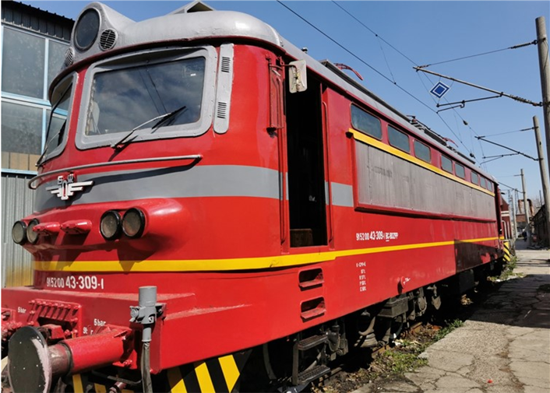

*Causes*

The direct cause of the fatal accident was electrocution of the employee (during troubleshooting in the engine compartment of the locomotive) by an electric shock with an alternating current of voltage 1500 V, 50 Hz, which flowed through the power circuit of the train heating as a result of uncoordinated actions of those involved experts in locomotive testing (lifting the locomotive pantograph and turning on 25 kV voltage, without disclosure).

*Status of the investigation*

The investigation was closed with a final report and five safety recommendations on 25.07.2022.

* + 1. Railway accident – collision at railway level crossing, locomotive of FT № 7623 in freight truck between the stations Oreshets – Dimovo on 07.06.2022.

*Brief description*

On 07.06.2022 at 12:25 p.m. train No. 7623 departed from Vidin station, consisting of 4 passenger coaches, 175 tons, hauled by locomotive No. 91520044158-1, operated by a locomotive driver first person and a locomotive driver second person and a train crew with train master and conductor. The train run daily under TOS in the Vidin - Sofia direction. FT No. 7623 moved on time, arrived at Dimovo station at 13:14 p.m., and after a 1-minute layover, it departed at 13:15 p.m. for Oreshets station, with a regular exit signal and an order given by the traffic manager on duty.

The traffic manager on duty at the Oreshets station, around 13:18 p.m., ordered the signalman at Post No. 2 to prepare a route for accepting FT No. 7623 on the second main track and to open the entrance signal.

During the movement of the train in the Dimovo - Oreshets interstation, a remote sensor was activated to control the ALCS automatic crossing signalling at km 127+123, which, after being activated, turned on the pre-crossing semaphore, which began to glow with a flashing moon-white light. That indicated to the locomotive driver that the ALCS was engaged and operating normally. The train approached the level crossing and with the locomotive whistle gave the signal "Caution".

At that time, on the road, to the right of the rail track in the direction of the train, a loaded Iveco dump truck was approaching parallel to it. The driver of the car turned left and did not stop in front of the regularly activated prohibitory semaphore, entered the dangerous zone of the level crossing and at around 13:30 p.m. the train was moving at a speed of 70 km/h hit the heavy goods vehicle passing through the railway crossing.

*Consequences*

Because of the collision, the driver of the car was killed and fell from the cab of the car, and the heavy goods vehicle was thrown from the locomotive to the right in the direction of the movement of the train 20 meters after the level crossing with a destroyed cab. From the subsequent collision, the cab of the locomotive was severely deformed and the two locomotive drivers were killed. Three passengers from the train were slightly injured. Two were given medical aid at the Vidin General Hospital and were released; the third passenger was given medical aid on the spot and released. The injured passengers were traveling in the first passenger coach next to the locomotive with № 51522563027-3, which derailed with both track wheel sets of the first bogie and one-track wheel set of the second bogie.

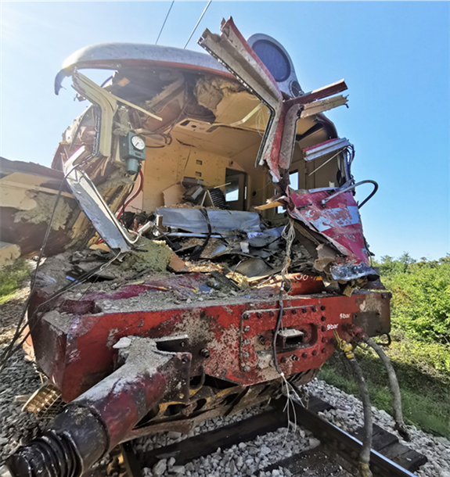

*Causes*

The accident was caused by the illegal passage of the loaded heavy goods vehicle "Iveco" through the railway level crossing at km 127+123 in the Dimovo - Oreshets interstation in front of the approaching FT No. 7623. The ALCS was activated, a prohibitory indication of the road traffic light giving a light signal consisting of two sequentially flashing red lights and an audible signal, which meant "Passing of traffic is prohibited".

*Status of the investigation*

The investigation was closed with a final report and six safety recommendations on 15.12.2022.

* + 1. **Derailment of wagons of DFT № 30592 between the stations Yana and Kremikovtsi on 26.07.2022**

*Brief description*

On 26.07.2022 at 12:30 p.m., DFT No. 30592 departed from Plovdiv marshalling yard, assigned by telegram/timetable of SE NRIC with a route from Plovdiv marshalling yard to Iliyantsi station at the request of the railway undertaking "Rail Cargo Carrier - Bulgaria" EOOD. The train was operated by the railway undertaking "Rail Cargo Carrier - Bulgaria" EOOD, with a route of movement Svilengrad - Plovdiv - Karlovo - Iliyantsi, consisting of 20 loaded wagons, type R and S, 80 axles, 1566 tons, with train locomotive No. 918111161116 and auxiliary locomotive at the head No. 918111162593. The two locomotives operated on a multi-unit SME system and the first locomotive carried out the control with a locomotive brigade, first-person driver and second-person driver. The train passed Stolnik station without stopping at 16:50 p.m., passed Yana station without stopping at 16:56 p.m., and at the Yana - Kremikovtsi interstation at km 19+041 at 17:01:13 p.m., five wagons of the train derailed, which caused a break in the train and it stopped at 17:01:43p.m. After the inspection by the locomotive crew, they found that the train was separated in two places (the wagons were in three parts) and five wagons at the end of the train had derailed, they informed the traffic manager on duty of Yana station and the train dispatcher of the railway line. The wagons of the train were flatbed, loaded with container/tanks full of cement.

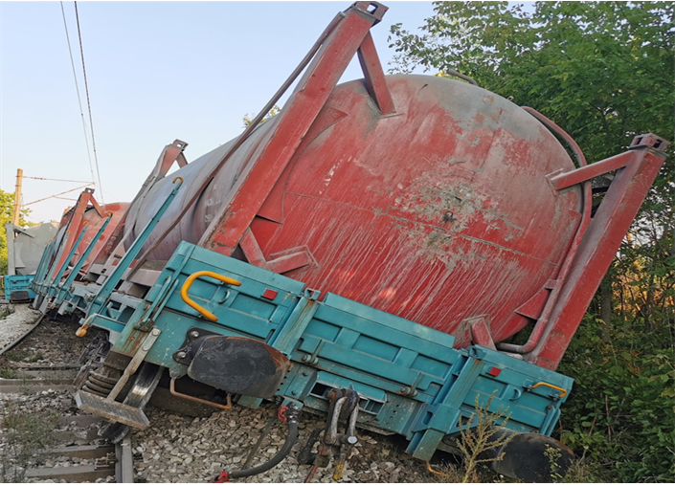

*Consequences*

Train traffic between Yana and Kremikovtsi stations was interrupted from 17:20 p.m. on 26/07/2022 until 15:00 p.m. on 29/07/2022, restored at a speed of 25 km/h. On 30.09.2022, the train movement was restored at a speed of 40 km/h according to the schedule.

Because of the derailment, about 100 m of railway was destroyed; the derailed wagons were also damaged.

*Causes*

The accident occurred because of a combination of factors. The high temperatures in the rails caused their longitudinal displacement, combined with the dynamic forces induced by the passing freight train, which resulted in the track being swept under the train in the zone of the transition from continuously welded to jointed track. The lower track resistance of of derailment wooden sleepers compared to that of concrete sleepers has resulted in rail sweeps in that zone.

*Status of the investigation*

The investigation was closed with a final report and four safety recommendations on 28.11.2022.

# **3.4. Investigations, started in 2022 and completed in 2023**

Таблица 3: Investigations, started in 2022 and completed in 2023

|  |  |  |  |
| --- | --- | --- | --- |
| **Date of the event** | **Visit card of the investigation** | **Legal base** | **Completed** |
| 03.11.2021 | Railway accident – fire in two coaches of FT № 2613 occurred between Kaspitchan –Provadya on 03.11.2022 | Directive 2016/798/EP, art. 20, par. 2/а, art. 115к, par. 1, item 2 of RTA, art. 78, par. 1 and art. 2 of Ordinance № 59 | 15.06.2023 |

**3.4.1. Railway accident – fire in two coaches of FT № 2613 occurred between Kaspitchan –Provadya on 03.11.2022.**

*Brief description*

On 03.11. 2022, at 13:15 p.m., FT No. 2613, consisting of 4 coaches, 16 axles, 159 tons, with locomotive No. 91521080041-2, with a locomotive driver and an assistant locomotive driver and a transport crew with a train manager and a conductor, left Sofia station at 13:15 p.m. The train run daily according to the train operation schedule in the direction of Sofia - Gorna Oryahovitsa - Varna. At Kaspitchan station, the train arrived on schedule at 19:28 p.m. and, after a 4-minute delay, it departed at 19:32 p.m. Two kilometres after the Kaspichan station in the direction of the Provadya station on route No. 1, the locomotive driver noticed that the pressure in the MAD dropped to 0 bar and the train stopped. A passenger traveling in the second coach who smelled smoke and subsequently saw fire in the passenger coach (first class) stopped the train with the emergency brake. After the emergency stop of the train at 19:35, the driver sent the assistant locomotive driver to check the connections between the locomotive and the first coach, and he contacted the train master on the mobile phone. At the same moment, the assistant locomotive driver informed the driver that the train was on fire between the first and second coaches. The locomotive driver saw the fire and both immediately took measures to disconnect the train between the first and second coaches in order to prevent the fire from reaching the first coach.

*Consequences*

No passengers or staff were injured in the fire. Damage was caused to the catenary, and to the first two burned passenger coaches of FT No. 2613.

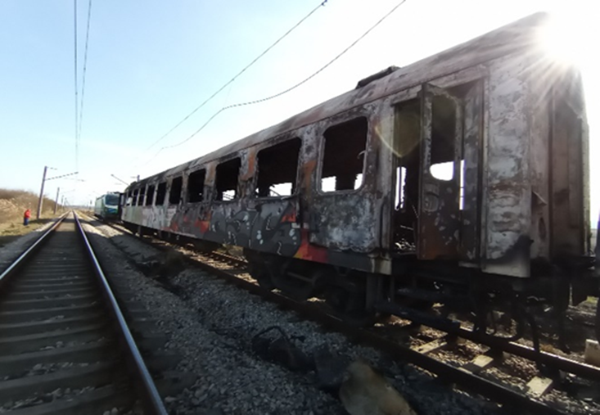

*Causes*

The accident occurred because of ignition of the power inverter of the fluorescent lighting unit in the corridor to the exit, in front of the toilet unit in the front part of the coach in the direction of train movement. The causes for that are complex, involving several factors.

*Status of the investigation*

The investigation was closed with a final report and five safety recommendations on 15.06.2023.

# **3.5. Investigated accidents and incidents in 2022**

Table 4: Investigated accidents and incidents in the period 2012÷2022

|  |  |  |  |  |  |  |  |  |  |  |  |  |
| --- | --- | --- | --- | --- | --- | --- | --- | --- | --- | --- | --- | --- |
| **Investigated events** | **2012** | **2013** | **2014** | **2015** | **2016** | **2017** | **2018** | **2019** | **2020** | **2021** | **2022** | **Total** |
| Train collision in railway vehicle | - | **-** | **-** | 1 | **-** | **-** | **-** | 1 | **-** | - | 1 | **3** |
| Collision with obstacle | - | **-** | **-** | - | **-** | **-** | **-** | - | **-** | - |  | **0** |
| Train derailment | - | 1 | 2 | 1 | 4 | 5 | **-** | 2 | 2 | 6 | 1 | **24** |
| Accident at level-crossing | - | - | 2 | **-** | - | **-** | **-** | 1 | **-** | - | 1 | **4** |
| Accident with persons of RRS in motion | - | **-** | **-** | **-** | - | **-** | **-** | - | **-** | 0 | 1 | **1** |
| Fire in rolling stock | 1 | 2 | 2 | 1 | 4 | 1 | 2 | 2 | 1 | 1 | 1 | **18** |
| Accident with dangerous goods | - | **-** | - | **-** | 1 | **-** | **-** | - | **-** | - | - | **1** |
| Incidents | - | **-** | - | **-** | - | **-** | **-** | **-** | **-** | - | - | **0** |
| **Total:** | **1** | **3** | **6** | **3** | **9** | **6** | **2** | **6** | **3** | **7** | **5** | **51** |

**Chart of investigated accidents and incidents in the period 2012÷2022**

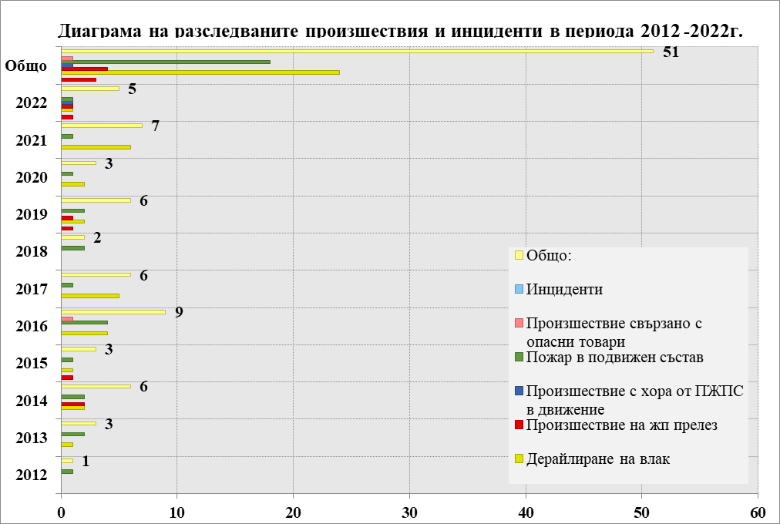

Total

Incidents

Accidents with dangerous goods

Fire in RRS

Accident with person caused by RRS in motion

Level crossing accident

Train derailment

# SAFETY RECOMMENDATIONS

**4.1. Brief summary of the safety recommendations that the NRTAIB issued**

The safety recommendations given by the National Railway Transport Accident Investigation Board (NRTAIB) are aimed at improving safety and preventing other accidents of similar nature. The recommendations are addressed to the National Safety Authority (RAEA), the Railway Infrastructure Manager (NRIC), railway undertakings and other persons related to the maintenance of rolling stock to take measures and actions to improve the safety in railway transport.

#### Table 5: Issued and implemented recommendations in the period 2012÷2022 г.

|  |  |  |  |  |
| --- | --- | --- | --- | --- |
| **Year** | **Given recommendations** | **Status of implementation of the recommendations** | | |
| **Implemented** | **In process of implementation** | **Accepted and implemented** |
| 2012 | 7 | 2 | 1 | 4 |
| 2013 | 16 | 8 | 6 | 2 |
| 2014 | 16 | 7 | 4 | 5 |
| 2015 | 10 | 8 | 2 | 0 |
| 2016 | 27 | 19 | 5 | 3 |
| 2017 | 28 | 17 | 5 | 6 |
| 2018 | 11 | 11 | 0 | 0 |
| 2019 | 23 | 20 | 2 | 1 |
| 2020 | 15 | 8 | 2 | 4 |
| 2021 | 25 | 20 | 0 | 5 |
| 2022 | 26 | 19 | 2 | 5 |
| **Общо** | **204** | **139** | **29** | **35** |

**Chart of issued and implemented recommendations in the period 2012 ÷ 2022**

**RECOMMENDATIONS 2012-2022**

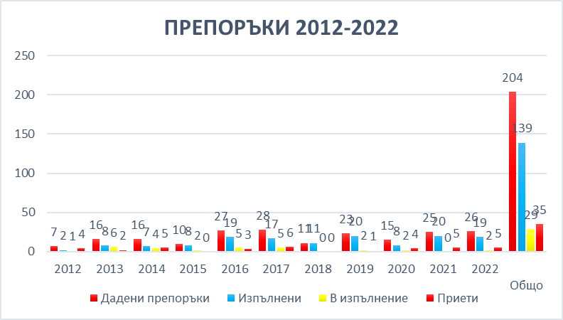

Given recommendations Implemented In process of implementation Accepted Total

# **4.2.** **Safety recommendations, issued in 2022**

* + 1. **Occurred lateral collision at railway switch № 39 in Ilyiantsi station of locomotive № 91522086001-8, serviced DFT № 20691 with locomotive № 91522086005-9, serviced DFT №20698 on 21.01.2022**

*Safety recommendations: (31.05.2022)*

Recommendation 1, proposes SE NRIC and "Bulmarket Rail Cargo" EOOD to familiarize the interested personnel with the contents of the report.

Recommendation 2, proposes "Bulmarket Rail Cargo" EOOD to assess the psychological human factor of the locomotive staff in order to improve teamwork in a positive atmosphere.

Recommendation 3, proposes that "Bullmarket Rail Cargo" EOOD periodically hold talks with the locomotive staff in the presence of a psychologist, at which the development and validation of collective good practices will be discussed.

Recommendation 4, proposes that RAEA evaluates the functioning of the Safety Management Systems in terms of carrying out pre-shift briefings and checking for alcohol and other intoxicating substances of the locomotive staff in the railway enterprises carrying out freight and passenger transport and, at the discretion and need, to restore the points for carrying out pre-trip medical examinations.

Recommendation 5 proposes in the event that, when assessing the functioning of the Safety Management Systems of railway undertakings, inconsistencies or omissions are found regarding compliance with the requirements of item *4.2. Competences and item* *4.6 Integration of the human and organizational factor from Annex 1 of Delegated Regulation (EU) 2018/762 of the Commission*, RAEA to issue mandatory instructions to railway undertakings to organize staff training for the formation of mechanisms such as stress resistance, working out personal stability and dynamic balance of the psychological state, building and playing off a subjective sense of control.

Recommendation 6 proposes that RAEA carry out an inspection regarding the types of signalling at Ilyiantsi station and, together with SE NRIC, take actions to comply with the requirements of art. 305 of Ordinance No. 58.

*Taken measures*

Five recommendations have been implemented.

One recommendation has been accepted and not implemented.

* + 1. **Railway accident – functional tests performance of locomotive № 91520043309-1, before commissioning on 24.03.2022**

*Safety recommendations: (25.07.2022)*

With recommendation 1, it is proposed that BDZ PS EOOD and BDZ Cargo EOOD conduct an extraordinary briefing for the personnel in the repair and operation of railway transport and familiarize them with the final report of the NAMRTAIB on the railway accident that occurred.

With recommendation 2, it is proposed that BDZ PS EOOD and BDZ Cargo EOOD conduct refresher training for the personnel in the repair and operation of public transport vehicles for the safety measures under Ordinance No. 7 and Ordinance No. 13.

With recommendation 3, it is proposed BDZ PS EOOD and BDZ Cargo EOOD to make amendments and additions to the normative documents regulating the types of repairs of TPRS (Regulations for the organization of repair activities in locomotive depots, Instructions for safe work when servicing electric locomotives and motor trains in locomotive depots; Regulations for depot repair and maintenance of BDZ electric locomotives and tests with which TPRS is accepted and handed over for repair as necessary).

With recommendation 4, it is proposed that BDZ PS EOOD and BDZ Cargo EOOD change the work instructions and PLC, which will guarantee increased control by the officials during the execution and acceptance of the repair works, checking of the protective interlocks of the locomotives, ensuring traceability and nominal responsibility.

With recommendation 5, it is proposed BDZ PS EOOD and BDZ Cargo EOOD to create order and organization after coming out of repair and during operation, upon acceptance of the locomotive, the locomotive crews shall check and enter in the logbook the status of all protective locks of the locomotives.

*Taken measures*

The issued five recommendations have been implemented.

* + 1. **Railway accident – collision at railway level crossing of locomotive of FT № 7623 in freight truck between the stations Oreshets- Dimovo on 07.06.2022**

*Safety recommendations: (15.12.2022)*

With recommendation 1, it is proposed that SE NRIC and "BDZ-Passenger Services" EOOD inform the interested personnel with the content of the report.

With recommendation 2, it is proposed that the National Safety Authority RAEA organize and propose amendments and additions to Ordinance No. 4 of 27.03.1997 on railway level crossings, that a representative of the State Agency Road Safety is included in the commission under chapter five of the Ordinance of road traffic.

With recommendation 3, it is proposed that the National Safety Authority RAEA organize and propose an amendment and addition to Ordinance No. 4 of 27.03.1997 on railway level crossings, regarding updating the categorization of level crossings, on the main railway lines railway level crossings equipped with ALCS, to re-equipped with automatic semi-barriers (ALCS).

With recommendation 4, it is proposed that the SE NRIC develop a program for the phased re-equipment of level crossings equipped with ALCS in the interstation of the main railway lines with automatic semi-barriers (ALCS), after amending and supplementing Ordinance No. 4 to update the categorization of level crossings.

With recommendation 5, it is proposed that SE NRIC gradually build 24-hour video surveillance covering the passing flow of road vehicles and rolling stock through the level crossings located on the main railway lines.

With recommendation 6, it is proposed that the Municipality of Dimovo restore and maintain the missing road signs A33 (railway crossing without barriers) and A35 (balises) from the two road approaches to the railway crossing at km 127+123 in the Dimovo - Oreshets interstation in accordance with the requirements of PPZDvP and Ordinance No. 4/27.03.1997 on railway crossings.

*Taken measures*

Four recommendations have been implemented.

Two recommendations have been accepted and are being implemented.

* + 1. **Derailment of wagons of DFT № 30592 between the stations Yana and Kremikovtsi on 26.07.2022**

*Safety recommendations: (28.11.2022)*

With recommendation 1, it is proposed that SE NRIC and "Rail Cargo Carrier - Bulgaria" EOOD familiarize the interested personnel with the contents of the report.

With recommendation 2, it is proposed that the RAEA analyse and evaluate the functioning of the Safety Management System of the SE NRIC in terms of operation, maintenance and repair of the rail track and the transitions between continuously welded and jointed rail track.

With recommendation 3, it is proposed that the SE NRIC restore the whitewashing of the continuously welded track during the summer season, in order to limit the increase in temperatures in the tracks due to solar heating.

With recommendation 4, it is proposed that SE NRIC plan and carry out repairs of the rail track at the Kremikovtsi - Yana interstation, guaranteeing traffic safety.

*Taken measures*

The issued four recommendations have been implemented.

**4.3. Safety recommendations, issued in 2023**

* + 1. **Railway accident – fire in two coaches of FT № 2613 occurred between the stations Kaspitchan – Provadya on 03.11.2022**

*Safety recommendations: (15.06.2023)*

With recommendation 1, it is proposed that SE NRIC and "BDZ-Passenger Services" EOOD inform the interested personnel with the content of the report.

With recommendation 2, it is proposed that BDZ PS EOOD organize talks to acquaint the repair personnel in the Wagon-repair depots of the enterprise with the circumstances and causes for the occurrence of the accident.

With recommendation 3, it is proposed that BDZ PS EOOD, when carrying out capital repairs of passenger coaches in railway plants, control the requirements for compliance with the relevant fire protection requirements for electrical installations and internal equipment, listed in Regulation (EU) No. 1302/2014 of the Commission of 18 November 2014.

With recommendation 4, it is proposed that BDZ PS EOOD, during the monthly electrical revisions of the passenger cars, series 1974 and 2974, undertakes inspection and measurements of the electrical installations and equipment in order to prevent the ignition of other coaches. To install video surveillance cameras in the passenger coaches.

With recommendation 5, it is proposed that the RAEA undertakes an amendment and supplement to the regulations regulating the actions of the operating personnel related to switching off and switching on the voltage in the catenary in emergency cases where a fire has occurred in the rolling stock (locomotive or coaches) during the train movement in an interstation.

*Taken measures*

One recommendation has been implemented.

Four recommendations have been accepted and non-implemented.

Pursuant to the requirements Directive (EU) 2016/798 and Ordinance № 59, the addressees of recommendations regularly report to the Head of the National Railway Transport Accidents Investigation Board on the measures taken or planned for implementation as a result from the issued recommendations.

**Dr. Eng. Boycho Skrobanski**

*Deputy President of the NAMRTAIB AB*