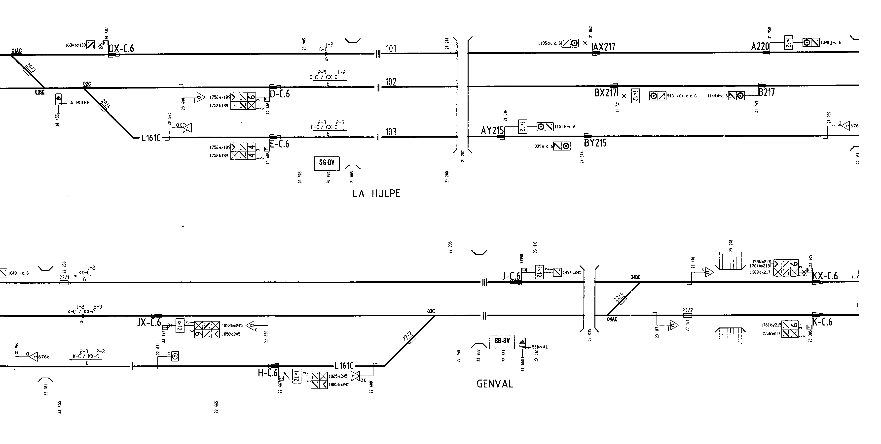

**EXTRAITS DU PSS (Plan Schématique de Signalisation).**

EXTRAITS DU PSS (suite).

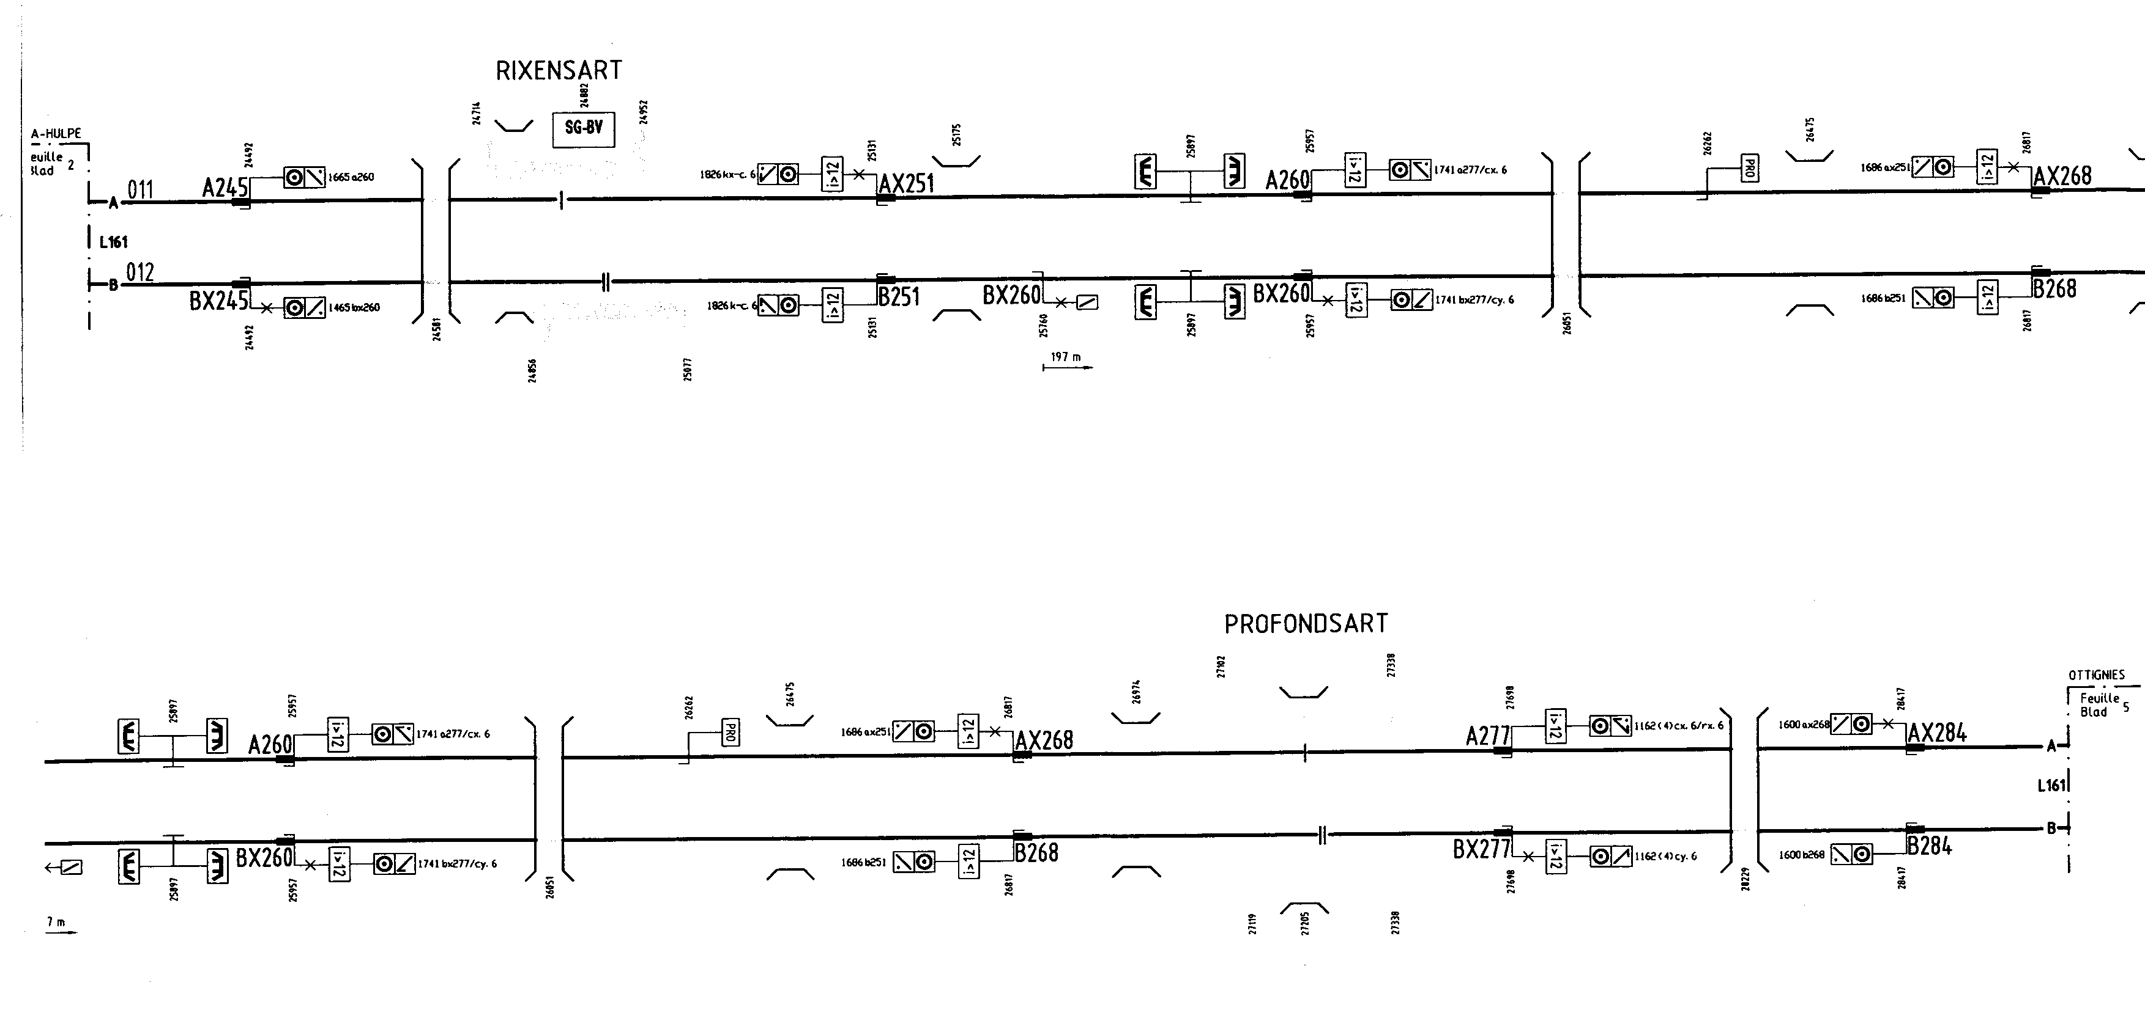EXTRAITS DU PSS (suite).

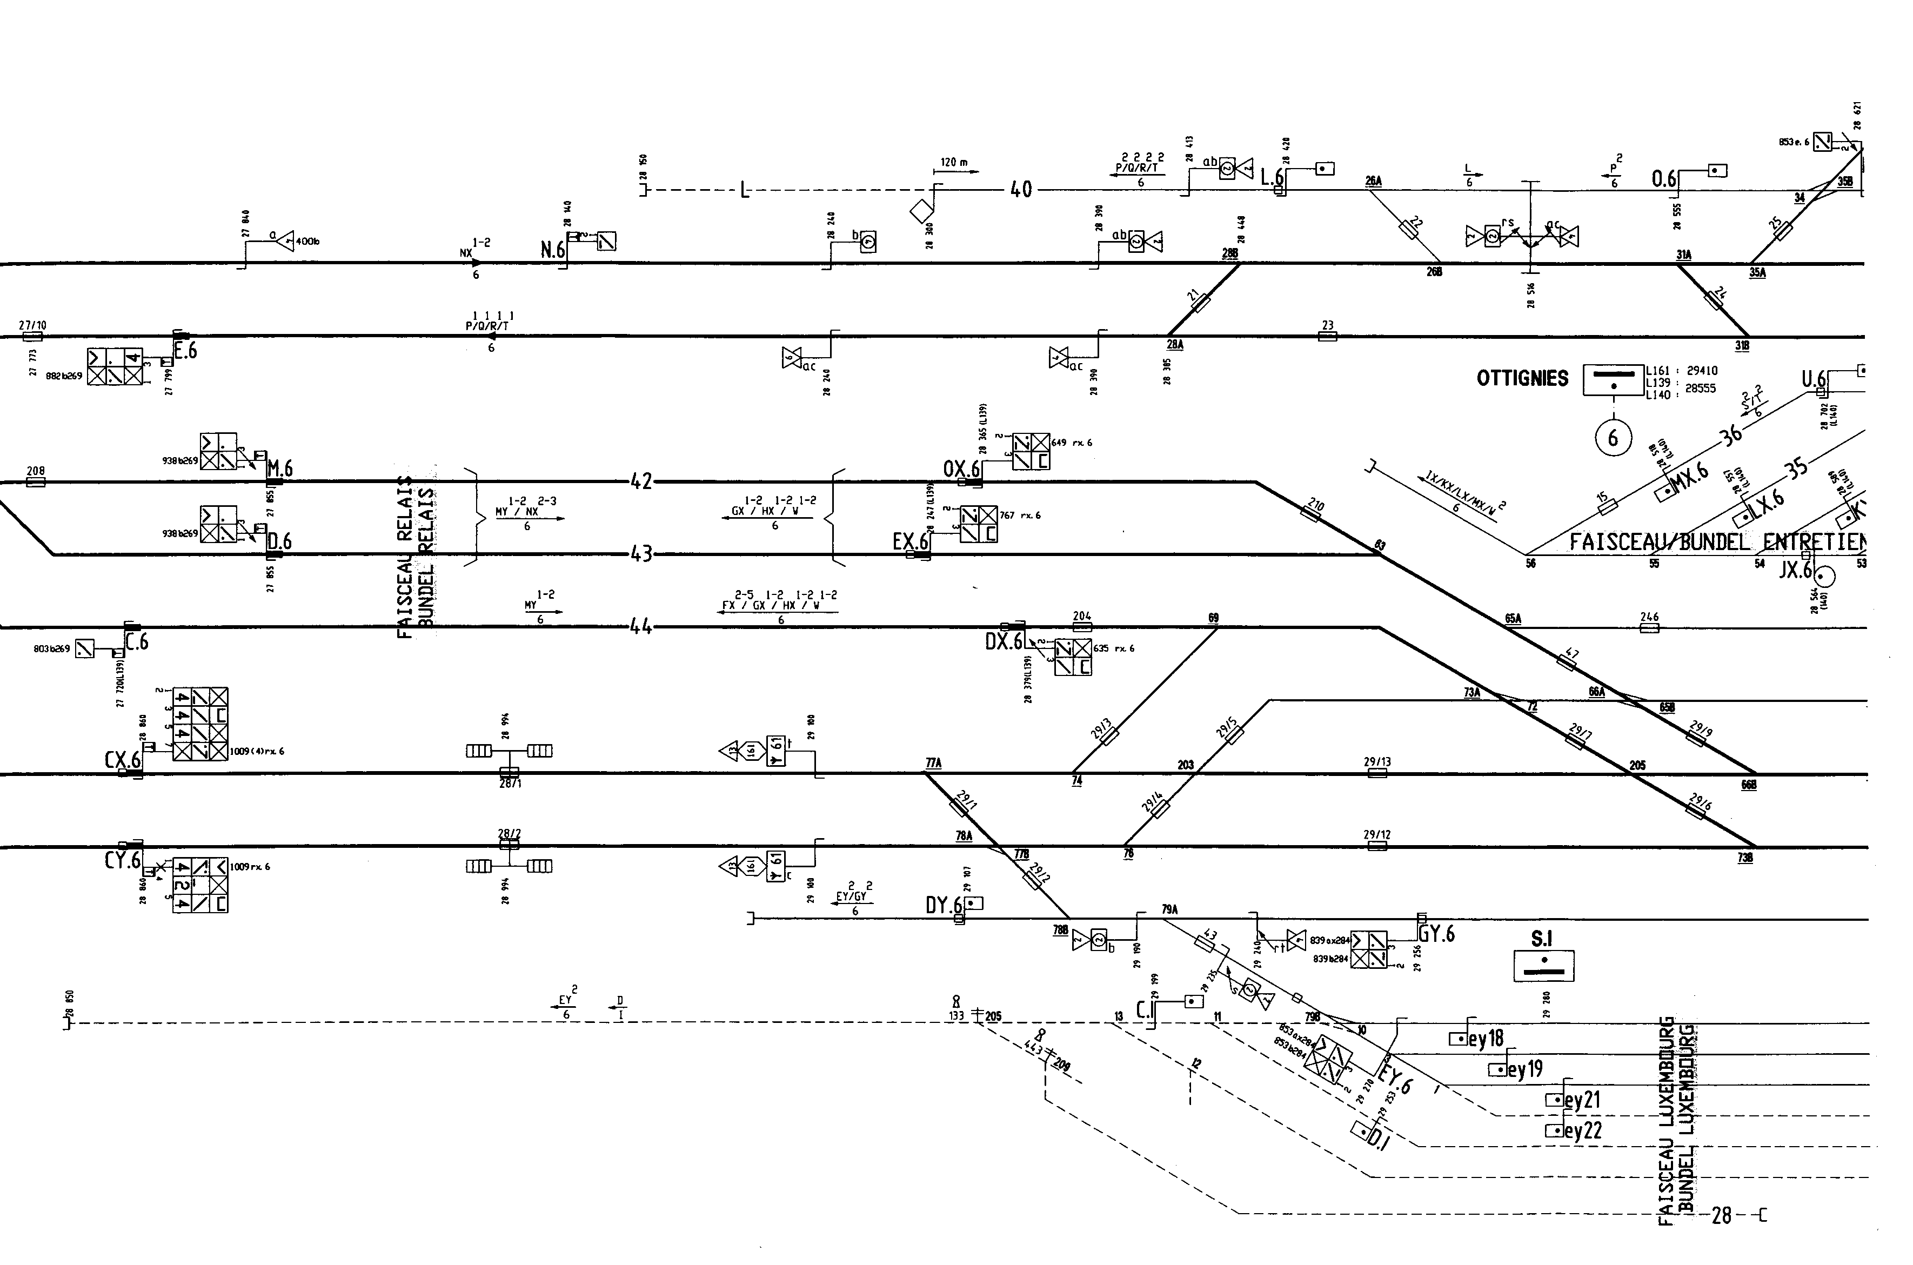EXTRAITS DU PSS (suite).

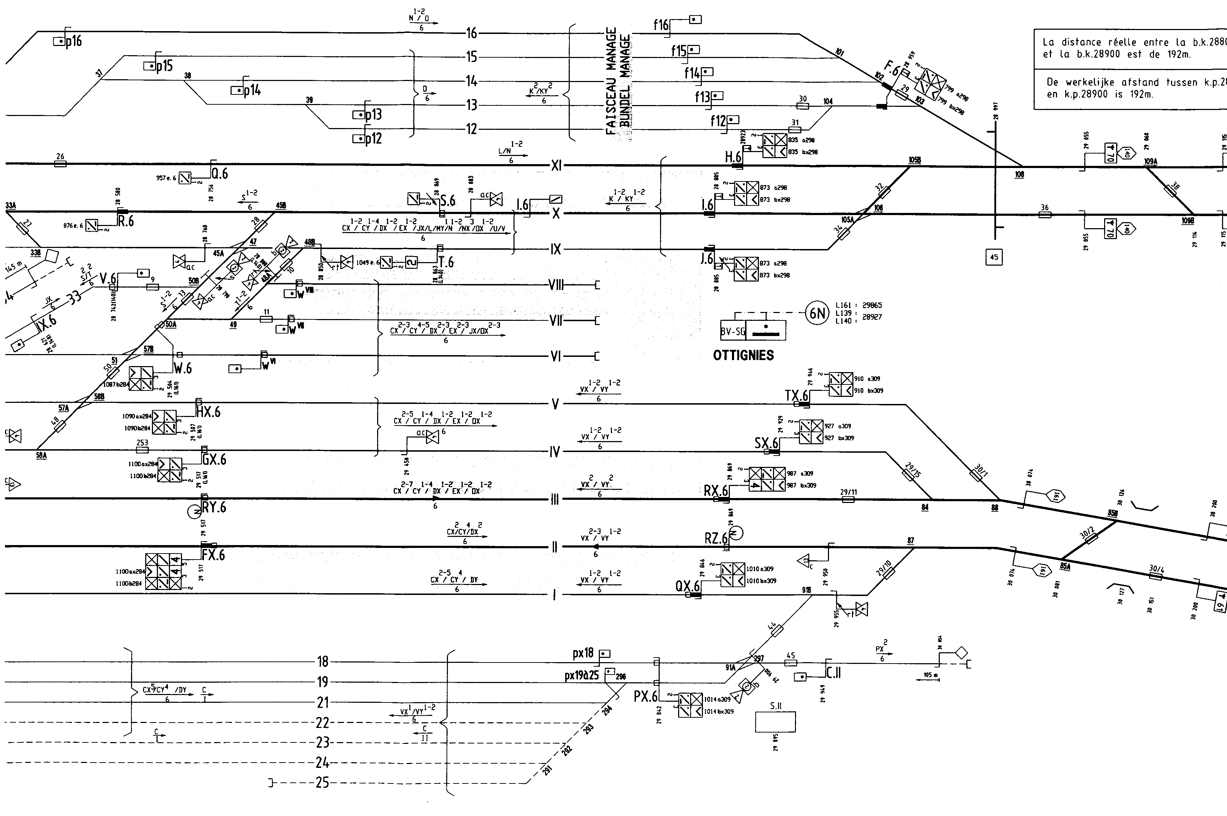EXTRAITS DU PSS (suite).

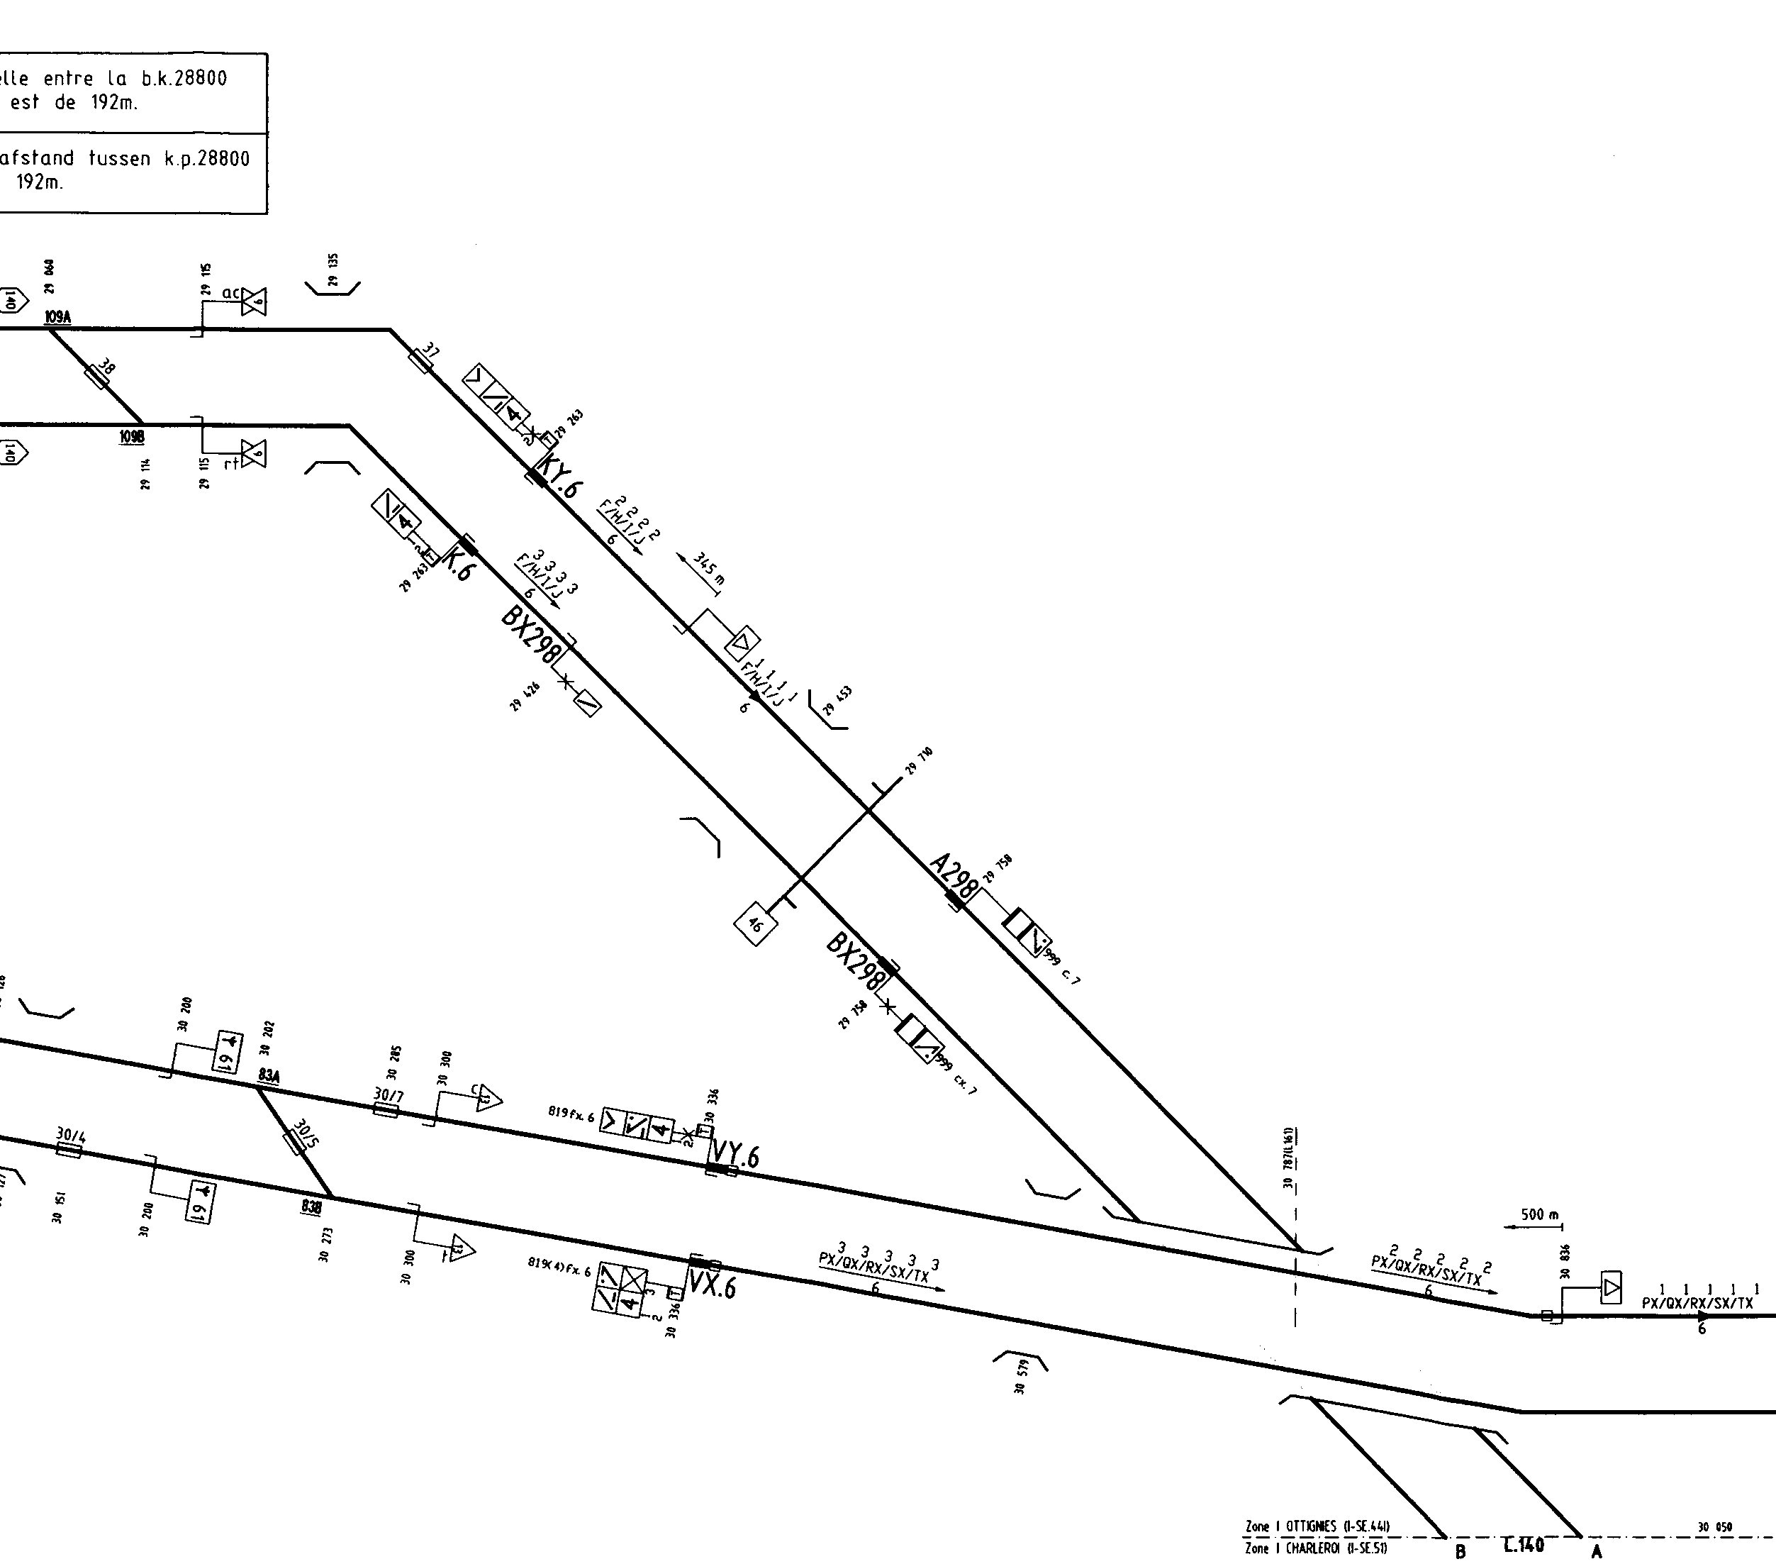EXTRAITS DU PSS (suite).

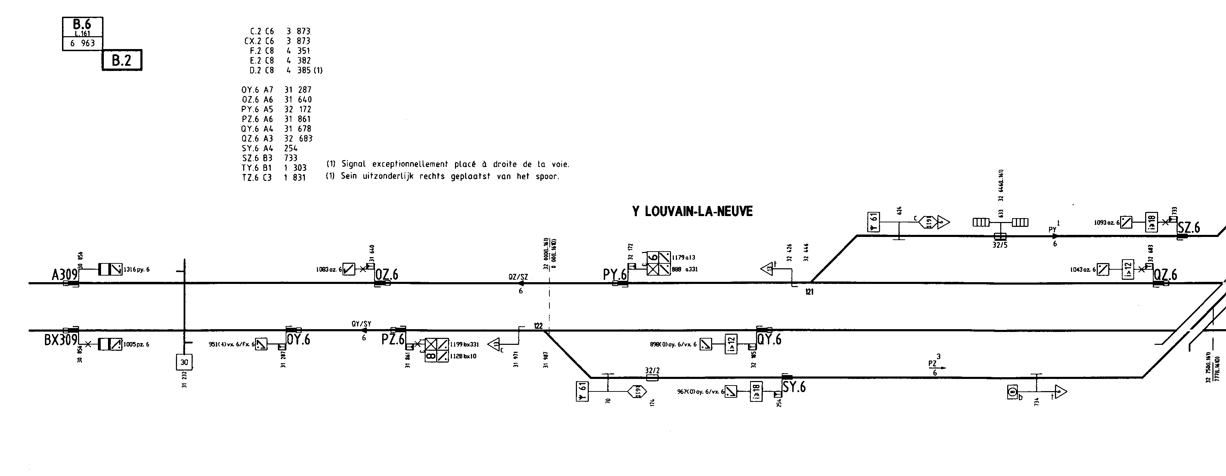

|  |
| --- |
| **INFORMATIONS, INTERVENTIONS ET MESURES PRISES POUR RETABLIR LE SERVICE.** |

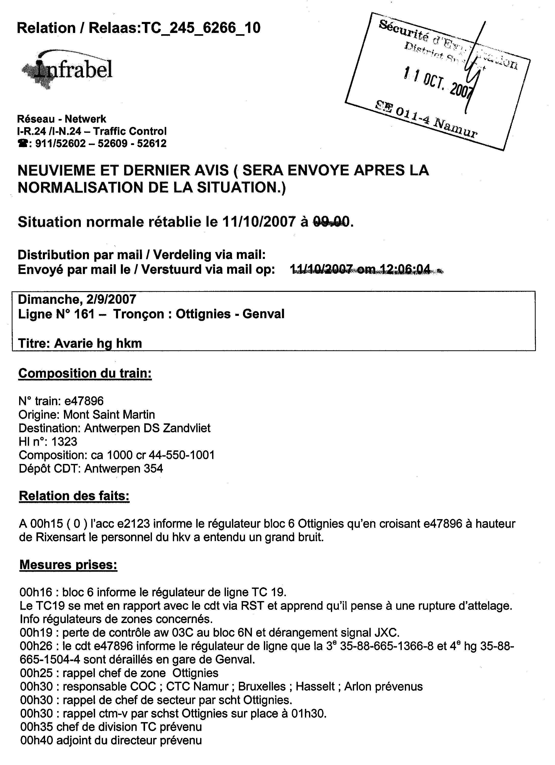

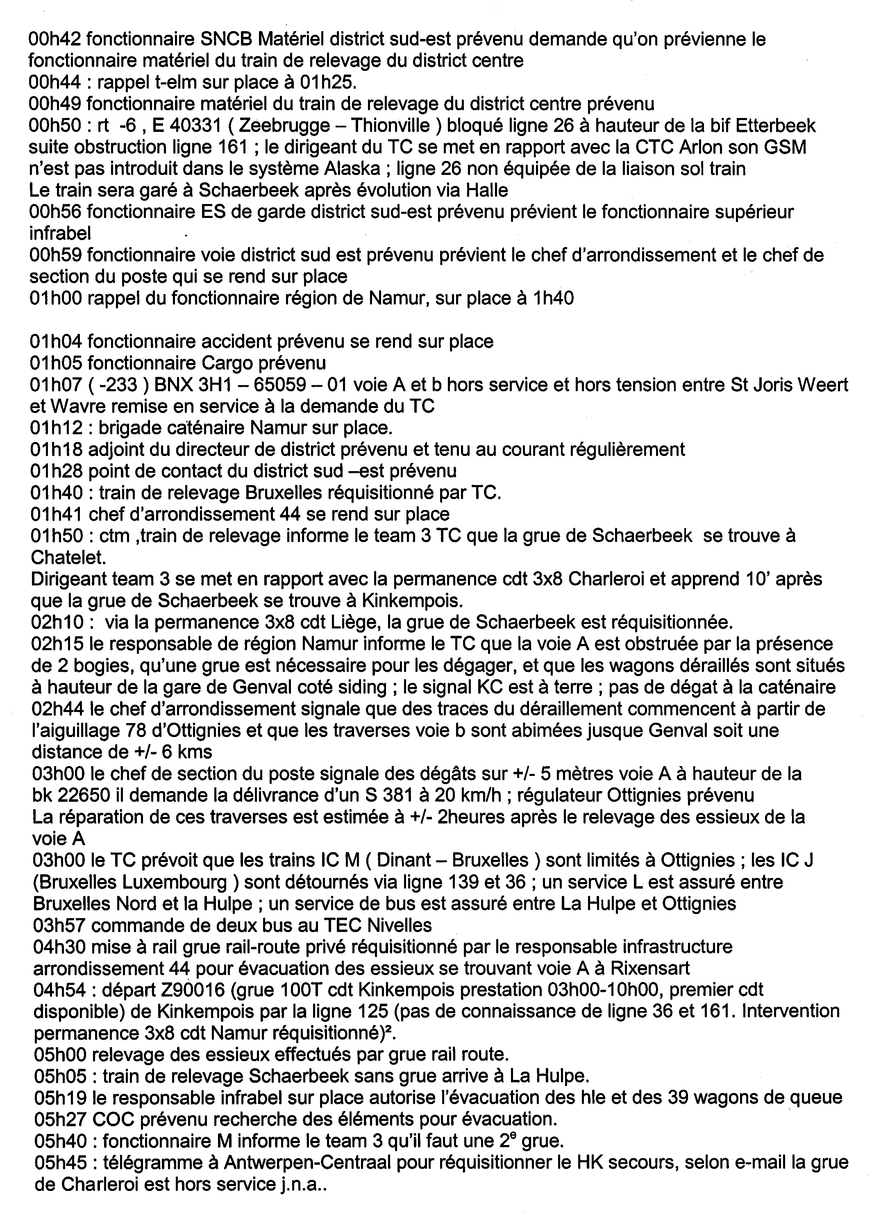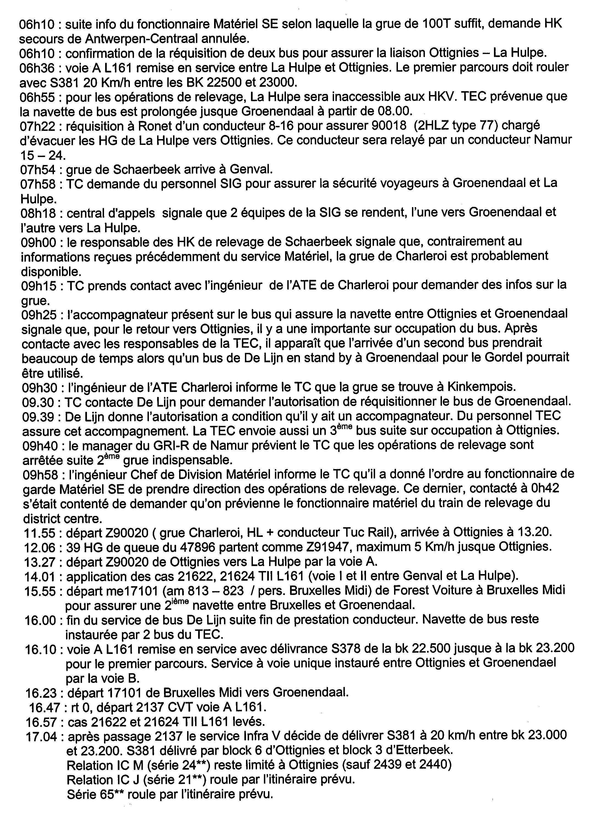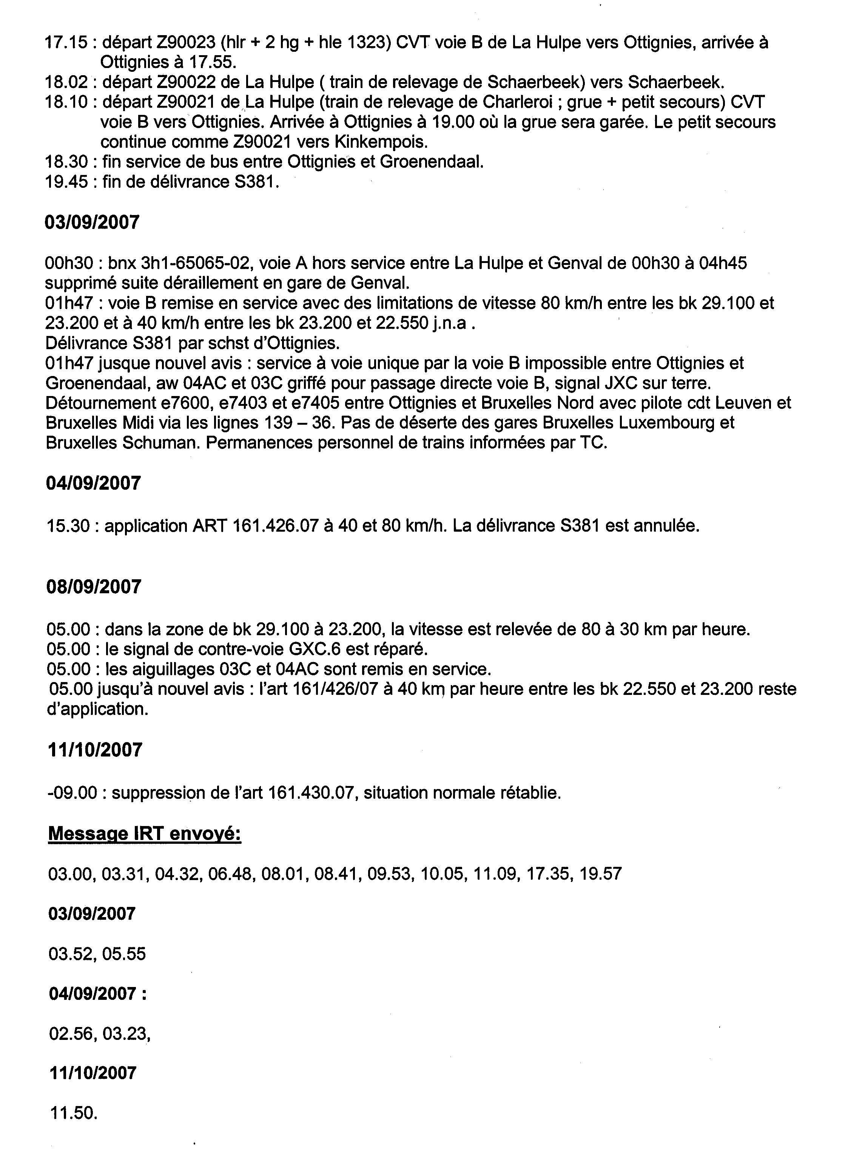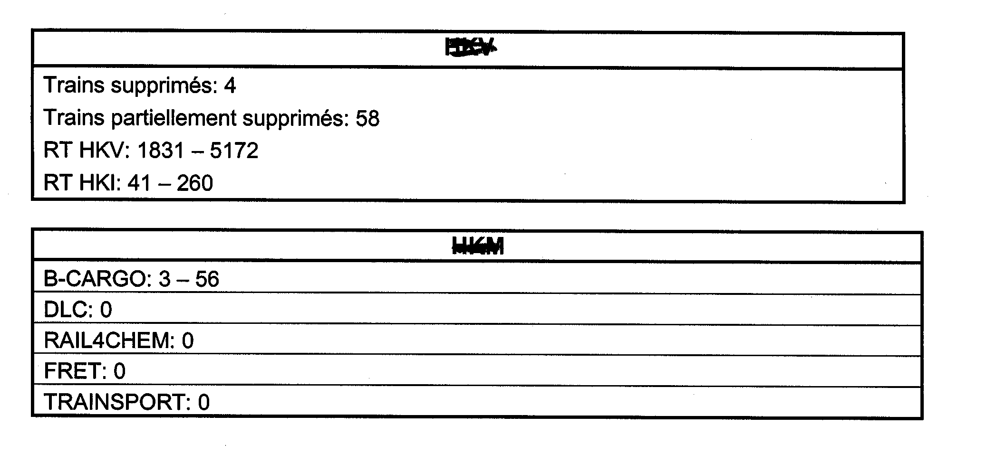Le détails des conséquences (retards de trains) n’est pas communiqué (18 pages).

**Tableau récapitulatif ci-après :**

**HORAIRES SELON ARTWEB.**

**circulation de la rame chargée :**

|  |  |  |  |  |  |  |  |  |
| --- | --- | --- | --- | --- | --- | --- | --- | --- |
| 47899 | ZANDVLIET | 31/08 18:51:33 | 6 | S |  | Départ |  |  |
| 47899 | Y.BERENDR | 31/08 19:02:49 | 10 | S |  | Passage |  |  |
| 47899 | Y.STABROEK | 31/08 19:03:24 | 10 | S |  | Passage |  |  |
| 47899 | Y.WALENHOEK | 31/08 19:16:48 | 20 | S |  | Passage |  |  |
| 47899 | ANTW-N-TOEA2 | 31/08 19:23:43 | 24 | S |  | Passage |  |  |
| 47899 | ANTW-ND-B.L9 | 31/08 19:28:55 | 25 | S |  | Passage |  |  |
| 47899 | ANTW-N-UITB3 | 31/08 19:30:23 | 25 | S |  | Passage |  |  |
| 47899 | ANTW-N-TOEA1 | 31/08 19:31:10 | 25 | S |  | Passage |  |  |
| 47899 | Y.SCHIJN | 31/08 19:31:39 | 24 | S |  | Passage |  |  |
| 47899 | NOORDERDOKK | 31/08 19:35:02 | 21 | S |  | Passage |  |  |
| 47899 | Y.HOLLAND | 31/08 19:40:32 | 21 | S |  | Passage |  |  |
| 47899 | ANTW-SCHPT-Q | 31/08 19:41:13 | 21 | S |  | Passage |  |  |
| 47899 | ANTW-SCHPT-Q | 31/08 19:42:08 | 22 | S |  | Passage |  |  |
| 47899 | Y.ANTW-SCHPT | 31/08 19:42:50 | 21 | S |  | Passage |  |  |
| 47899 | ANTW-OOST | 31/08 19:44:30 | 21 | S |  | Passage |  |  |
| 47899 | Y.O.BERCHEM | 31/08 19:45:51 | 20 | S |  | Passage |  |  |
| 47899 | ANTW-BERCHEM | 31/08 19:46:24 | 21 | S |  | Passage |  |  |
| 47899 | ANTW-BERCHEM | 31/08 19:46:33 | 21 | S |  | Passage |  |  |
| 47899 | Y.Z.GROENENH | 31/08 19:47:14 | 21 | S |  | Passage |  |  |
| 47899 | Y.KRIJGSBAAN | 31/08 19:49:08 | 20 | S |  | Passage |  |  |
| 47899 | Y.AUBRY | 31/08 19:49:59 | 19 | S |  | Passage |  |  |
| 47899 | LIER-C/G | 31/08 19:55:11 | 19 | S |  | Passage |  |  |
| 47899 | LIER | 31/08 19:55:46 | 18 | S |  | Passage |  |  |
| 47899 | LIER | 31/08 19:56:55 | 19 | S |  | Passage |  |  |
| 47899 | LIER | 31/08 20:09:51 | 32 | S |  | Passage |  |  |
| 47899 | LIER | 31/08 20:10:33 | 33 | S |  | Passage |  |  |
| 47899 | Y.NAZARETH | 31/08 20:12:44 | 33 | S |  | Passage |  |  |
| 47899 | KL'HEIDE | 31/08 20:13:44 | 33 | S |  | Passage |  |  |
| 47899 | HEIST-BERG | 31/08 20:23:57 | 32 | S |  | Passage |  |  |
| 47899 | HEIST-BERG | 31/08 20:24:01 | 33 | S |  | Passage |  |  |
| 47899 | NIEUWE Y.ND | 31/08 20:33:15 | 32 | S |  | Passage |  |  |
| 47899 | Y.N.AARSCHOT | 31/08 20:34:43 | 32 | S |  | Passage |  |  |
| 47899 | Y.Z.AARSCHOT | 31/08 20:42:16 | 38 | S |  | Passage |  |  |
| 47899 | AARSCHOT | 31/08 20:44:31 | 39 | S |  | Passage |  |  |
| 47899 | AARSCHOT | 31/08 20:45:17 | 40 | S |  | Passage |  |  |
| 47899 | Y.HOLSBEEK | 31/08 20:56:10 | 40 | S |  | Passage |  |  |
| 47899 | LEUVEN-M | 31/08 20:59:38 | 39 | S |  | Passage |  |  |
| 47899 | LEUVEN-M | 31/08 20:59:40 | 39 | S |  | Passage |  |  |
| 47899 | LEUVEN | 31/08 21:01:11 | 39 | S |  | Passage |  |  |
| 47899 | LEUVEN | 31/08 21:01:17 | 39 | S |  | Passage |  |  |
| 47899 | LEUVEN-P | 31/08 21:02:07 | 37 | S |  | Passage |  |  |
| 47899 | LEUVEN-P | 31/08 21:02:43 | 37 | S |  | Passage |  |  |
| 47899 | Y.PARKBRUG | 31/08 21:04:16 | 34 | S |  | Passage |  |  |
| 47899 | HEVERLEE-K/L | 31/08 21:05:38 | 34 | S |  | Passage |  |  |
| 47899 | ST-JOR-WEERT | 31/08 21:12:43 | 34 | S |  | Passage |  |  |
| 47899 | ST-JOR-WEERT | 31/08 21:12:47 | 34 | S |  | Passage |  |  |
| 47899 | WAVRE | 31/08 21:21:58 | 34 | S |  | Passage |  |  |
| 47899 | WAVRE | 31/08 21:25:02 | 38 | S |  | Passage |  |  |
| 47899 | OTTIGNIES | 31/08 21:33:15 | 37 | S |  | Passage |  |  |
| 47899 | COURT-ST-ET | 31/08 21:36:35 | 35 | S |  | Passage |  |  |
| 47899 | LA ROCHE | 31/08 21:40:42 | 34 | S |  | Passage |  |  |
| 47899 | TILLY | 31/08 21:46:25 | 33 | S |  | Passage |  |  |
| 47899 | TILLY-GARAGE | 31/08 21:47:36 | 32 | S |  | Passage |  |  |
| 47899 | TILLY-GARAGE | 31/08 21:47:42 | 32 | S |  | Passage |  |  |
| 47899 | TILLY-GARAGE | 31/08 21:47:55 | 32 | S |  | Passage |  |  |
| 47899 | FLEURUS | 31/08 21:53:03 | 30 | S |  | Passage |  |  |
| 47899 | FLEURUS | 31/08 21:53:12 | 30 | S |  | Passage |  |  |
| 47899 | JEMEPPE-S-S | 31/08 22:02:00 | 30 | S |  | Passage |  |  |
| 47899 | Y.MOUSTIER | 31/08 22:03:17 | 30 | S |  | Passage |  |  |
| 47899 | MOUSTIER | 31/08 22:04:34 | 30 | S |  | Passage |  |  |
| 47899 | FLOREFFE | 31/08 22:09:41 | 28 | S |  | Passage |  |  |
| 9 | FLOREFFE | 31/08 22:09:55 | 28 | S |  | Passage |  |  |
| 47899 | AUVELAIS | 31/08 22:14:39 | 28 | - | ??? | Passage |  |  |
| 47899 | Y.FLAWINNE | 31/08 22:16:22 | 31 | S |  | Passage |  |  |
| 47899 | RONET-FORM | 31/08 22:19:00 | 31 | S |  | Arrivée |  |  |
| 47899 | RONET-FORM | 31/08 22:23:00 | 31 | S |  | Départ |  |  |
| 47899 | RONET | 31/08 22:24:01 | 31 | S |  | Passage |  |  |
| 47899 | Y.RONET | 31/08 22:26:38 | 30 | S |  | Passage |  |  |
| 47899 | NAMUR | 31/08 22:29:18 | 30 | S |  | Passage |  |  |
| 47899 | NAMUR | 31/08 22:29:31 | 30 | S |  | Passage |  |  |
| 47899 | JAMBES | 31/08 22:32:31 | 31 | S |  | Passage |  |  |
| 47899 | JAMBES | 31/08 22:32:39 | 31 | S |  | Passage |  |  |
| 47899 | LUSTIN | 31/08 22:40:33 | 30 | S |  | Passage |  |  |
| 47899 | YVOIR | 31/08 22:46:49 | 30 | S |  | Passage |  |  |
| 47899 | YVOIR | 31/08 22:46:56 | 30 | S |  | Passage |  |  |
| 47899 | DINANT | 31/08 22:54:35 | 32 | S |  | Passage |  |  |
| 47899 | DINANT | 31/08 22:54:38 | 32 | S |  | Passage |  |  |
| 47899 | ANSEREMME | 31/08 22:57:58 | 29 | S |  | Passage |  |  |
| 47899 | GENDRON-CELL | 31/08 23:04:18 | 30 | S |  | Passage |  |  |
| 47899 | GENDRON-CELL | 31/08 23:04:23 | 30 | S |  | Passage |  |  |
| 47899 | HOUYET | 31/08 23:08:04 | 28 | S |  | Passage |  |  |
| 47899 | HOUYET | 31/08 23:08:15 | 28 | S |  | Passage |  |  |
| 47899 | BEAURAING | 31/08 23:17:06 | 30 | S |  | Passage |  |  |
| 47899 | BEAURAING | 31/08 23:17:16 | 30 | S |  | Passage |  |  |
| 47899 | VONECHE | 31/08 23:27:47 | 30 | S |  | Passage |  |  |
| 47899 | GEDINNE | 31/08 23:33:52 | 29 | S |  | Passage |  |  |
| 47899 | GEDINNE | 31/08 23:33:57 | 29 | S |  | Passage |  |  |
| 47899 | PALISEUL | 31/08 23:45:19 | 31 | S |  | Passage |  |  |
| 47899 | R.JEHONVILLE | 31/08 23:51:49 | 31 | S |  | Passage |  |  |
| 47899 | BERTRIX | 31/08 23:56:02 | 33 | S |  | Arrivée |  |  |
| 47899 | BERTRIX | 31/08 23:58:33 | 29 | S |  | Départ |  |  |
| 47899 | BERTRIX | 31/08 23:59:43 | 36 | S |  | Arrivée |  |  |
| 47899 | FLORENVILLE | 01/09 00:15:20 | 30 | S |  | Passage |  |  |
| 47899 | FLORENVILLE | 01/09 00:16:01 | 31 | S |  | Passage |  |  |
| 47899 | ST-VINCENT-B | 01/09 00:23:27 | 29 | S |  | Passage |  |  |
| 47899 | VIRTON | 01/09 00:35:25 | 31 | S |  | Passage |  |  |
| 47899 | VIRTON | 01/09 00:35:55 | 31 | S |  | Passage |  |  |
| 47899 | HALANZY | 01/09 00:49:17 | 33 | S |  | Passage |  |  |
| 47899 | Y.AUBANGE | 01/09 00:54:55 | 33 | S |  | Passage |  |  |
| 47899 | AUBANGE-E | 01/09 00:56:36 | 34 | S |  | Passage |  |  |

**circulation de la rame retour à vide :**

Haut du formulaire

|  |  |  |  |  |  |  |  |  |
| --- | --- | --- | --- | --- | --- | --- | --- | --- |
| 47896 | AUBANGE-FR-F | 01/09 19:59:40 | -17 | S |  | Passage | F-U.23-2 | F-U.23-1 |
| 47896 | AUBANGE-E | 01/09 20:00:53 | -17 | S |  | Passage | E-U.23 | AW03U |
| 47896 | AUBANGE-E | 01/09 20:01:28 | -16 | S |  | Passage | D-U.23 | CX-U.23 |
| 47896 | Y.AUBANGE | 01/09 20:02:35 | -16 | S |  | Passage | CX-U.23 | TT23 |
| 47896 | AUBANGE-ZG | 01/09 20:04:18 | -17 | S |  | Passage | TT23 | LXT23 |
| 47896 | HALANZY | 01/09 20:06:16 | -17 | S |  | Passage | KT23 | CXT23 |
| 47896 | VIRTON | 01/09 20:17:47 | -20 | S |  | Passage | ES23 | CXS23 |
| 47896 | VIRTON | 01/09 20:18:01 | -19 | S |  | Passage | KS23 | HXS23 |
| 47896 | ST-VINCENT-B | 01/09 20:29:30 | -21 | S |  | Passage | TR23 | LXR23 |
| 47896 | FLORENVILLE | 01/09 20:36:08 | -23 | S |  | Passage | KR23 | HXR23 |
| 47896 | FLORENVILLE | 01/09 20:36:31 | -23 | S |  | Passage | ER23 | CXR23 |
| 47896 | BERTRIX | 01/09 20:50:31 | -25 | S |  | Arrivée | KQ23 | MXQ23 |
| 47896 | BERTRIX | 01/09 20:52:14 | -23 | S |  | Arrivée | MXQ23 | EQ23 |
| 47896 | BERTRIX | 01/09 20:54:59 | -25 | S |  | Départ | EQ23 | DXQ23 |
| 47896 | R.JEHONVILLE | 01/09 20:59:37 | -23 | S |  | Passage | UQ23 | BX698 |
| 47896 | R.JEHONVILLE | 01/09 20:59:46 | -23 | S |  | Passage | TQ23 | SXQ23 |
| 47896 | PALISEUL | 01/09 21:06:03 | -23 | S |  | Passage | TO23 | LXO23 |
| 47896 | GEDINNE | 01/09 21:15:40 | -26 | S |  | Passage | EO23 | CXO23 |
| 47896 | GEDINNE | 01/09 21:15:45 | -26 | S |  | Passage | KO23 | HXO23 |
| 47896 | VONECHE | 01/09 21:21:02 | -27 | S |  | Passage | TN23 | LXN23 |
| 47896 | BEAURAING | 01/09 21:29:51 | -31 | S |  | Passage | KN23 | HXN23 |
| 47896 | BEAURAING | 01/09 21:29:55 | -31 | S |  | Passage | EN23 | CXN23 |
| 47896 | HOUYET | 01/09 21:37:52 | -32 | S |  | Passage | VM23 | LXM23 |
| 47896 | HOUYET | 01/09 21:37:57 | -32 | S |  | Passage | MM23 | AW11 |
| 47896 | HOUYET | 01/09 21:38:02 | -31 | S |  | Passage | TM23 | PXM23 |
| 47896 | GENDRON-CELL | 01/09 21:42:03 | -33 | S |  | Passage | EM23 | CXM23 |
| 47896 | GENDRON-CELL | 01/09 21:42:17 | -33 | S |  | Passage | KM23 | HXM23 |
| 47896 | ANSEREMME | 01/09 21:48:50 | -33 | S |  | Passage | T7 | SX7 |
| 47896 | DINANT | 01/09 21:51:33 | -35 | S |  | Passage | M7 | KX7 |
| 47896 | DINANT | 01/09 21:51:57 | -35 | S |  | Passage | E7 | CX7 |
| 47896 | YVOIR | 01/09 21:57:30 | -35 | S |  | Passage | K5 | HX5 |
| 47896 | YVOIR | 01/09 21:57:40 | -35 | S |  | Passage | E5 | CX5 |
| 47896 | LUSTIN | 01/09 22:02:27 | -37 | S |  | Passage | K4 | CX4 |
| 47896 | JAMBES | 01/09 22:09:50 | -40 | S |  | Passage | K2 | HX2 |
| 47896 | JAMBES | 01/09 22:09:53 | -40 | S |  | Passage | E2 | CX2 |
| 47896 | NAMUR HERB | 01/09 22:14:47 | -38 | s |  | Passage | R-H.30 | CX1-H.30 |
| 47896 | NAMUR | 01/09 22:15:28 | -37 | S |  | Passage | CX1-H.30 | K1-G.30 |
| 47896 | NAMUR | 01/09 22:16:06 | -36 | S |  | Passage | K1-G.30 | FXG.30 |
| 47896 | Y.RONET | 01/09 22:18:58 | -37 | S |  | Passage | HX-G30 | EXG30 |
| 47896 | RONET-FORM | 01/09 22:21:00 | -38 | S |  | Arrivée |  |  |
| 47896 | RONET-FORM | 01/09 23:14:00 | 1 | S |  | Départ |  |  |
| 47896 | Y.FLAWINNE | 01/09 23:16:26 | 0 | S |  | Passage | PF900.2 | QO30 |
| 47896 | FLOREFFE | 01/09 23:21:30 | 0 | S |  | Passage | NX-O30 | M-O30 |
| 47896 | FLOREFFE | 01/09 23:21:46 | 0 | S |  | Passage | JX-O30 | G-O30 |
| 47896 | FRANIERE-GAR | 01/09 23:28:47 | 5 | S |  | Passage | FX-030 | EX-O30 |
| 47896 | FRANIERE-GAR | 01/09 23:28:49 | 5 | S |  | Passage | D-O30 | CX-O30 |
| 47896 | MOUSTIER | 01/09 23:32:47 | 5 | S |  | Passage | C36 | EX36 |
| 47896 | Y.MOUSTIER | 01/09 23:38:43 | 10 | S |  | Passage | H36 | KY36 |
| 47896 | GEMBLOUX | 01/09 23:56:56 | 11 | S |  | Passage | L24 | GX24 |
| 47896 | GEMBLOUX | 01/09 23:57:32 | 12 | S |  | Passage | F24 | CX24 |
| 47896 | MONT-ST-GUIB | 02/09 00:05:34 | 12 | S |  | Passage | KE6 | GXE6 |
| 47896 | MONT-ST-GUIB | 02/09 00:05:50 | 12 | S |  | Passage | DE6 | CXE6 |
| 47896 | OTTIGNIES | 02/09 00:13:00 | 15 | S |  | Passage |  |  |
| 47896 | GENVAL | 02/09 00:19:27 | 15 | S |  | Passage | KC6 | JXC6 |
| 47896 | LA HULPE | 02/09 12:33:47 | 748 | S |  | Passage | B217-4 | B217-3 |

Bas du formulaire

Bas du formulaire

**CIRCULATION DU E 2123 (TRAIN CROISEUR).**

|  |  |  |  |  |  |  |  |
| --- | --- | --- | --- | --- | --- | --- | --- |
| 2123 | BRUXELL-MIDI | 01/09 23:36:08 | 0 | S | Départ | G10 | C4 |
| 2123 | BRUX-M-JNM | 01/09 23:37:31 | 0 | S | Passage | GZ4 | EX3 |
| 2123 | BRUXELL-CHAP | 01/09 23:38:16 | 0 | S | Passage | A309.1 | A309.2 |
| 2123 | BRUX-CENTRAL | 01/09 23:39:18 | 0 | S | Arrivée | C3C8.1 | C3C8.2 |
| 2123 | BRUX-CENTRAL | 01/09 23:40:11 | 0 | S | Départ | A318.1 | A318.2 |
| 2123 | BRUX-CONGRES | 01/09 23:41:37 | 0 | S | Passage | A323.1 | A323.2 |
| 2123 | BRUXELLES-ND | 01/09 23:43:19 | 0 | S | Arrivée | G7D8 | H7E8 |
| 2123 | BRUXELLES-ND | 01/09 23:43:37 | 0 | S | Arrivée | E3D8 | G7D8 |
| 2123 | BRUXELLES-ND | 01/09 23:45:14 | 0 | S | Départ | H7E8 | J7E8 |
| 2123 | BRUXELL-ND-F | 01/09 23:46:31 | 0 | S | Passage | K7F8 | RXF8 |
| 2123 | Y.JOSAPHAT | 01/09 23:48:02 | 0 | S | Passage | N-J.8 | QX-J8 |
| 2123 | BRUX-SCHUMAN | 01/09 23:50:43 | 0 | S | Arrivée | A56 | AY56 |
| 2123 | BRUX-SCHUMAN | 01/09 23:52:43 | 0 | S | Départ | J1.3 | O1.3 |
| 2123 | BRUXELL-LUX | 01/09 23:54:09 | 0 | S | Arrivée | O1.3 | O2.3 |
| 2123 | BRUXELL-LUX | 01/09 23:55:02 | 0 | S | Départ | O2.3 | GY2.3 |
| 2123 | ETTERBEEK | 01/09 23:58:13 | 0 | S | Arrivée | E3.3 | KY3.3 |
| 2123 | ETTERBEEK | 01/09 23:59:12 | 0 | S | Départ | L8.3 | DY8.3 |
| 2123 | WATERMAEL | 02/09 00:00:35 | 0 | S | Passage | L9 | DY9 |
| 2123 | GROENENDAAL | 02/09 00:05:34 | 0 | S | Passage | J12 | JY12.4 |
| 2123 | GROENENDAAL | 02/09 00:05:35 | 0 | S | Passage | C11 | CY11 |
| 2123 | GROENENDAAL | 02/09 00:05:46 | 0 | S | Passage | M13 | MY13 |
| 2123 | LA HULPE | 02/09 00:08:39 | 0 | S | Arrivée | CC6 | DXC6 |
| 2123 | LA HULPE | 02/09 00:09:46 | 0 | S | Départ | A220-5 | A220-6 |
| 2123 | GENVAL | 02/09 00:12:44 | 0 | S | Départ | JC6 | KXC6 |
| 2123 | OTTIGNIES | 02/09 00:22:00 | 0 | S | Arrivée |  |  |
| 2123 | OTTIGNIES | 02/09 00:23:00 | 2 | S | Départ |  |  |
| 2123 | MONT-ST-GUIB | 02/09 00:28:36 | 2 | S | Passage | CE6 | DXE6 |
| 2123 | MONT-ST-GUIB | 02/09 00:28:40 | 3 | S | Passage | GE6 | KXE6 |
| 2123 | GEMBLOUX | 02/09 00:34:39 | 3 | S | Arrivée | C24 | FX24 |
| 2123 | GEMBLOUX | 02/09 00:35:36 | 3 | S | Départ | GY24 | KX24 |
| 2123 | RHISNES | 02/09 00:41:38 | 2 | S | Passage | U-G.30 | QX-G.30 |
| 2123 | RHISNES | 02/09 00:41:38 | 0 | S | Passage | O-G.30 | NX-G.30 |
| 2123 | NAMUR | 02/09 00:46:18 | 0 | S | Arrivée | CG30 | K10G30 |

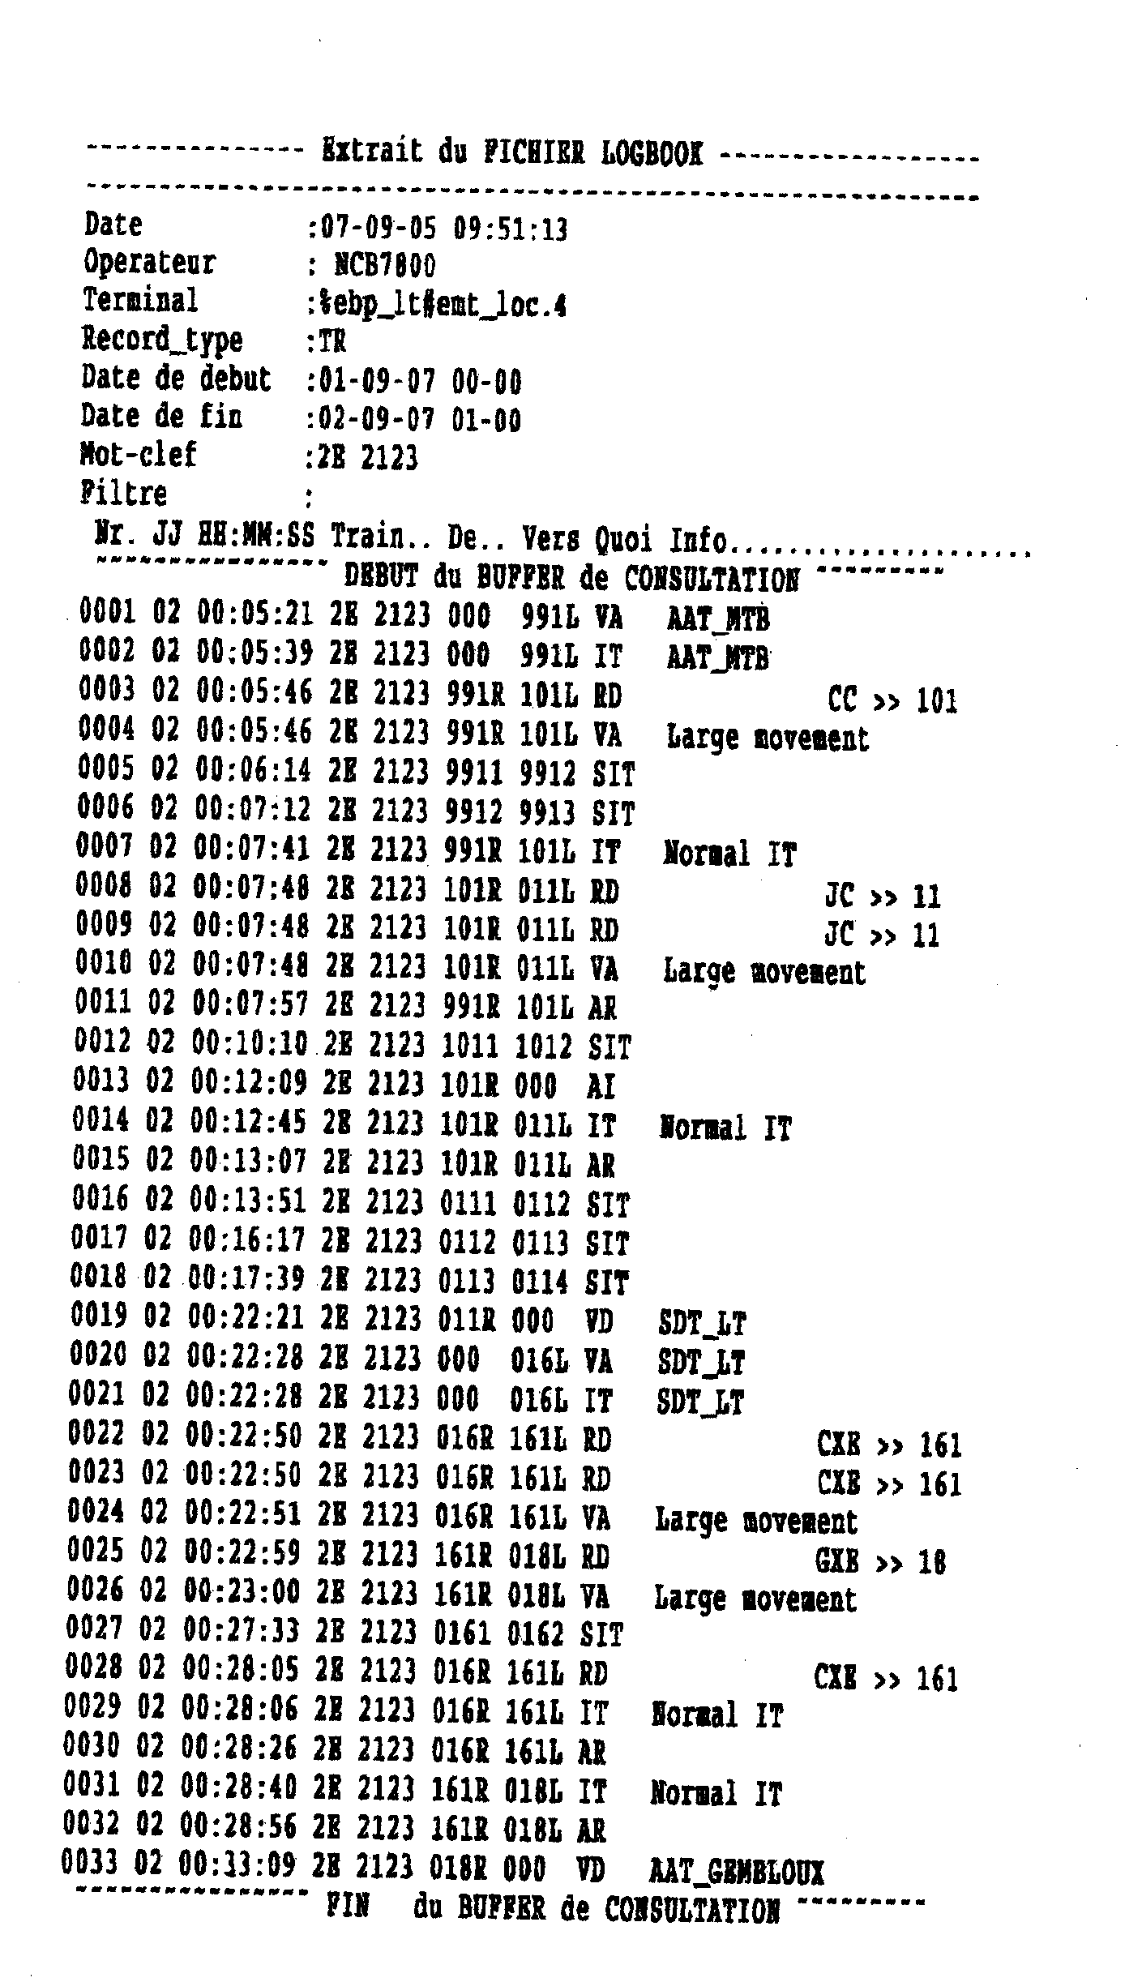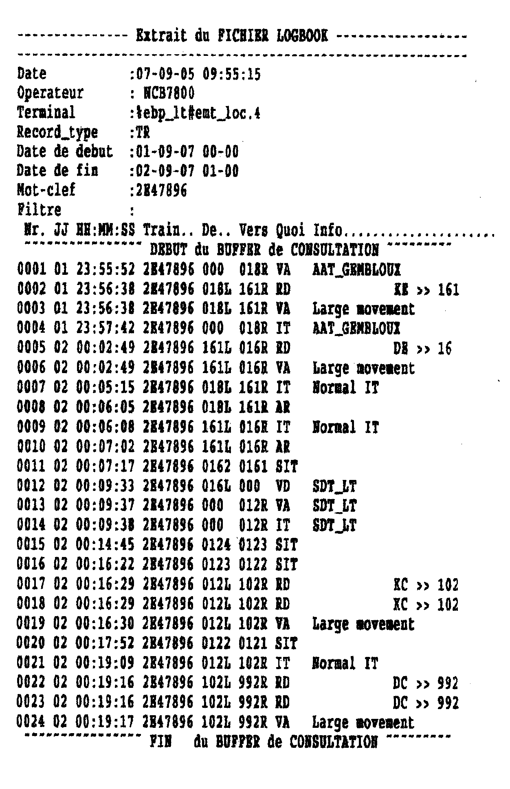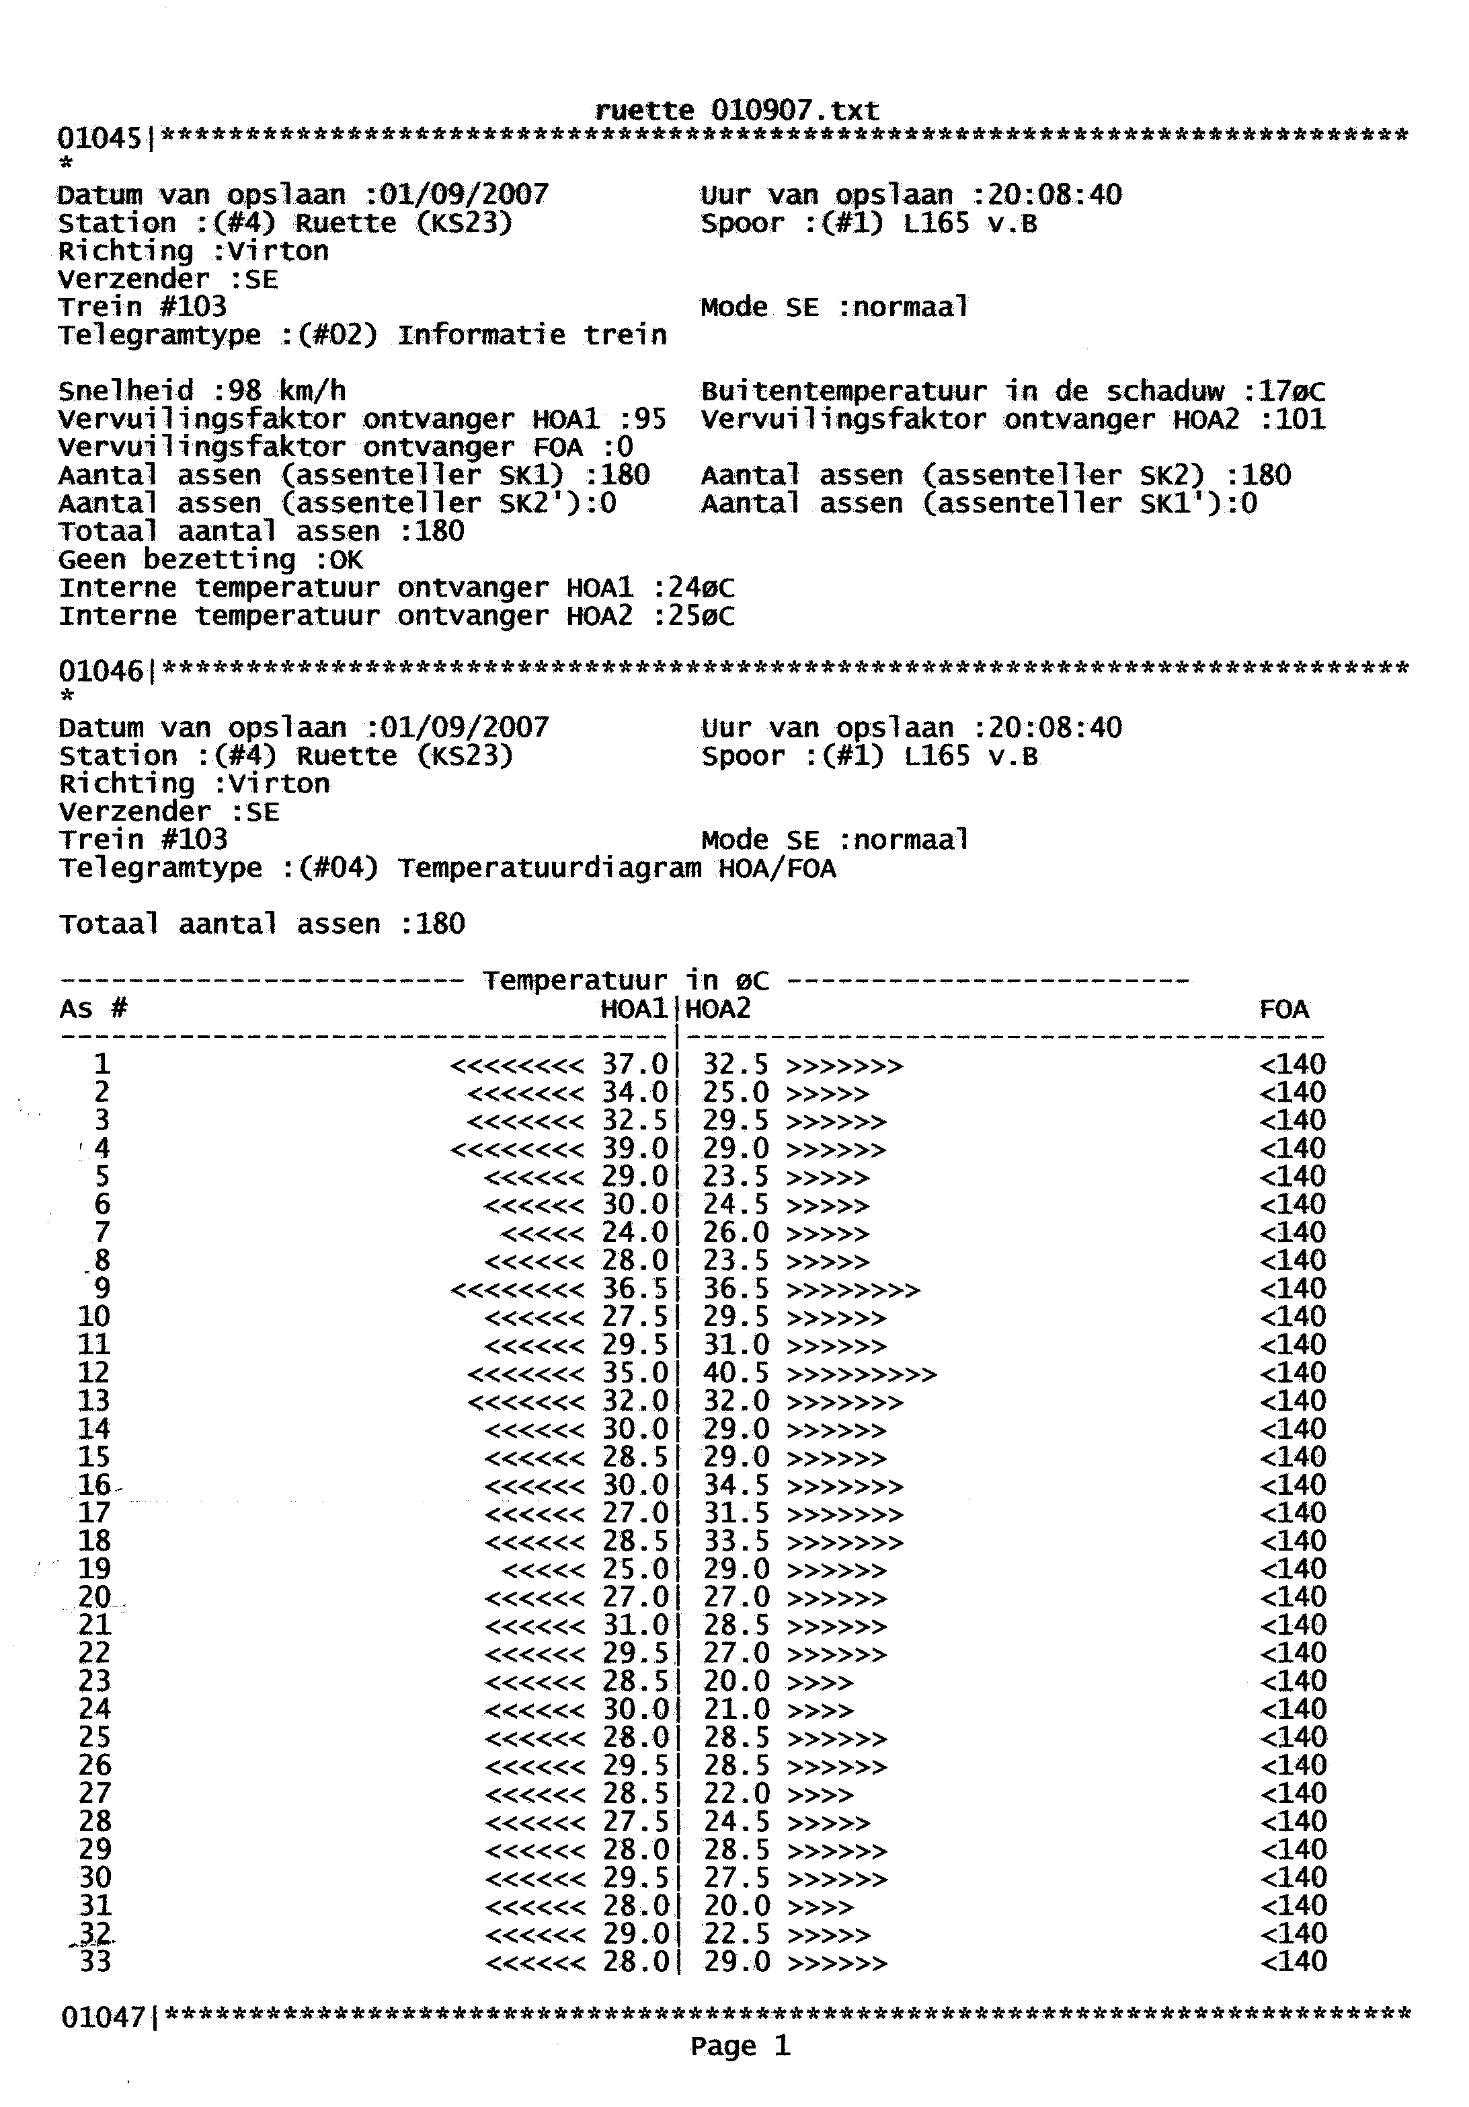

**EXTRAITS DU LOGBOOK – EBP OTTIGNIES.**

**4e wagon**

**hle**

**47896 détecteur de Ruette entre Athus et Virton.**

**ENREGISTREMENTS DETECTEURS DE BOITES CHAUDES.**

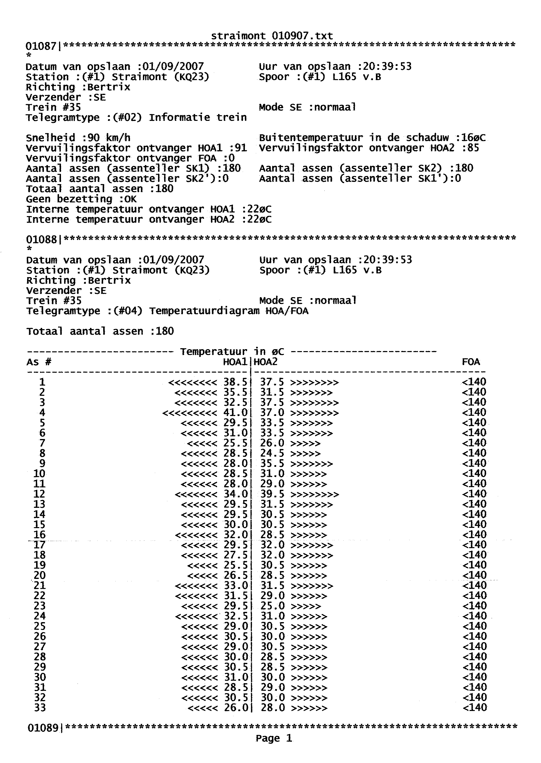

**hle**

**4e wagon**

**47896 détecteur de Straimont entre Virton et Bertrix**

