**HU-6051**

**2019-0928-5 Vámosgyörk (Railway accident / Derailment)**

### Overview of the accident

On 23 August 2019, the freight train № 77559-2, comprising 33 empty 4-axle freight wagons was on its way from Békéscsaba to Felsőzsolca. When approaching Vámosgyörk station, the last but one wagon of the train derailed with two axles on the turnout № 14, after which the train came apart and stopped. The reason of derailment was that the wheel rim wedge slipped off the fourth wheel on the left, which made the wheel pair unguided.

The cause of loosening of the rim wedge was not clearly identified, but it was probably influenced by the fact that the thickness of the wheel rim was close to the relevant lower limit.

Wear-out of the wheel rim may lead to loosening of the rim wedge rarely, but it may be identified by following the relevant inspection methods therefore the IC does not find it necessary to issue a safety recommendation.

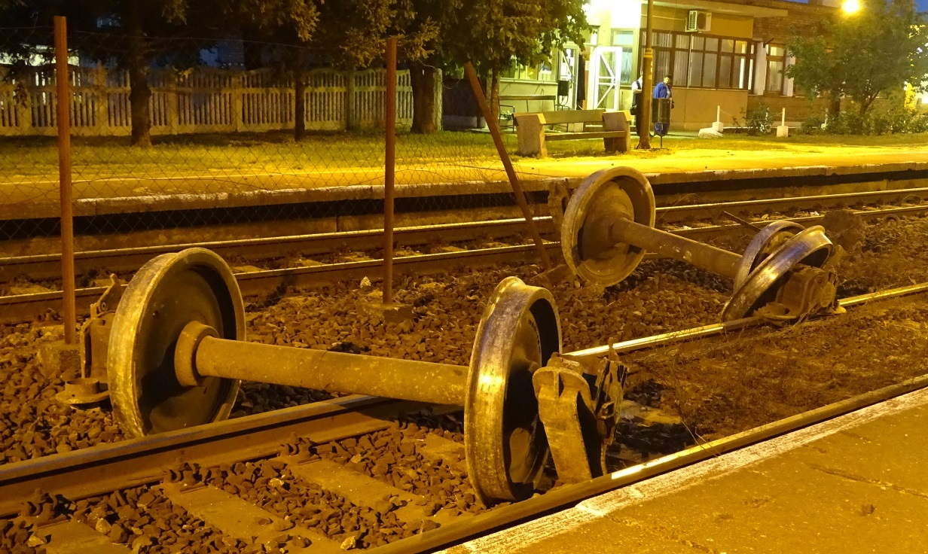

# CONCLUSIONS

## Direct causes

The factors which had direct effect on the occurrence were as follows:

1. the rim wedge got loose and slipped off the fourth wheel at the 8th axle journal on the left hand side, as a result of which the wheel pair became unguided and derailed,
2. the loosening of the rim wedge was part of a longer-lasting process, i.e. the wagon had covered a longer distance with loose rim wedge, but the defect (loosening) remained undetected during wagon inspection because of lack of match marks.

## Indirect causes

Those findings relating to competences, procedures and maintenance which are related to the factors enumerated above:

1. the wheel rim thickness was close to the relevant lower limit,
2. the radial pressure between the wheel and the rim wedge disappeared or became so low that the rim wedge got loose.

## Root causes

The IC makes no such statement.

## Other risk factors

A factor which is not related to the occurrence but increases risk is that unrealistic braking effect was found in a freight train which had contained the wagon concerned earlier.