**HU-6165**

**2019-1245-5 Nyírbátor (Railway accident / Derailment)**

### Overview of the accident

On 11 November 2019, at 09:25 am, a freight train was approaching Nyírbátor station, on a locked route, with signal handling, in a turnout direction, when the leading bogie of its 29th wagon went to diverging direction and the second bogie went straight on, which caused the wagon to derail, and the 30th wagon separated from the train and went straight on. The derailed wagon knocked down the signal K3.

The IC found during the investigation that the pointsman had changed the (№ 6) switch position under the 29th wagon of the approaching train, to which a technical error of the safety installation also contributed.

Relating to the accident, TSB issues a safety recommendation proposing that the long-known possibility of failure of the type Siemens-Halske safety installations should be presented in the operation manual of the safety installations concerned.

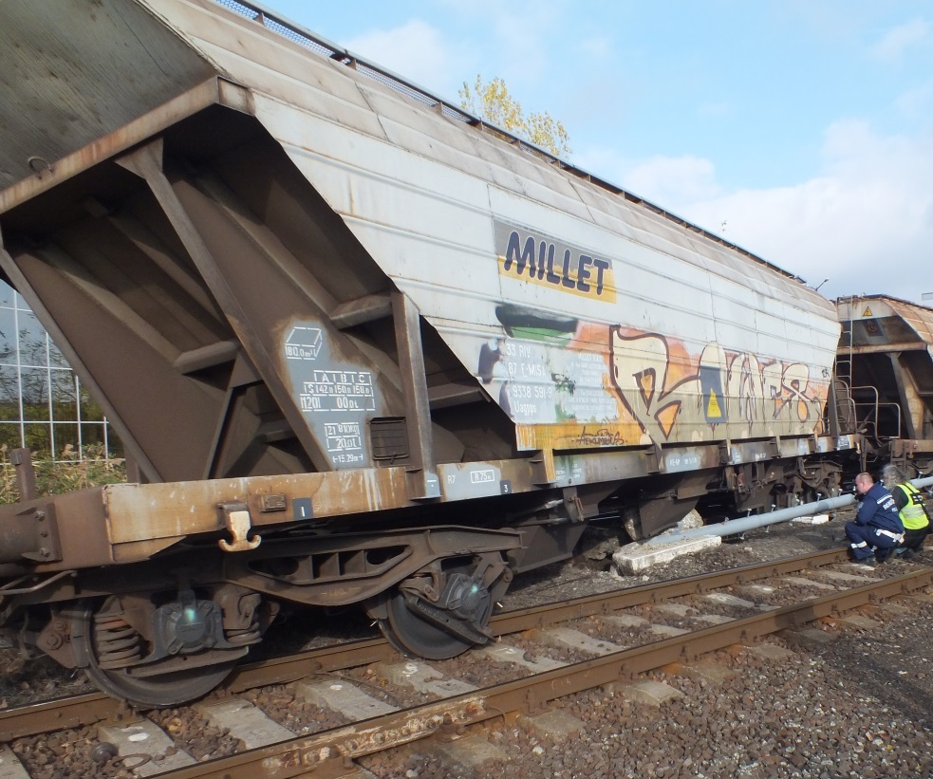

# CONCLUSIONS

## Direct causes

The factors which had direct effect on the occurrence were as follows:

1. the pointsman did not wait until the whole train entered the station but started the process earlier by handling the safety installation, at the end of which the switch was able to change position under the moving train;
2. the safety installation did not prevent irregular switch handling due to its fault not known by the pointsman.

## Indirect causes

Those findings relating to competences, procedures and maintenance which are related to the factors enumerated above:

1. when receiving the train, the traffic manager failed to check visually whether the train had actually moved in fully but only relied on the information from the safety installation before he released the block indicator of the route, thus making it possible for the pointsman to change the switch position under the moving train;

## Root causes

Causes that are distant in time and space from one another but which are related to system operation within the regulatory environment and in the safety management system:

1. the Operation Manual of the safety installation does not contain a description of the technical error which may lead to a similar accident, neither its risk, nor the procedure to follow in a similar case.

## Other risk factors

Factors which cannot be related to the occurrence but increase risk:

1. the safety installation designed about 100 years ago can only function if its rules of operation are strictly applied; the chances of human error and omission are rather high. Hazardous situations caused by human errors cannot be prevented in all cases.

# ACTIONS TAKEN

Each safety installation within the area of MÁV Zrt. PTI Debrecen was inspected out of turn following the occurrence, and, pursuant to a newly issued instruction, such installation must be specifically examined during every maintenance session.

No anomaly of operation was detected during the out-of-turn inspections.

On one occasion, a contact problem was detected and fixed during a subsequent monthly maintenance session.

# SAFETY RECOMMENDATION

**BA 2019-1245-5-01:** *On 11 November 2019, at Nyírbátor station, a train approaching with signal handling derailed due to changing of switch position under the moving train. The investigation conducted by TSB found that a technical error of the safety installation and the operating personnel’s activity contributed to the occurrence.*

**Transportation safety Bureau recommends MÁV Zrt. to consider completing the operation manual of type Siemens-Halske safety installations with a description of the technical defect which led to this accident, including its risk, detection and the procedure to apply if it occurs.**

*By acceptance and expected implementation of the safety recommendation, the relevant personnel will understand the importance of the applicable rules, and have adequate competences to manage critical situations arising from similar technical errors.*